VOLUMUL UNU

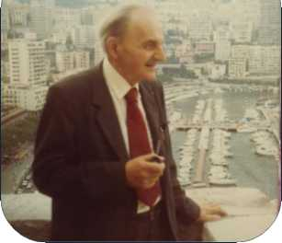

Constantin Noica

(1909-1987)

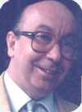

Edited by

C. George Sandulescu

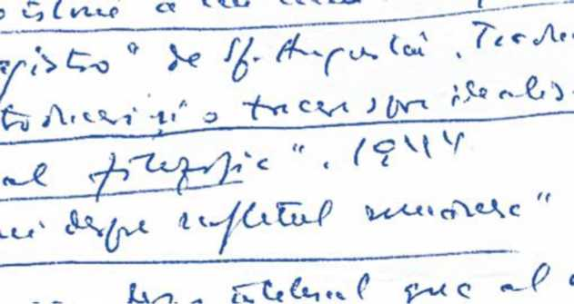

'Bucureşti  
2013

Comunicat de presă

Miercuri 4 decembrie 2013

Un cuvinţel pentru presă

Doi oameni de care am fost deosebit de ataşat—intelectual şi afectiv: unul, o rudă foarte apropiată, şi celălalt, un mare profesor universitar (descendent a 17 generaţii de preoţi români get-beget).

Să fie două genii diferite oare?

Nu le-am întâlnit perechea nicăieri în lumea asta mare!

Printr-o stranie coincidenţă Joyceană, ambele noastre volume apar la aniversarea morţii lui Constantin Noica—la 4 decembrie 1987—, în ajun de Sf. Niculae.

Ambele volume sunt presărate cu „filozofia" istoriei văzută amuzant.

C. George Sandulescu

Monte Carlo, Noel 2013

Press Release

Wednesday 4 December 2013

A Little Word to the Press

Two great men to whom I attached myself—intellectually and emotionally: one was a close relative, the other a great professor, descendant of 17 generations of Romanian priests.

Two different geniuses?

In the whole world I have never come across anyone like them!

By a strange Joycean coincidence, both our volumes are issued on the anniversary of Constantin Noica's death—4 December 1987—, on the Eve of St Nicholas.

To make them more amusing, we have spiced both volumes with thoughts on the "philosophy" of history.

C. George Sandulescu

Monte Carlo, Noel 2013

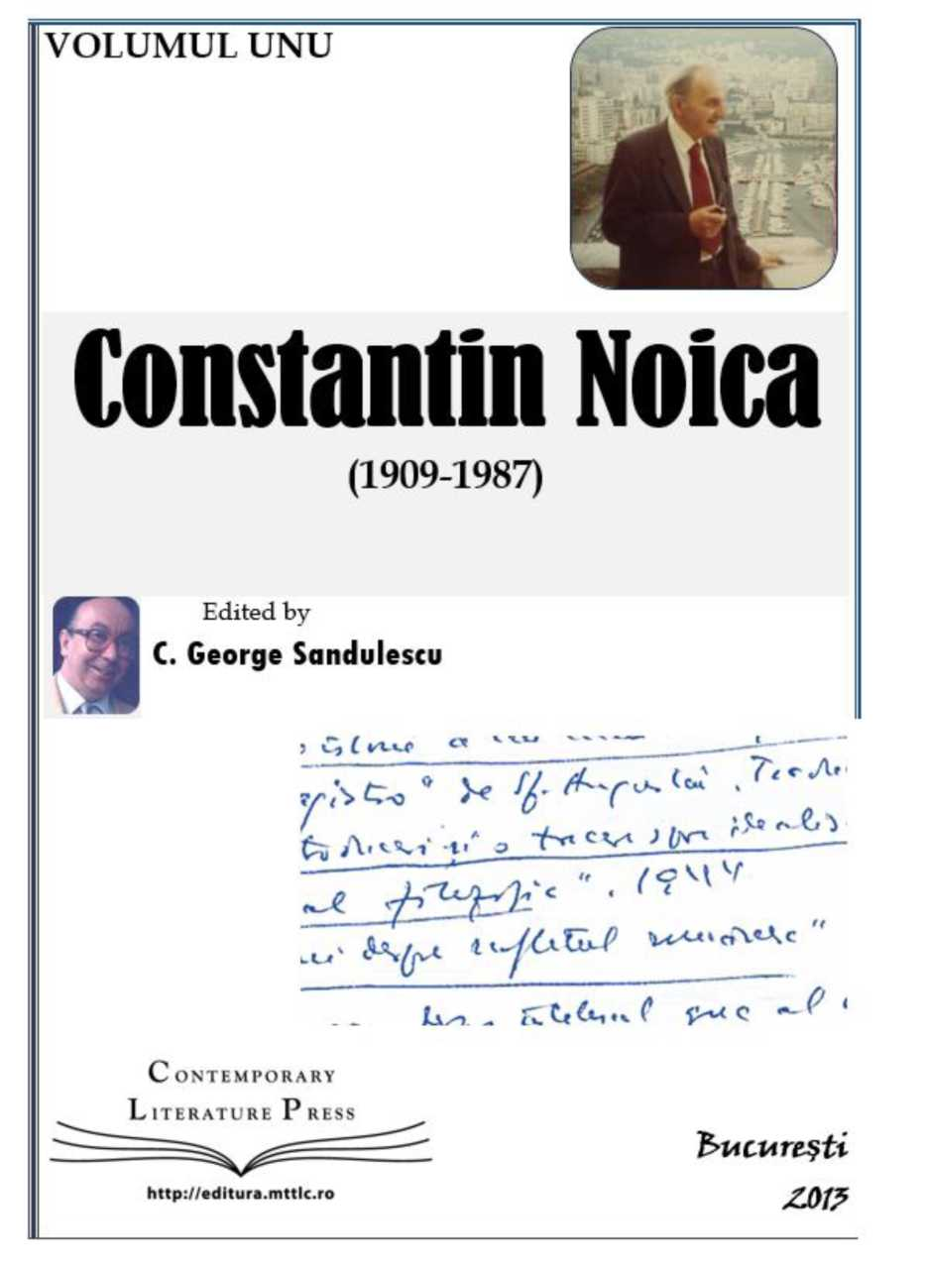

C ONTEMPORARY Literaturi; Press

http://cditura.mttlc.r<

Director:

LIDIA VTANU

Executive Advisor:

GEORGE SANDULESCU

**Contemporary Literature Press**

Editura pentru Studiul Limbii Engleze prin Literatură

**•• BRITISH •• COUNCIL**

I Universitatea

U C U R E Ş T 1

D I N

**O**

INSTITUTUL

CULTURAL

ROMÂN

Ambasâid na hEireann Embassy of Ireland Ambasada Irlandei

The only online Literature Publishing House of the University ofBucharest

ISBN: **978-606-8366-90-6**

© Universitatea din Bucureşti © C. George Sandulescu

Cover Design, Illustrations, and overall Layout: Lidia Vianu

IT Expertise: Simona Sămulescu, Cristina Petrescu. Publicity: Violeta Baroană Logo: Manuela Stancu

Constantin Noica

(1909-1987)

Edited by

C. george Sandulescu



Bucureşti

2013

Constantin Noica (1909-1987)

1

Table of Contents

1. **"My nephew!"** this is how I introduced him to my friends. p. 3

C- George Sandulescu Atitudinea Noica p. 4

C- George Sandulescu Noica, Complete Works?.. p. 25

Noica's self-censorship p. 26

Where are the actual Noica Manuscripts? p. 27

Jacqueline de Romilly p. 31

EminescuNoica: Axiological Linguistics p. 32

1. **Noica's Eight Exiles** p. 45

Katherine Muston A Biography of C. Noica p. 46

Noica's Eight Exiles p. 49

Life and Work. Holograph text written by C. Noica in Monaco in p. 50

September 1985.

Jaqueline de Romilly Du chemin de la verite. p. 53

The Forgotten Prisoners, The Observer Weekend Review, p. 59

Sunday, May 18, 1961.

1. **Noica's Literary Testament** p. 62

C ONTEMFORARY

Literature Press

<http://edltura.mttlc.ro> Bucureşti 2013

Constantin Noica (1909-1987)

2

IV. Appendices p. 70

Noica in English, translated by his nephew CGS: p. 71

Extracts

Death of the Tomorrow Man p. 72

Mathesis p. 76

De Caelo p. 83

Philosophical Journal p. 89

"Do Invent Teachers - I Urge You! p. 100

Noica and Eminescu p. 110

The Notebooks of Eminescu and the p. 111

Notebooks of Valery.

Eminescu and the Non-Being. p. 124

Facsimilaţi „Caietele lui Eminescu"! p. 126

Scrisoare despre „Caietele lui Eminescu". p. 129

Prezenţa fizică a lui Eminescu în lumea noastră. p. 133

Constantin Noica Ce nu se vede. p. 136

C. George Sandulescu: Disectorium: HISTORY a la Morgue. p. 139

C ONTEMFORARY

Literature Press

<http://edltura.mttlc.ro> Bucureşti 2013

Constantin Noica (1909-1987)

3

I.

"My nephew!" this is how I introduced him to my friends.

i«

C ONTEMFORARY

Literature Press



<http://edltura.mttlc.ro> Bucureşti 2013

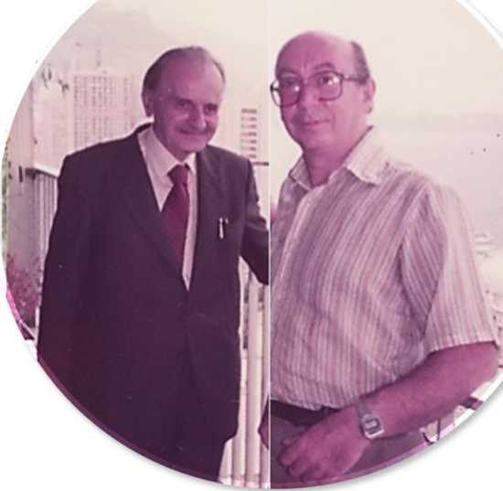

Constantin Noica, in Monaco, September 1985, with C. George Sandulescu

Constantin Noica (1909-1987)

4

C. GEORGE SANDULESCU

Atitudinea NOICA

To Julia, and Jemima, and James, and Kevin... and to the Noica's who know less Romanian. Or not at all.

C ONTEMFORARY

Literature Press



<http://edltura.mttlc.ro> Bucureşti 2013

Constantin Noica (1909-1987)

5

Revenirea la lume. [i]

Care a fost prima uşă la care a bătut Noica când — adus cu maşina miliţiştilor până la Piaţa Armenească — i s-a dat drumu' din puşcărie? Vă întreb eu: care a fost prima uşă? A fost la uşa mea!

În parte din întâmplare. Dar nu tocmai. Eu eram pe vremea aceea un prăpădit de asistent la universitate. La engleză!

Deschid uşa. Îngheţ! Îl recunosc pe Noica. De ani de zile înfundase închisoarea... Îl văd. Şi mi-e frică. Dacă era o capcană întinsă mie, ce fac?

Dar Noica nu mă recunoaşte. Natural: nu mă mai văzuse de aproape douăzeci de ani. Nu e de mirare — mai întâi domiciliu forţat la Câmpulung, iar apoi lungi ani de închisoare...

Noica întreabă: "Îl caut pe Titan Vlădescu!" Răsuflu uşurat. Îi răspund oarecum liniştit: "Unchiu' Titan a fost mutat cu un etaj mai jos, la etaju' ntâi!" Aş fi vrut să adaog 'nene Dinule!', căci avea un profil de neuitat. Dar nu o fac. Din laşitate oare?

Vrusesem să-i spun: 'a fost mutat cu forţa'. Dar n-am îndrăznit. Unchiu' Titan locuise în apartamentul 5 la etajul II. Acum era în apartamentul 3 la etajul I. Exact dedesubt. Noi ar fi trebuit să fi locuit în apartamentul 6 la etajul II, în partea opusă, de la bun început. Dar niciodată nu a fost aşa în timpul vieţii tatălui meu. Mama şi cu mine abia dacă reuşisem să intrăm acolo, când plecase cineva în Israel. Abia intraţi, vedem că o familie de la Ambasada Sovietică e băgată în restul apartamentului. Aşa că vă închipuiţi că eram în bună companie când bătuse Noica la uşă.

Auzindu-mi răspunsul, Noica zâmbeşte trist, dar tot nu mă recunoaşte. Nu face decât să-mi strângă mâna şi porneşte încet pe scări în jos.

Era cu puţin înainte de prânz, mi se pare. Mama era în bucătărie: alerg la ea şi- i strig în fugă — "E nenea Dinu aici!" — şi dau goană pe scări la etajul de dedesubt pe scara din dos. Dar soneria de la intrarea unchiului Titan sunase deja. Şi Titan era la uşa din faţă cu mult înainte ca eu să fi putut să-i spun că era Nenea Dinu cel care suna... şi că venea la el.

*

Eram trei în familie: dar Dinu era numai unul singur. Eu eram doar Den. Cel de-al treilea era Dan, de pe Pictor Luchian. Avocatul. Fost avocat.

C ONTEMFORARY

Literature Press



<http://edltura.mttlc.ro> Bucureşti 2013

Constantin Noica (1909-1987)

6

Avocatul Dan Noica, cel pomenit în romanul Cişmigiu & Co. de Grigore Băjenaru, cel care pusese paltonul în capul unui profesor, ca să-i tragă o bătaie, locuia pe strada Pictor Luchian la jumătatea drumului între Blocul Vlădescu din străzile Popa Soare şi Pictor Romano şi Blocul Noica de la Armenească.

Eram toţi "foşti". Eu mă puteam chiar mândri că eram unul dintre "foşti" de pe la treisprezece sau paisprezece ani...

*

Peste câteva minute, mă strigă unchiu' Titan; eu eram aproape chiar acolo. Mă ia înăuntru, prin bucătărie fireşte, şi mă prezintă lui Noica: "băiatu'Elenii! A crescut mare. Nu l-ai văzut demult—e acum la universtate, şi vorbeşte engleză mai bine decât Wendy." Aproape că n'aveam nume. Aveam doar un nume explicativ. Din fragedă copilărie. Lucru care mă turbura peste măsură. Aşa mă prezenta şi bunica mea Alexandrina— chiar în acelaşi apartament—invitatelor ei la ceai: tanti Sevasti, tanti Matilda, tanti Clemenţa, tanti Tudosica... Erau multe în Neamul Noica. Umpleau odaia. Vreau să zic, salonul. Iar ele mă întrebau şi ele: 'Da' pe mine cum mă cheamă?' Şi eu nu ştiam niciodată cum le cheamă. Că erau multe. Şi arătau cam la fel. Aşa că răspundeam simplu: 'Noica!' Iar ele râdeau, pline de aprobare... Şi tot mă întorceam în cămăruţa mea de la parter aproape plângând: supărat pe mine însumi că nu ţineam minte cum le cheamă exact pe fiecare. Dar Comuniştii au avut grijă de asta, şi curând a trebuit să uit cu totul că o familie Noica ar fi existat vreodată, dacă vroiam să mai rămân pe la şcoală. Mare familie de "foşti". Deveniţi criminali?

*

Noica venise la noi de-a dreptul, că nu avea unde pune capu' — în toată România cât de mare era ea. La ieşirea din închisoare. Ştia el ce face: unchiu' Titan, întreprinzător ca'ntotdeauna, l-a instalat cât se poate mai confortabil în camera servitoarei. (Un viitor biograf va măsura poate dimensiunile acelei camere; în care am locuit şi eu o vreme în timpul divorţului meu.) La Paris "les chambres de bonne" se află toate situate la mansardă. La Bucureşti, ele erau însă plasate lângă bucătărie. Cu intrare separată.

Şi a stat nenea Dinu la noi—adică la Titan Vlădescu, adică în Blocul Vlădescu (totul naţionalizat fireşte), luni de zile... Ba chiar ani. Nu-mi mai aduc bine aminte. Şi

C ONTEMFORARY

Literature Press



<http://edltura.mttlc.ro> Bucureşti 2013

Constantin Noica (1909-1987)

7

se plăcea mult acolo, în cămăruţa lui de servantă. (Eu cunoscusem multe servitoare care se perindaseră pe acolo, în vremea bunicii mele, în tot timpul războiului.)

*

Serile — după nouă — ne întâlneam la Titan şi puneam ţara la cale. Titan cunoştea toate ştirile externe pe dinafară din Scânteia noastră cea de toate zilele (ale cărei localuri formează astăzi birourile lui Liiceanu). Noica, la rândul lui, vedea aspectele folosofico-abstracte ale problemelor. Iar eu ascultam cu sfinţenie posturile de radio engleze, urmând tradiţia creată de tatăl meu, care nu ascultase decât Radio Londra în engleză (că doar făcuse şcoala la un Colegiu American).

*

Numele de botez aveau un loc important în Neamul Noica. Seara de seară, ne întâlneam astfel cei trei Constantini—numiţi la fel din aceeaşi voinţă familială: Constantin Vlădescu gazda, Constantin Noica binevenitul oaspete, şi Constantin Săndulescu nepotul de la etajul de sus (numele de George, dat mie de tatăl meu, nu am început, din motive ascunse, să-l folosesc decât odată ajuns în Occident).

Uitându-mă la ei discutând cu aprindere evenimentele zilei, versurile pe care le tot morfoleam de mic copil, fără să le găsesc vreun sens, îmi reveneau des în minte—

Împăratu' Constantin,

Boier vechi şi domn creştin...

De ce oare? până mi-am dat seama: cam aşa arăta Noica, şi nici Titan nu era prea departe; o imagine despre Brâncoveanu, aplicată aerului relativ aristoratic pe care îl degajau unii dintre Noiculeşti. Şi privindu-l pe Dinu, îmi revenea înaintea ochilor imaginea tatălui său Grigore discutând frontul de Răsărit cu tatăl meu. So very much alike, and yet so diferent — the two Noica's - father & son!

Foarte des se adăuga nouă un al patrulea, o victimă a Primului Război Mondial, 'Fratele Iacov', cum îi spunea Titan, care rămăsese patologic lipsit de iniţiativă personală de pe urma prizonieratului la Nemţi.

Cum Bunica nu dăduse decât nume biblice celor doisprezece copii ai ei — şase băieţi şi şase fete—el era Iacov Vlădescu, vecin de cameră de bonă cu Noica, pe acelaşi palier. Marea lui calitate era că tăcea tot timpul. Dar şi era tot timpul ocupat. Era bun

C ONTEMFORARY

Literature Press



<http://edltura.mttlc.ro> Bucureşti 2013

Constantin Noica (1909-1987)

8

meşteşugar, şi săritor; un suflet mare, care l-a ajutat mult pe Noica în viaţa de zi cu zi, destul de grea în anii aceia. Mai ales că Noica avea întotdeauna nevoie de mulţi secretari în jurul lui, şi ştia bine cum să-i recruteze şi pentru ce anume corvezi ; cum nu avea telefon, trimetea mesaje. Apoi trimetea, de pildă, multe din cărţile sau articolele sale, o dată publicate, cu dedicaţie scrisă de mâna lui, la multe adrese profesionale, cum era obiceiul pe vremuri.

În acest mediu familial a venit Noica, atunci când l-au lăsat liber. L-am îmbrăţişat cu toţii cu mult entuziasm: îi sorbeam cuvintele de parcă rostea Predica de pe Muntele Athos. Şi ... Aramis, adăugam eu, cam maliţios, în mintea mea.

Într-o seară ne aduce vestea că va lucra la Centrul de Logică, pe atunci condus de Academicianul Atanase Joja. Şi unde se afla acest Centru de Logică? La doi paşi de noi, pe strada Negustori, dincolo de strada Paleologu. Simbolic vorbind, această casă ca oricare alta de pe strada Negustori, se afla la jumatatea distanţei dintre Blocul Vlădescu şi locuinţa în care şi-a petrecut copilăria Mircea Eliade, foarte aproape de

Bulevardul Domniţei.

/

O slujbă acolo a fost o raţiune în plus pentru Noica să continuie să locuiască la noi. După aceea s-a mutat într-un apartament, care i s-a dat la celălalt capăt al Bucureştiului, nu departe de Spitalul Central.

*

O altă coincidenţă mai mult decât simbolică: unde, exact, se află Blocul Vlădescu, la care a venit Noica când i s-a dat drumu'? Nimeni poate nu ar putea face legătura afară de mine: locul favorit de joc al copilăriei mele era un teren viran care se afla în faţa casei noastre chiar la jumătatea străzii Pictor Romano. Un teren care era bine îngrădit, şi în care nimeni nu intra afară de mine. Mulţi copaci, ierburi înalte, bălării, gângănii de tot felul. Ideal pentru mine —copil solitar, singuratic, dar îndeajuns de curajos, care se juca întotdeauna de unul singur. Mi s-a spus că maidanul aparţine unor călugări. A rămas teren viran chiar şi în anii când a locuit Noica la noi. Terminasem Universitatea şi tot nu aflasem ce fusese acolo. Ei bine, coincidenţa coincidenţelor (filosofie în care credea atât de mult James Joyce): acolo fusese Ospiciul Şuţu, unde şi-a dat sufletul Eminescu. (O placă comemorativă se află undeva pe strada Plantelor, mai precis la numărul nouă, chiar alături de locuinţa fiicei scriitorului Ioan Slavici. Numai că pe placă ospiciul nu se mai cheamă 'Şuţu'. Ce păcat!)

C ONTEMFORARY

Literature Press



<http://edltura.mttlc.ro> Bucureşti 2013

Constantin Noica (1909-1987)

9

* Noica a ieşit la lumină după lungul surghiun arbitrar-totalitar chiar pe locul unde a murit Eminescu: la familia sa Noica-Vlădescu.
* Eminescu, la rândul său, a venit, prin Caietele sale, chiar pe locul unde a murit Noica. La Păltiniş... Deci la Sibiu.
* Mai vreţi încă o coincidenţă? Cartierul Mântuleasa era legat de copilăria şi tinereţea lui Mircea Eliade. Citiţi cu atenţie romanul Pe Strada Mântuleasa, scris prin 1956 (personaj principal fiind Ana Pauker), care se petrece chiar acolo. Citiţi şi primul volum al Memoriilor sale intitulat Les Promesses de l'equinoxe 1907-1937, unde Eliade scrie că locuia pe strada Melodiei...
* Sibiul este, la fel, de legat de copilăria şi tinereţea lui Emil Cioran (care descrie atât de pregnant cum îşi petrecea insomniile umblând în sus şi'n jos pe toate străzile oraşului, nopţi întregi). Chiar şi prin faţa bibliotecii unde zace azi sărmanul nostru Eminescu... în caiet manuscris + Ediţie Princeps + Electronic Disc. În versiune ne-expurgată.
* Mă minunez eu singur de miracolul joycean—coincidenţa —care îţi îngăduie să descoperi singur-singurel atâtea lucruri.
* Trei prieteni la cataramă au fost ei vreme de mai bine de o jumătate de veac —Noica, Eliade, Cioran. De prin anii douăzeci până prin anii optzeci... Trei Crai de Curtea Veche. Doi munteni şi un ardelean... un cadru aproape mioritic... care duce şi la căsăpirea lor vremelnică... atunci şi acum. T.S. Eliot, într-un poem despre The Magi, îi va defini pe cei trei într-un fel pe care-l putem numi chiar profetic. Crai de Răsărit ar putea spune francezii, mai cunoscători în ale Bibliei. Doi din ei poate mai franţuziţi, dar al treilea rămas românaş sadea până la sfârşitul sfârşitului.

Cei Trei Crai de la Răsărit pot fi reuniţi—fireşte—prin multe fire vizibile. Prietenia lor strânsă de-a lungul anilor, de pildă. Dar şi pe baza coincidenţelor obiective de mai sus, prin multe fire cu totul invizibile cu ochiul liber al criticului convenţional.

* Noica e acum pe internet, mulţumită Universităţii Bucureşti.

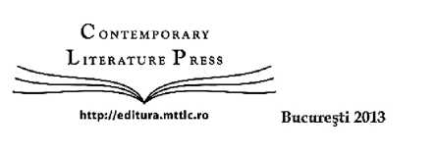

Constantin Noica (1909-1987)

10

* Pe când şi Caietele Eminescu pe internet? Că doar probleme de copyright nu ştiu să mai existe...

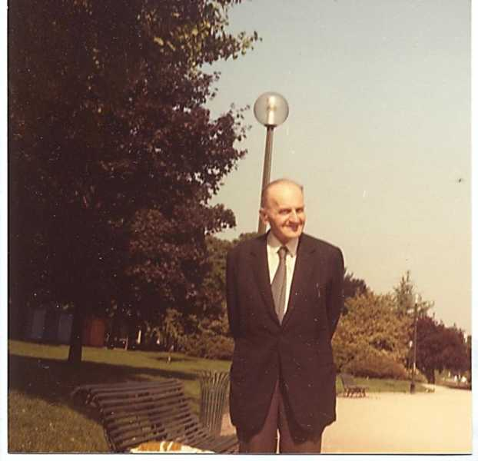

C ONTEMFORARY

Literature Press



<http://edltura.mttlc.ro> Bucureşti 2013

Constantin Noica (1909-1987)

11

Vizita lui NOICA la Monaco. [2]

‘A shady place?' Never!

Monaco şi Monte Carlo a fost penultima etapă în cursul ultimei vizite pe care Dinu Noica a facut-o în străinătate în toamna anului 1985.

A sosit cu trenul de la Paris; l-am întâmpinat cu maşina la gară. A stat aproape o săptămână la mine acasă. Apoi, într-o frumoasă duminică dimineaţă de septembrie am pornit împreună, tot cu maşina, spre Tourette-sur-Loup, dans l'arriere pays nigois, unde eram invitaţi la masă de Marianne Parlier şi de soţul ei—celebrul avocat parizian Parlier—în căsuţa pe care o aveau ei, residence secondaire, chiar în centrul orăşelului. O întâlnisem pe Marianne Parlier de mai multe ori, căci mama mea Elena Săndulescu o cunoştea foarte bine: doar fuseseră, se pare, la şcoală o vreme împreună.

La Monte Carlo, după cum bine ştie Simina Noica de la Paris, (care mă vizitase deja împreună cu fosta mea studentă Anca Ghica, chiar în timpul vieţii mamei mele)

eu locuiesc chiar la malul Mării Mediterane. În fiecare dimineaţă, Dinu Noica se instala

/ '

pe balcon şi, îşi lua cu tot tabietul micul dejun, purtând inevitabilele ghetre. Iar apoi, împreună, puneam ţara la cale. Ce vom face în ziua care începea, şi în zilele următoare. Dar de fapt, ne pierdeam în discuţii, ţintuiţi pe scaune o bună bucată de timp.

Discutam toate subiectele imaginabile, căci trebuie sa spun că rar am întâlnit pe cineva mai dispus să discute absolut orice subiect..., dar lucrul care mă impresiona cel mai mult la el era curiozitatea demnă de un învăţăcel de geniu: nu era deloc îngâmfat sau înfumurat, îl interesa absolut tot, şi era dispus să discute despre câte-n lună şi în soare. Lucru foarte de seamă: nu zicea niciodată că nu se pricepe. Sau că nu a citit. Sau că nu-şi mai aduce aminte. Cum fac mult prea mulţi în ziua de azi. Deduc că nu îl lăsa profilul său moral de filosof cu renume.

Dar, în cursul lungilor discuţii, apărea dintr'odată filosoful, ridicându-se de dindărătul acestei atitudini generale: cu forţa unui neaşteptat şuvoi de munte — apărea verdictul Noica. Îmi pare rău şi acum că nu am înregistrat pe bandă de magnetofon conversaţiile noastre, căci aveam mai multe aparate prin casă.

Dar nu m-a lasat inima sa o fac: bucuria revederii era mult prea mare, nu numai ca membri ai aceleiaşi familii, dar şi ca intelectuali înclinaţi puternic spre filosofia limbii, a limbajului, şi a lingvisticii, şi în general spre soarta lumii întregi, atât în

C ONTEMFORARY

Literature Press



<http://edltura.mttlc.ro> Bucureşti 2013

Constantin Noica (1909-1987)

12

prezent, cât şi în viitor. Aveam multe de discutat, uneori, e adevărat, în contradictoriu. E straniu că nu-mi mai amintesc deloc punctele de dezacord... Modul său de a argumenta avea întotdeauna o putere extraordinară, tocmai prin vădita sa sinceritate.

Am discutat însă împreună un lucru important, care trebuie menţionat aici şi anume, ideea unei Antologii Noica în limba engleză. (Ideea unei antologii în limba română fusese iniţial lansată de Simina Noica la Paris.) Argumentul meu însă pentru

o Antologie în limba engleză fost faptul că lucrările publicate într-o limbă mică într-o ţară mică au foarte puţine şanse de succes pe o scară mai largă, oricare ar fi valoarea lor intrinsecă. Noica a fost întru totul de acord cu mine, şi m-a întrebat ce am putea face. Cum eu tocmai în acel moment istoric porneam The Princess Grace Library Publication Programme (pe care l-am susţinut vreo 10-15 ani), i-am propus lui Noica ceva asemănător. Vizitând apoi localurile instituţiei Princess Grace Library, i-am explicat mai pe îndelete ce aveam de gând acolo. Dar în ce-l priveşte pe el, am văzut atunci necesitatea unei Liste de Lucrări. I-am spus că în vederea unei Antologii, ar fi nevoie de o listă cât mai completă... Iar Noica, tânăr entuziast ca întotdeauna, s-a aşezat la masa de pe balcon, şi mi-a furnizat această listă... din memorie ... şi imediat. Pe nepusă masă şi... din memorie. (O reproducem pe coperta acestor volume, ca având un caracter de simbol iniţial, şi document de bază a ceea încercăm să facem azi aici.) A venit deci astăzi vremea să scoatem acest proiect utopic din raft, şi cu sprijinul Universităţii din Bucureşti să vedem ce putem face. Subliniez aici că Simina Noica a creat ea însăşi acest volum manuscris în română încă din timpul vieţii lui Noica, în 1986. Şi mi l-a trimes, plocon, mie — sute de pagini.(A zăcut deci în rafturile mele până acum, când Universitatea din Bucureşti îşi exprimă interesul...)

Dar subiectul cel mai frecvent de discuţie era întocmirea, pas cu pas, a programului de vizite, la Monaco bineînţeles, în cursul relativ scurtei sale şederi aici. Am facut mai multe tururi, mai ales cu maşina, spre a-i arăta locurile. Casinoul cel Vechi, Casinoul American, Teatrul, Bibioteca Princess Grace, pe care o fondasem împreună cu scriitorul englez Anthony Burgess la moartea Prinţesei, si unde eram Director, dar şi persoanele si personalităţile care s-au întâmplat să fie disponibile

C ONTEMFORARY

Literature Press



<http://edltura.mttlc.ro> Bucureşti 2013

Constantin Noica (1909-1987)

13

atunci. Aş fi vrut mult să găsesc un localnic care să cunoască bine limba locului şi care să-i vorbească lui Noica pe limba monegască... dar am constatat atunci că nu cunoşteam pe absolut niciunul. Nimeni nu vorbea curent limba monegască — singura limbă latină cu două infinitive distincte, tocmai ca şi limba română... Ba da! Cunoşteam unul—un casier de la Banca mea. Mergem deci acolo cu mari speranţe: dar casierul meu nu era în ziua aceea de serviciu.

Aşa că l-am dus să-i viziteze pe nemţi. Pe Doamna Christel Renkl, mare proprietară de fabrici în Germania, care locuia la etajul 18 al clădirii deumită The Sun Tower. Elle avait une vue imprenable de la Mediterranee...

Sâmbată la prânz, am dat eu o masă pe balcon la care l-am invitat pe Paul Dimitriu, scriitor şi gazetar, care ştiam sigur că fusese implicat destul de mult în procesul atât de răsunător pe care îl avusese Noica. Când a intrat pe uşă, Dimitriu s-a plecat până în pământ—de parcă l-ar fi salutat pe Împăratul Haile Selassie în persoană! Dar Dinu nu s-a bucurat prea mult la vederea lui. Abia după ce am citit cartea de documente intitulată Prigoana am înţeles mult mai bine de ce.

Acest prânz îl gătisem şi pregătisem eu însumi—friptură de berbec la cuptor, însoţită de tot ce trebuie înainte şi după... Toată lumea a fost mulţumită, şi discuţiile au fost spontane şi intense. Dar nici aici nu-mi aduc aminte mare lucru din ce s-a discutat... în parte şi pentru că, fiind gazdă, tot alergam în sus şi-n jos, să-i servesc cum nu se poate mai bine pe mosafirii mei. (Dimitriu însă a scris după aceea un articolaş despre această întâlnire, care a fost descoperit şi republicat ulterior de Nicolae Noica în foarte folositoarea sa carte intitulată Neamul Noica, la paginile 159-161)

Prigoana: Documente ale procesului C. Noica, C. Pillat, etc. Colecţia FID Fapte, Idei, Documente. Editura Vremea, Bucureşti 1996. 558 pp.

Paul Dimitriu. Exerciţii de memorie. Bucureşti 2002.

C ONTEMFORARY

Literature Press



<http://edltura.mttlc.ro> Bucureşti 2013

Constantin Noica (1909-1987)

14

Întâlnirea de la Marianne Parlier. [3]

Cei Trei Crai de la Răsărit erau răspândiţi în lumea întreagă — în trei Continente diferite. Unul din ei era în Continentul European—la Paris. Altul era pe Continentul American—la Chicago. Şi ultimul, cel mai bogat pe vremuri, dar şi cel mai hărţuit de viaţă — la Bucureşti, în Continentul Comunist.

Dar la începutul lui septembrie 1985, la exact un an după moartea mamei mele, şi la exact doi ani după moartea Prinţesei Grace de Monaco, pentru care lucrasem cu devotament în ultimii ani ai vieţii sale, Doamna Marianne Parlier reuşeşte să-i strângă la un loc pe toţi trei în locuinţa ei pariziană, nu departe de Palais de l'Elysee. Numele de Marianne Parlier este bine cunoscut tuturor celor care au urmărit Procesul Noica, întrucât se vorbeşte mult despre ea acolo.

Au participat la întâlnire: Domnul şi Doamna Parlier, împreună cu fiul lor, Madame Jacqueline de Romilly, membre de l'Academie Frangaise, cât şi fiica lui Noica — Alex, domiciliată în Cornwall. In plus, Simina Noica, colaboratoare apropiată a Doamnei Jacqueline de Romilly în domeniul studiilor clasice, era şi ea acolo. Eu eram deasemenea prezent în calitate de invitat personal al lui Constantin Noica.

Doamna Parlier, care fusese la şcoală pe vremuri împreună cu mama mea, era peste tot, ocupându-se de toate; în ochii mei de nechemat la Paris, o asociam într-un fel vag şi nedesluşit cu actriţa de origine română de pe vremuri—Elvire Popesco.

Singurul care ar fi trebuit să fie prezent, dar nu era, era Ionesco... care de undeva, din apropiere, trebuie că se gândea fără doar şi poate la noi.

Era însă, într-un fel straniu, o oarecare tensiune în aer. Voi încerca să explic cum şi ce. Sau poate că prezenţa lui Eliade, Cioran şi Noica, la un loc, era mult prea mult pentru nervii mei, deja întinşi la maximum.

Şi unde mai pui că lucrurile încep prost. Cum este obiceiul meu de-o viaţă, sosesc devreme. Îl găsesc deja pe Mircea Eliade, supărat şi pus pe ceartă la intrare. Fireşte, împreună cu doamna. Dar aveam de urcat trei etaje, iar ascensorul nu funcţiona. Era supărat de fapt pentru că nu i se spusese la telefon că ascensorul era stricat, că n-ar fi venit. Încerc să-l liniştesc şi să-l conving să urce pe scări. Se vedea de departe că nu se simţea bine: avea un braţ în ghips, afecţiune cronică. Văzându-l atât de iritabil, dau fuga sus pe scări, trei etaje, să anunţ că Eliade a venit şi că vrea să

C ONTEMFORARY

Literature Press



<http://edltura.mttlc.ro> Bucureşti 2013

Constantin Noica (1909-1987)

15

se întoarcă acasă din pricina liftului defect. Ajung sus, sun la uşă, şi Noica deschide uşa chiar el. Îi spun în grabă ce s-a întâmplat, şi că Mircea Eliade refuză să urce scara. Noica anunţă înăuntru ce s-a întâmplat, şi apoi se pregăteşte să coboare scările. Dar Eliade, între timp, se hotărâse să urce pe scări, şi tocmai se apropia de etajul trei urcând încet... Nu-l văzusem niciodată atât de slăbit, şi atât de ursuz.

Noica îl vede şi îl aşteaptă pe pragul uşii de la intrarea apartamentului. Doi prieteni atât de buni se întâlnesc după atâta vreme... Dar Noica ţine neapărat să schimbe atmosfera, şi îi spune cu jovialitatea lui proverbială, şi cu un mare zâmbet pe buze: "Auzi ce zice nepotu-meu—că nu mai eşti în stare să urci nişte scări!"

Eu o cam bag pe mânecă, şi mă simt vinovat. N-am vrut să spun eu asta. Prietenie, prietenie, dar expresia lui Noica e cam prea tare... cred eu.

Preocupat de suferinţa sa, Eliade nu răspunde mare lucru, şi intră. Încerc să-i ţin companie mai toată seara, ca să cârpesc, chipurile, o greşeală pe care nici n-o făcusem. Rămân singur cu Eliade într-un colţ: nu discutăm decât politică. Situaţia în Europa în septembrie 1985 este mai mult decât urâtă. Mai ales acum a la rentree politique... Eliade e ursuz, suferind, puţin comunicativ. Dar când aduc vorba de pericolul rusesc, dintrodată prinde viaţă şi devine combativ: "Ruşii nu vor îndrăzni niciodată să intre-n România," îmi spune el cu vehemenţă. Şi pe bună dreptate. Era dovada clară şi limpede că intuia situaţia politică din toată Europa cu multă preciziune: văzuse deja că, mult mai târziu —în 1989—situaţia Românei nu-i va interesa nici pe ruşi, nici pe americani cât de puţin. 'Să se descurce cum pot!' se pare că spuneau fiecare încă de prin 1985. Şi românii s-au descurcat cum au putut. Singura ţară din Răsăritul comunist unde trecerea s-a făcut cu ceva vărsare de sânge. Cam prea multă vărsare de sânge... comparativ vorbind.

Dar în casa doamnei Parlier plutea deja un aer de îngrijorare, chiar de dramă. Aveam momente când simţeam că Noica însuşi intuia că e poate ultima sa vizită în Occident. Cum? Dovada? A fost singura dată când nu a trecut în Anglia: fiica sa Alex—'Dina', cum îi ziceam din copilarie — a venit special la Paris spre a-l întâlni.

Săptămâni mai târziu, soţia sa, Wendy Muston, bună traducătoare, îmi telefonează din Anglia spre a mă întreba pe mine: "Ce-a vrut Dinu să spună când mi­a declarat atât de convins că 'Anglia nu-l interesează întrucât 'este o ţară fără filosofi'?". Mă simt obligat să-i răspund la obiect, şi să-i spun "Mai toţi filosofii englezi worth the notice sunt materialişti până'n măduva oaselor!" Wendy acceptă argumentul meu, nu prea convinsă.

*

C ONTEMFORARY

Literature Press



<http://edltura.mttlc.ro> Bucureşti 2013

Constantin Noica (1909-1987)

16

Singura persoană în foarte bună dispoziţie, şi volubilă tot timpul era, paradoxal, Emil Cioran. Radia de sănătate, mult mai mult decât ceilalţi. Era plin de dinamism şi optimism în conversaţie. Răsuna de parcă tout etait pour le mieux dans le meilleurs des mondes possibles.

Cum eu îl cunoşteam cel mai puţin bine dintre toţi trei, rămăsesem întrucâtva surprins la disonanţa pe care, foarte voit, o crea.

Erau în aer tensiuni negative. Dar erau în aer şi tensiuni pozitive. Eu, dezorientat, încercam să înţeleg. Dar trebuie să spun că nu pricepeam prea mare lucru...

Eliade, din ce în ce mai ursuz, stă cât stă, şi declară dintr-odată că nu va rămâne la masa de seară pentru care fusese special invitat. Eu încerc să-l conving—cu argumente româneşti—dar, din nou, fără mare succes.

Când toată lumea se scoală să se îndrepte spre sufragerie, Mircea Eliade spune un larevedere, voit rapid, tuturor, şi după oarecare tergiversări, se îndreaptă spre ieşire şi dispare, împreună cu doamna (fiica dirijorului român, stabilit în America, Ionel Perlea).

Mircea Eliade va muri la şase luni după aceea, de Sf. Gheorghe 1986 la Chicago.

Constantin Noica va muri şi el la ceva mai bine de doi ani după aceea, de Sf. Niculae 1987.

Numai Emil Cioran va continua să trăiască. Va fi martor la prăbuşirea rapidă a Comunismului de peste tot, în afară de China şi Cuba. Şi va vizita chiar România cu mare pompă.

*

C ONTEMFORARY

Literature Press



<http://edltura.mttlc.ro> Bucureşti 2013

Constantin Noica (1909-1987)

17

Nu noi suntem stăpânii limbii, ci limba e stăpâna noastră.

Eminescu

Dar la masă, în seara cu pricina, discuţia e susţinută pe subiecte mai mult sau mai puţin anodine. Se cam simte absenţa voită a lui Mircea Eliade. Până când, nu prea ştiu cum, eu aduc vorba despre limba engleză!

Este momentul când Cioran intră în acţiune. Ne ţine aproape o micro-prelegere improvizată despre marile limbi europene; nu ştiam că Cioran cunoaşte engleza atât de bine în toate subtilităţile ei, mai ales la meta-nivel. Astfel, se apucă să discute, captând atenţia tuturor, asemănarea dinamic-diacronică a limbii engleze şi a limbii române.

Noica ascultă.

Cioran vorbeşte nu cu morga teoreticianului steril, ci cu entuziasmul meşteşugarului întreprinzător —mândru de uneltele sale. Pe care le studiază şi le îngrijeşte cu deosebită meticulozitate. Nu pe degeaba e considerat el cel mai mare stilist al limbii franceze. De către francezii înşişi.

Rezumă simplu şi rapid prelegeri care ar putea dura un an de zile. Limbile franceză şi italiană se trag dintr-o singură sursă, pe care o cunoaştem cu toţi cum nu se poate de bine. Dar româna şi engleza au în comun următorul lucru: se trag în mod echilibrat din două surse distincte: engleza are o temelie germanică pe care s-a construit latin în mai toate domeniile. Româna are un fundament latin cu multiple eşafodaje slave... toată biserica, toată agricultura, alfabetul până aproape de Eminescu... Deci, ambele sunt 'bi', în termeni mai pornografici.

Mă uimeşte nu numai simplitatea expunerii, ci şi exactitatea şi conciziunea ei. Câtă dreptate are! Şi cu ce entuziasm îşi susţine teza!

Avântul lui reprezintă viaţa însăşi: nici vorbă de moarte aici... iar pesimism ioc. Cioran rămâne plin de admiraţie faţă de bogăţia de sinonime în română şi engleză! The famous synonymous doublets, care abundă mai ales în traducerea făcută de Ralph Robinson Utopiei lui Thomas More. Aud din nou meşteşugarul vorbind. (Dar îmi răsună în urechi şi Noica, care îmi şoptise cu câteva zile înainte, cam răutăcios — "Cioran? I-ai citit o carte... le-ai citit pe toate!")

Descoperisem eu oare secretul sănătăţii lui Cioran? Ori de câte ori vorbeşte despre limbă devine alt om: devine un incorigibil optimist. Noica ascultă, oarecum

C ONTEMFORARY

Literature Press



<http://edltura.mttlc.ro> Bucureşti 2013

Constantin Noica (1909-1987)

18

absent. Iar eu bolborosesc inutil că, tehnic vorbind, româna este o limbă mică, prea mică, iar engleza este cu totul atotputernică pe lumea asta. Afirmaţie care nu pare să­

1. placă nici lui Cioran şi nici lui Noica. Am spus, e drept, o platitudine cu totul adevărată, dar de o absurditate demnă de umorul lui Ionesco şi al cântăreţelor sale.

Alexandra Noica-Wilson. Treziţi-vă, suntem liberi. Humanitas 2007. paginile 55, 56 şi 57.

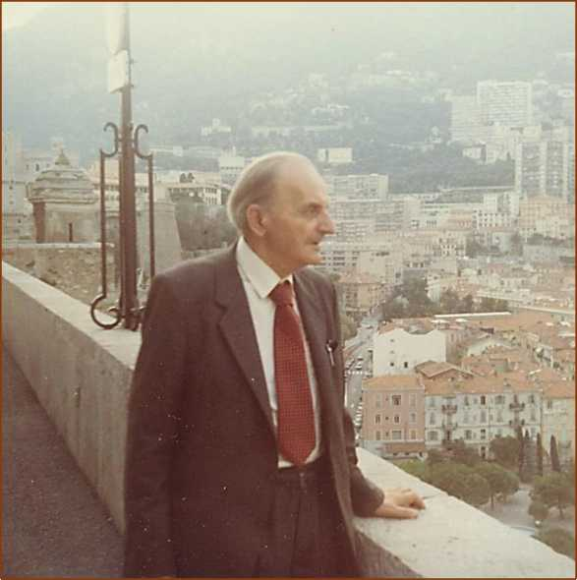

C ONTEMFORARY

Literature Press



<http://edltura.mttlc.ro> Bucureşti 2013

Constantin Noica (1909-1987)

19

Post Scriptum despre Nobel. [4]

In 1975, mă aflu la Paris pentru a participa şi a ţine o comunicare la Simposionul Internaţional James Joyce, care avea loc la Sorbonne.

Cu acest prilej vizitez mai mulţi români, cât şi pe profesorul Alain Guillermou de la Sorbona— profesor de română, care tocmai tradusese unul din romanele lui Mircea Eliade în limba franceză; dacă ţin bine minte, romanul era Pădurea interzisă.

Cu acest prilej, iau legătura şi cu Sanda Stolojan, nepoata romancierului Duiliu Zamfirescu, care se hotărăşte să dea o recepţie cu prilejul vizitei mele la Paris. La această recepţie, eu, venind de la Stockholm şi fiind bun prieten cu Bibliotecarul Academiei Suedeze, cer, în calitatea mea de cetăţean suedez de origine română, comunităţii române de la Paris să îl propună pe Mircea Eliade pentru Premiul Nobel de Literatură. Încerc să le explic ce procedură exactă ar trebui să urmeze.

Seara decurge paşnic. La sfârşitul recepţiei mi se comunică însă, relativ oficial şi dogmatic de către Monica Lovinescu, că ar fi mult mai bine dacă eu însumi l-aş propune (în loc de Eliade!) pe Constantin Noica, din partea oricărei universităţi mi-ar place. Răspund sec că Noica nu a scris literatură, ci filosofie. Iar un Premiu Nobel pentru Filosofie nu există.

Aşa s-a încheiat discuţia. Eu am reţinut 'reţinerea' lor faţă de Mircea Eliade,

» / / / / '

reţinere pe care eu nu o împărtăşeam. Cred că mulţi alţi români nu aveau nici ei o

asemenea reţinere.

/

Nici Noica şi nici Eliade nu au fost niciodată propuşi pentru Premiul Nobel. (Â propos: ştiţi cumva de ce nu a luat James Joyce niciodată Premiul Nobel? E simplu: pentru că nimeni nu s-a gândit să-l propună. Academia Nobel nu are dreptul să propună singură!)

Să mulţumim deci doamnei Herta Muller, cât şi Germaniei întregite, pentru absolut primul Premiu Nobel pentru Literatură pe care l-a obţinut România par pays interpose.

Eliade ar fi fost poate singurul care l-ar fi meritat, cronologic vorbind, înaintea ei. (În 1956, Eliade însuşi, după spusele sale mie, îl propusese pe poetul Lucian Blaga... şi unde mai pui că i-am aflat şi de ce Blaga fusese dat atât de brusc la o parte.)

C ONTEMFORARY

Literature Press



<http://edltura.mttlc.ro> Bucureşti 2013

Constantin Noica (1909-1987)

20

APPENDIX about Genealogy. [5]

Sunt într-un fel cum nu se poate mai uimit de propria mea desoperire: în descendenţa filosofului Constantin Noica am cunoscut personal şi cum nu se poate mai bine cinci generaţii, astfel:

1. PRIMA GENERAŢIE: I-am cunoscut bine pe părinţii filosofului—pe tatăl său Grigore şi pe mama sa Clemenţa. În tot timpul războiului, Grigore Noica (1880-1946) avea discuţii politice aprinse cu tatăl meu, situându-se pe o poziţie relativ opusă, tatăl meu ţinând întodeauna cu englezii şi americanii. Iar Tanti Clemenţa (1886-1964), născută Cassassovici, locuia după moartea soţului ei, nu departe de Statuia Rosetti, pe strada Vasile Lascăr; o vizitam din când în când, copil fiind, la cererea uneia sau alteia din mătuşile mele Vlădescu, cu care locuiam împreună în blocul Vlădescu, din strada Pictor Romano, naţionalizat printre primele clădiri din Bucureşti.
2. A DOUA GENERAŢIE: Am cunoscut-o foarte bine pe soţia sa Wendy Muston (1907-1996) (traducătoarea în engleză a cărţii Pray for Brother Alexander), scrisă de Noica chiar în închisoare. O întâlneam adeseori la Bush House, sediul londonez al postului B.B.C., pe la cinci după amiază, când termina orele de lucru ca traducătoare la Secţia Română. Era foarte mândră de colegii ei: astfel, mi l-a prezentat pe marele lingvist al postului de radio B.B.C., şi anume pe omul care cunoştea 60 —I repeat, şaizeci de limbi străine: este omul care a scris cartea Compendium of the World's Languages, publicată de Routledge în 1995, care are 670 pagini. Omul se chema George L. CAMPBELL. He had been Supervisor of the B.B.C. World Service for no end of years during the Second World War. He was the only man whose job and knowledge I ever envied in my life. The others I could hopefully match... Not him. And I must add that Wendy was equally proud of his acquaintance. (Campbell was listed in the Guinness Book of World Records during the 1980s as one of the world's greatest living linguists; he could speak and write fluently in at least 44 languages, and had a working knowledge of about 20 others.)

Wendy era foarte religioasă, şi foarte singură. După pensionarea de la B.B.C., locuia in a village called Tolleshunt D'Arcy, foarte aproape de singura mănăstire ortodoxă din Anglia. De ce? La această mănăstire se afla fiul ei Răzvan, pe cale de a

C ONTEMFORARY

Literature Press



<http://edltura.mttlc.ro> Bucureşti 2013

Constantin Noica (1909-1987)

21

deveni Fratele Rafail. Între 1977 şi 1980, pe vremea când ţineam câteva cursuri la Universitatea din Essex, care se afla la Colchester, mă întâlneam adesea cu Wendy: sau venea şi ea la Colchester, şi atunci luam masa de prânz pe undeva prin oraş împreună; sau o vizitam eu la Tolleshunt D'Arcy. Mi-aduc aminte că uneori dormeam la ea un week-end întreg cu scopul de a merge la biserică duminica dimineaţă. Luam trenul îndărăt spre Londra vreo două staţii, iar fiul ei ne întâmpina la gară cu maşina mănăstirii pe care o conducea singur. Asistam la slujbă, luam masa cu călugării, iar după aceea aveam o conversaţie cu stareţul.

În cursul întâlinrilor noastre Wendy îmi vorbea des despre cartea pe care vroia să o facă, şi anume Pray for Brother Alexander. Avea toate scrisorile care compuneau cartea, dar îi lipsea una sau două. Şi se tot văita pe această temă. Eu încercam să o consolez, dar nu prea ştiam nici eu bine cum. Nu îmi mai amintesc deloc unde şi când a fost publicată versiunea românească. Dar ştiu că o preocupa o versiune engleză, la care chiar se pare că lucra pe atunci. Nu cunosc soţie care să-şi fi apărat soţul cu mai mult curaj, forţă şi inventivitate. Prin poziţia ei la Secţia Română de la B.B.C. a avut prilejul să cunoască multe personalităţi britanice însemnate, şi intervenţiile ei în sprijinul lui Dinu au fost nenumărate, şi deosebit de eficace. În conversaţiile ei de zi cu zi cu mine, ea nici nu vorbea despre altceva. Cartea pe care o publicăm aici, intitulată Pray for Brother Alexander are, în consecinţă, o istorie deosebit de dramatică şi de sugestivă care a acoperit mai bine de un sfert de secol. Ba mai mult: scrisorile publicate azi aici datează de o jumătate de veac, formând parte integrantă dintr-o stranie istorie a intelectualului român.

1. A TREIA GENERAŢIE: Noica a avut cu Wendy doi copii—un băiat şi o fată. I-am cunoscut bine pe amândoi: Răzvan (later become fratele Rafail) n. 1942 şi Dina (sau Alex; cu numele complet Alexandra Noica-Wilson) n. 1944. Fratele Rafail este acum călugăr foarte vestit în munţii din România, iar sora sa Alex/Dina locuieşte în Cornwall, nu departe de Torquay, împreună cu soţul ei, şi doi dintre cei patru copii ai săi. Cele doua fete ale sale se află una la Bath si cealaltă la Bristol. Alexandra Noica- Wilson a publicat recent o carte de memorii la editura Humanitas.

C ONTEMFORARY

Literature Press



<http://edltura.mttlc.ro> Bucureşti 2013

Constantin Noica (1909-1987)

22

1. A PATRA GENERAŢIE: Din copiii fetei lui Noica — Anita, Julia, Brian şi

Angela — o cunosc cât se poate de bine pe Julia, pe care am întâlnit-o destul de des, fie în Anglia, mai ales la Londra, (unde locuia chiar lângă Olympia, în prima ei căsătorie), fie prin vizitele pe care mi le-a făcut ea la Monaco, ultima din ele fiind în septembrie 2010, împreună cu întreaga familie.

1. A CINCEA GENERAŢIE: Iar fata ei Jemima — Mimi, cum îi spun eu mai pe

româneşte — e născută de Sf. Constantin şi Elena — la 21 mai, anul 2000 — ziua numelui, atât a mea, cât şi a filosofului... Mimi are astăzi un frate, James Gibbs, născut în 2007, deci mult mai mic decât ea, din a doua căsătorie a Juliei cu Kevin Gibbs, avocat englez. Toată familia este stabilită la Bristol.

Dacă ne gândim că Grigore Noica s-a născut la 1880, a cincea generaţie—Jemina — s-a născut în anul 2000, iar James chiar în 2007, cele cinci generaţii pe care le-am cunoscut personal acoperă exact 127 de ani... o raritate poate în existenţa unui singur om ca mine.... când te gândeşti că totul în această discuţie se concentrează fireşte în jurul unei singure figuri centrale— filosoful Noica. O personalitate atât de complexă încât vom avea întotdeauna nevoie să ştim din ce în ce mai multe lucruri despre el.

Dar ne-am cam depărtat de la subiectul iniţial care era ATITUDINEA NOICA. Iat-o pe scurt:

Zâmbetul, de care vorbea Mitropolitul Antonie al Transilvaniei, la înmormântarea lui Noica.

Dragostea nemărginită pentru idei:

BUCURIA DE A GÂNDI.

Dinamismul spiritual excepţional.

O combativitate amabilă şi cordială în orice discuţie, presărată pe ici pe colo cu

o ironie caldă şi înţelegătoare.

C ONTEMFORARY

Literature Press



<http://edltura.mttlc.ro> Bucureşti 2013

Constantin Noica (1909-1987)

23

Dar mai presus de orice, o pasionată curiozitate de adolescent în absolut toate domeniile, şi toată viaţa. Cu el puteai discuta politică sau matematică, artă sau lingvistică... aproape în acelaşi timp. Şi nu da niciodată vreun semn de oboselă sau plictiseală sau uitare.

În consecinţă, definiţia filosofiei, dată de filosoful Noica — chiar în ultima propoziţie

a tezei sale de doctorat din 1940 — este

"considerarea vieţii spiritului din perspectiva morţii sale."

Căci era obsedat de o posibilă moarte a spiritului.

Împotriva căreia lupta din toate puterile...

Să-l ajutăm şi noi!

Prin Atitudinea Noica înţeleg deci în ultimă instanţă un uomo universalis al

Civilizaţiei Româneşti... Să nu uităm că el însuşi îl numea pe Eminescu "omul deplin al culturii româneşti."

Această atracţie spre universalitate — interpretată cu totul greşit de către Comunişti drept cosmopolitism capitalist — a fost pricina de seamă pentru care a trebuit să fie şi el 'tras pe roată', suferind una şi alta, precum atât de mulţi dintre predecesorii săi.

Nicolae Şt. Noica, Neamul Noica, Editura Cadmos, Bucureşti 2009. 186 pagini. Alexandra Noica-Wilson. Treziţi-vă, Suntem liberi. Amintiri. Editura Humanitas, Bucureşti 2007. 164 pagini.

C ONTEMFORARY

Literature Press



<http://edltura.mttlc.ro> Bucureşti 2013

Constantin Noica (1909-1987)

24

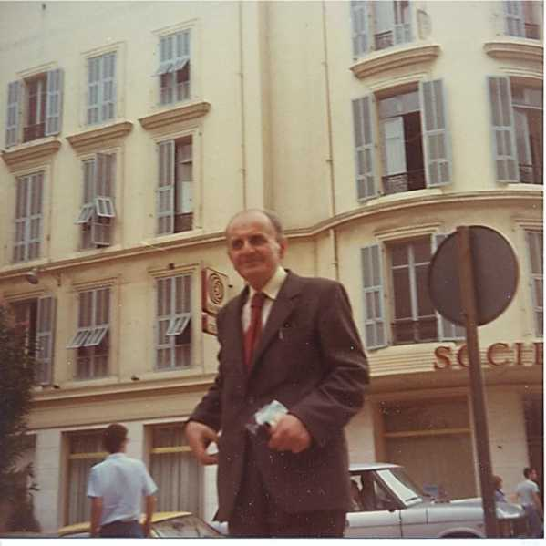

C ONTEMFORARY

Literature Press



<http://edltura.mttlc.ro> Bucureşti 2013

Constantin Noica (1909-1987)

25

C. George Sandulescu

Noica, Complete Works?..

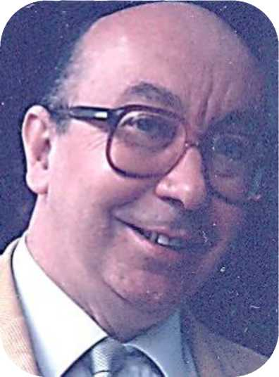

C ONTEMFORARY

Literature Press



<http://edltura.mttlc.ro> Bucureşti 2013

Constantin Noica (1909-1987)

26

Noica's self-censorship

After so many years of obligatory domicile at Câmpulung Muscel, and after the years in jail, Noica was acutely aware, as he told me himself, of the existence of the finest restrictions & permissions of such "Cap Limpede, or C.L." Censorship.

He was able to master it so well that he managed to beat it out of existence. Where? & How? In the book Pray for Brother Alexander, which is entirely made up of letters, the texts of which, sent to his own wife Wendy in England, managed to beat absolutely all his prison Censors. All, except one, who must have stopped one of the letters, as the Translator Wendy Noica points out in the Preface.

The point I am making here is that by the time he left prison, he was a consummate Censor himself, able to beat all the Agerpress ones! In his writings and in his Eminescu statements.

Everything he published after 1964 is minutely self-censored. Before it was officially censored. My Big Question at this stage is the following: Would Noica have written the same way, if he had not deliberately self-censored all his writings so carefully? And my answer is: Certainly not.

His wife Wendy testifies to it herself, when she writes in her brief biography of her husband that he did not publish anything after he was let out of prison. In a sense, she is right in saying that! Because she is in the know. His self-censorship had turned him into a philosopher that she was no longer able to recognise. A philosopher that was no longer himself as a free-thinker. They had both worked together, and translated together throughout the 1930's and a large part of the 1940's. And on the basis of that, she knew what she was talking about. And she knew full well the kind of philosopher that was in him. But he had learnt Censorship the hardest way, and was a past Master of it... I beg all Romanians to understand the complexity of this statement.

CGS

C ONTEMFORARY

Literature Press



<http://e> ditura.mttk.ro

Bucureşti 2013

Constantin Noica (1909-1987)

27

Where are the actual Noica Manuscripts?

There is more than flagrant TEXTUAL proof of what I advance! Here it is: It occurs in Constantin Noica's Jurnal filozofic, published in 1944:

6. Noi nu avem un termen românesc pentru „devenire". Avem câteva pentru fiinţă, dar nu avem pentru devenire. Am fi putut avea termenul de: petrecere (se petrece ceva, care e mai mult decât se întâmplă, are loc: are desfăşurare). Dar l-au expropriat chefliii. Singura noastră devenire este în chef, în

distracţie, — în înstrăinare.

/ '

1. We do not have a Romanian term for "becoming". We have a few for the term "being", but we do not have one for "becoming". We could have had the term "petrecere" (happening — something is happening, which is a little more than just occurring; for it has "development"). But it was taken up with other things... Our only development lies therefore in entertainment, in estrangement.

50. „Eu sunt cel ce sunt", spune Dumnezeu lui Moise (Exodul 3,14). Nu-i spune: „Eu sunt cel ce este." Chiar când îl îndeamnă să se ducă la ceilalţi, Dumnezeu îl învaţă pe Moise să le vorbească despre „cel ce se numeşte Eu sunt". Ce curios sună: „Eu sunt m-a trimis la voi"!

Căci Dumnezeu nu este. Numai noi ştim ce e aceea „este", fiinţa. În unele cazuri privilegiate, în filozofie, ştim pe „eşti", fiinţa

50. "I am what I am", says God to Moses (Exodus 3: 14). He does not say "I am He that IS". Even when He pushes him to go to the others, God instructs Moses to refer to him as "the One who calls Himself

1. AM". How curious it all sounds to say: "It is I AM who has sent me to speak to

you"!

Just because God IS NOT. It is only us who know what it really means to be IS. In other words, The Being. In certain privileged cases in philosophy, we know

C ONTEMFORARY

Literature Press



<http://edltura.mttlc.ro> Bucureşti 2013

Constantin Noica (1909-1987)

28

subiectivizată. În comunitate ştim pe „suntem" sau „sunteţi". Numai Dumnezeu ştie pe Eu sunt; ca să nu mai aibă nevoie de eşti, este, suntem...

only too well the "ARE", in other words: the subjectivised being. When we are within the community, we know full well the "ARE" all over the place... But only God fully knows the "I AM". So that He is never in need of any of the Other Items.

57. Nu există decât două filozofii mari: filozofia greacă şi filozofia idealismului german; filozofia fiinţei şi filozofia spiritului. Iar ce e interesant, e că amândouă s-au năşcut în marginea devenirii. Refuzând devenirea, filozofia greacă a găsit fiinţa. Integrând-o, cea germană a găsit spiritul. Poate că prima şi ultima problemă a filozofiei e: curgerea, pierderea, viaţa.

57. There are only TWO great philosophies in the world, and two only: the Greek philosophy, and the philosophy of German Idealism. The Philosophy of Being, and The Philosophy of the Spirit, in other words. But what is interesting in both of them is that they were — each separately — born on the fringes of the Concept of Becoming. The very first problem of philosophy as well as the very last problem of philosophy is the flowing, the passing away, Life itself.

Where is God and St. Augustine in the SECOND PART of this volume? They are not at all there.

They have been removed by the invisible hand of Censorship.

That is the Major Reason, in more senses than one, for which a Noica Bibliographie raisonnee will never be possible. Many of his works had been conceived, part on paper, part in the Mind only, over the years, as I will be giving circumstantial proof further down.

Unlike living beings, a text is endowed with several dates of birth: The date of writing, the date of publication, and finally, the date of our own reception.

C ONTEMFORARY

Literature Press



<http://edltura.mttlc.ro> Bucureşti 2013

Constantin Noica (1909-1987)

29

We do not possess the exact date of actual writing of many of his published texts. And we do not have any clear indications either about the degree of censorship adjustment the author himself performed on his nascent ideas over linie.

Nobody practically talks about the actual Noica Manuscripts. Where are they? In addition, there is a lot of Noica correspondence, largely addressed to his family and close friends, at the various periods of his life. No notables seem to be interested in all that at all, at all. This being just another symptom of the post-Communists tendency to deliberately marginalise a major Romanian thinker-writer.

The postCommunist Establishment tends to treat him like... just another writer

* bracketed together with dozens upon dozens of others "as good or even better...". He may be good enough for the making of some more money for one publishing house or another.

Both the principles and the details of the present English Anthology have at length been discussed and agreed upon with philosopher Constantin Noica in person, during the days he spent holidaying in the Principality of Monaco, at my house, in September 1985. He instructed members of his family to cooperate in this major undertaking that he himself welcomed most enthusiastically (cf His Holograph List of Writings).

The sole purpose of this Anthology is to put excerpts of his writings at the disposal of as wide a public as is humanly possible in the language of his own English wife. It so happens that now — almost a quarter of a Century after his death

* English is the sole language worth the notice in the world, largely thanks to the internet and the world impact of the Olympic Games.

CGS

C ONTEMFORARY

Literature Press



<http://edltura.mttlc.ro> Bucureşti 2013

Constantin Noica (1909-1987)

30



Vigneta 1.

În domeniul lui mic-mititel al lexicografiei — în fapt chiar opusul filozofiei — Leon Leviţchi a fost marele dascăl care Noica ar fi vrut atât de mult să fi reuşit să fie. Dar n-a ajuns decât un prăpădit de bibliotecar la Universitatea din Bucureşti. CGS

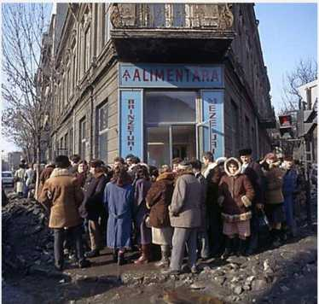

C ONTEMFORARY

Literature Press



<http://edltura.mttlc.ro> Bucureşti 2013

Constantin Noica (1909-1987)

31

**Jacqueline de Romilly,** membre de l'Academie frangaise

A last few words about Jacqueline de Romilly, membre de l'Academie frangaise, who died in 2010, 97 years old. I used to know her fairly well because she had given a few talks in Monaco over the years. Also, Madame de Romilly was present at the last Noica-Cioran-Eliade meeting in Paris in September 1985 (which I discussed in greater detail in Atitudinea Noica; and was also discussed by Alex Noica-Wilson on pages 55, 56 and 57 of her book of Amintiri, published by Humanitas in 2007).

As a homage for her thought and work, Jacqueline de Romilly had been made a Greek citizen in 1995 and given a Greek passport, for her services to the country. How incomparably greater and more gentle a gesture, particularly when related to Noica being given a posthumous seat in the Romanian Academy... (Is there really an empty seat with his name on it over there, as Nobel did the other day in Oslo for the Chinese prisoner who received the Peace Prize?) Or is it just empty words?

CGS

C ONTEMFORARY

Literature Press



<http://edltura.mttlc.ro> Bucureşti 2013

Constantin Noica (1909-1987)

32

Noica does not conceive-produce TEXTS: Noica conceive-produces PROCESSES.

Such Processes are utterly unlistable, largely unrecordable. The outcome? No proper bibliographies are ever bound to take them in in the proper way, and hand them out in

the proper way, too.

EminescuNoica:

Axiological Linguistics...

Here is what Noica writes in an unexpectedly linguistic context:

"Poate părea curios să revendicăm raţionalitate pentru o limbă creată de omul din popor, cel puţin în stadiul ei prim de dezvoltare; dar dacă un lingvist cum era americanul Lee Whorf putea spune că limba hopi a pieilor roşii era, sub multe raporturi, mai potrivită pentru teoria relativităţii decât germana ori engleza, nu ne vom sfii să credem că o limbă de obârşia nobilă şi dezvoltarea impresionantă a celei româneşti are a spune ceva raţiunii."

Sentimentul românesc al fiinţei, Bucureşti, Editura Eminescu, 1978, p. 51.

The Romanians, quite typically, do NOT understand their own language. I mean: They do not understand at all the STATUS of their language... in relation to other languages.

For the simple reason that that forms the subject of a special field of study in Theoretical Linguistics they know nothing about. And they never cared about — systematically.

Anecdotally — Yes. Perhaps they cared. We all hated the Russian language. Collectively. Just because it had been so brutally and forcibly imposed upon us. Many

* including myself, as a child, hated German for much the same reason: the language

C ONTEMFORARY

Literature Press



<http://edltura.mttlc.ro> Bucureşti 2013

Constantin Noica (1909-1987)

33

of the occupant... And somewhat before that, I remember there was another hate at school: My senior colleagues at the Lycee hated, in a quite different way, Latin and Greek. For the joint reason of outside imposition and apparent uselessness. And I also hated French and used to jump out of the window to escape my private teacher of French when she came for her regular lessons: just because I hated the teacher, poor woman, a Paris actress though she had been in her earlier married life... and a Bulandra.

We all have emotional global attitudes to languages. They are inescapable: "horrid German," as Oscar Wilde asks one of his girlie characters to say in The Importance of Being Earnest. Ultimately, each and every one of us has likes and dislikes about languages. For the widest variety of reasons. Explicable... only with great difficulty.

And the same kind of animosity is manifest against individual words. I love Italian for instance, but if there is one word I hate most of all it is cibo... And then ever since I was a teenager I used to say aloud—just for fun and ridicule — certain other Italian words like l'attaccapanni, or paracadutisti.

To say nothing of Swedish, where father is far. Grandfather? Farfar. Mother is mor. Grandmother is mormor. A most common way of address is hej! But the reply to that is as commonly hejhej! So, to summarize: How about a hypothetical sentence like

Hejhej, mormor och farfar!

Quite correct. But how ridiculous... An idiosyncratic valuation...

We are now in the domain of emotional language studies. And that special field of research is called Axiological Linguistics. No teachers dare to teach it. Few dare even to speak about it.

/W

/w

About axiology, philosophers are sure to know a lot. In France, it is even called deontologie...

My former Mihai Viteazu school chum Ludwig Grunberg, now deceased, used to know a lot about it as a Professor of Marxist Philosophy, so much so that he was even elected President of the World Association of Axiology as far back as the 1960's.

And he was working with, and under, Tudor Bugnariu, who was Dean of the Faculty of Philosophy of the University of Bucharest, in the high days of Ceauşescu. And they both once invited me to attend a special staff Seminar there. The topic, you

C ONTEMFORARY

Literature Press



<http://edltura.mttlc.ro> Bucureşti 2013

Constantin Noica (1909-1987)

34

may ask? It was about women, of all objects of study. Women philosophically dissected. I shouldn't say more, because if they were to know the exact topic, they are sure to skin me off. (For it was in the days before Feminism came about, and nobody had yet heard of "political correctness" on that particular side of the Iron Curtain.)

You are asking me why I mentioned Tudor Bugnariu? I am bound to talk about him not only because he was the boss of all the Professors of Marxist-Leninist Philosophy of the University of Bucharest in the days of glory of Old Nick, but he also happened to be the husband of Dorli Blaga.

And it was his family position and his professional status — both taken closely together and tightly knotted — that had saved the poet-philosopher Lucian Blaga from the Noica fate of doing a variable number of years in both prison and obligatory domicile. Or the other way round.

Well, what we are left with, after all the above axiology, is just another axiology.

That brand of axiology that is applied to LANGUAGES. The one that both Noica and Eminescu were hypnotised by and passioned for. So, let us start from there, and ask: What is Axiology?

s

Axiology is the study of value assignation. When you say "This wine is very pleasant," you are clearly making an axiological statement. And when you say "I hate waiting", you are making another. Women make far more axiological statements than men. And children of all ages make far more axiological statements — grounded, or groundless — than women do.

✓VW

*w\

When Noica speaks so very highly about întru, he makes a value judgment.

When Noica speaks about "Miracolul eminescian", he makes a most formidable value judgment.

The book Cuvânt împreună despre Rostirea Românească, the book Rostirea filosofică românească, the book Creaţie şi frumos în Rostirea Românească, and culminating with the essay Eminescu sau gânduri despre omul deplin al culturii româneşti, are all complex systems of value judgments, carefully constructing the field of Romanian Axiological Linguistics. It is not at all Linguistics: Alexandru Rosetti himself pooh-pooh'ed it all to me in no end of disparaging professional items of diagnosis. It is not Literary

C ONTEMFORARY

Literature Press



<http://edltura.mttlc.ro> Bucureşti 2013

Constantin Noica (1909-1987)

35

Criticism either. For all, or most, literary critics are either puzzled or baffled or both. It is Axiological Linguistics of the highest possible quality.

You feel you want simpler proof? Let's listen to Noica talking to the pupils of a Lycee quelconque in the city of Bucharest, one year before his untimely death. He refers in particular to Rostirea filosofică românească:

"O întrebare veche: ce şanse are filosofia care utilizează o limbă de circulaţie restrânsă să ajungă o filosofie universală? De circulaţie universală nu ştiu dacă poate fi vorba, dar de bună filosofare - da! De pildă, limba cu cea mai mare circulaţie azi este engleza. Dar în limba engleză, astăzi, nu e filosofie. Ce s-a dezvoltat la ei mai mult e lingvistica, filologia. Limba engleză nu are cuvinte, are numai sintagme, nu are adâncime. Pe când noi, sau, ştiu eu? vreo limbă slavă, cu siguranţă rusa, germana sunt limbi cu adâncime. Şi anume: sunt limbi în care cuvintele au biografie! Îmi pare rău că nu reuşesc să-l conving pe editor să retipărească Rostirea filosofică românească; vedeţi acolo vreo 30-40 de cuvinte româneşti care au o întreagă poveste a lor, cam de felul celor de care am pomenit mai înainte."

Putting Romanian on a par with Greek and German is no joke. It is a formidable value judgment, moreover when the discussion takes place in the specialised context of philosophy. The Philosophy of Linguistics, in particular.

s

When dealing with Rostirea Românească, Noica changes philosophical method radically. How many have noticed that, in as many words?

He clearly moves to a subjective, judgmental stance when dealing with the phenomenon of the Miracle. Which is just as elusive as Joyce's epiphany: it is not something that you can touch or count, even metaphorically speaking, at the most abstract level.

yVV*

Axiological Linguistics is a subjective science. Wholly. And whether we want it or not, we must swallow the oxymoron.

Most statements connected with Language are subjective to a variable degree, when we come to think of it. Take any area of language study for instance. As I already pointed out in my book entitled The Language of the Devil, the fundamental philosophical construct in advanced research on Language is Convention.

C ONTEMFORARY

Literature Press



<http://edltura.mttlc.ro> Bucureşti 2013

Constantin Noica (1909-1987)

36

One dialect is accepted and another is not, in much the same way in which one pronunciation of a single word is accepted, whereas another is not. That is why, Acceptability overrides Chomsky's Competence. Moving from the area of Pronunciation to the area of Grammar, just think of the rather "whimsical" uses of the Subjunctive in French or in Italian. Compare them with their Latin counterparts, just to realise how arbitrary Language choices can be over larger spans of Time and Space. That is why Chomsky is right, in his idiosyncratic way, to ban the study of syntax over longer spans of Time. And his construct of Linguistic Competence eliminates of course the taking in of the "Foreign" Language, no matter how closely related it might happen to be. Just think at this stage of the relation in one particular language compartment between Swedish, Danish, and Norwegian. The two brands of Norwegian, to be precise. And in the closely knit Europe, who could dare to leave out

o

"Finlands svenska", with its own quite specific Universities and Academies at Abo / Turku ?

Moving from Pronunciation and Grammar to the Lexis, or rather to Lexicology, to use its name favoured by most Russian linguists, things get even worse. None of us were born with a mobile telephone in our pockets. It is a new gadget. Very new. Now, in this very silly Europe of ours, one would logically imagine that the sometimes bothersome contraption would carry the same name in all, or most, European languages. But is it so? Not at all. Not at all. It is called mobile in English, cellphone in American, cellulare in Italy, and worst of all, portable in French, and handy in Germany... So, Noica's folklore is definitively gone, as he admits himself, overboard. What are we left with today? The language mess on the Internet, in order to replace... Noica's folklore.

The point I am making is that it is Subjectivism that carries the value judgments. And ultimately, Noica was more proud of putting across a philosophical Way of Thinking, rather than a handful of dogmatic philosophical conclusions. His whole professional behaviour was tantamount to stating that The Process is far more important than the Outcome in the shape of a statement, more particularly so when the statement he was trying to undermine by his very Attitude was simply "Heil Hitler & Stalin" all in one. And now, that Stalin is gone out of the Moscow Mausoleum, there is persistent talk — in the News today — that the century-old body of embalmed Lenin will go too... Another tangible dogma gone overboard.

That is why Noica was for the Process. Folklore was a process; it is gone. Eminescu was a miracle, hence a process. Thanks to the more than enigmatic mess surrounding the Princeps Edition of "Les Cahiers Eminescu", the touch of Miracle is

C ONTEMFORARY

Literature Press



<http://edltura.mttlc.ro> Bucureşti 2013

Constantin Noica (1909-1987)

37

gone too. So, Romania as a country — after Noica — happens to be left with very little. And when the Romanians themselves marginalise their language in Europe, what are they really going to be left with?

The answer is in your hands.

s

The major significance of Noica lies in the fact that he discovered, described, and philosophically discussed the EMOTIONAL valencies of individual words — get- beget româneşti — like Dor and ÎNTRU, and all the others.

Further, and perhaps more importantly, he pointed to the central fact that the MOTHER TONGUE should be scientifically looked at — and systematically as well

* from a purely emotional viewpoint. He has learnt that from Eminescu, as soon as he was let out of prison — in the years 1964 and 1965 and 1966. It was precisely in those years that he started publishing both about Eminescu and about Rostirea Românească.

And it is there that the MIRACLE lies. In other words, the Eminescu Linguistic Miracle is, after Noica, adducible to scholarly — hence philosophical — investigation.

That Stance (Atitudine, in Romanian!) was never possible before the EminescuNoica miraculous fusion: one genius of one kind PLUS one genius of another kind. Stanley discovering Livingstone, and Livingstone discovering Stanley all in one.

Noica says in the BackCover blurb of the book Introducere la Miracolul Eminescian (a quotation from page 14):

"În clipa de faţă Eminescu nu e decât cel mai mare poet al României. Avem temeiuri să credem că el poate fi transformat în PEDAGOG al ei dacă se pun la discpoziţia oricui, şi mai ales a tineretului, caietele cuprinse în cele 44 manuscrise de la Biblioteca Academiei Române."

Noica thus creates a NEW field of Research — that of Axiological Linguistics. It is — conceivably — applicable to other languages, particularly in point of METHOD. Which is PANCHRONIC (q.v.) in its very essence. To understand the philosophical category of "panchronic" in the theoretical study of Languages, you must necessarily pitch Ferdinand de SAUSSURE, (q.v.) against Edward SAPIR & Noah CHOMSKY, (qq.v.), an antagonism which would in itself take two or even three hundred pages of discussion.

C ONTEMFORARY

Literature Press



<http://edltura.mttlc.ro> Bucureşti 2013

Constantin Noica (1909-1987)

38

It was Saussure who put forth the options synchronic vs diachronic in his Cours de Linguistique Generale (passim).

It was Sapir & Chomsky who indignantly rejected the Diachronic, in the whole of American, and even World, Theoretical Linguistics, with rather disgraceful effects for staff and students alike.

In the past half century...

It is Noica, coming from outside Linguistics proper, who brings in a New Approach. The Past is gone, but let us take it with us "dead as a doornail" as it is, anyhow. That is what a PANCHRONIC ATTITUDE is about...

And as Ludwig Wittgenstein says in his very Epigraph to Tractatus Logico- Philosophicus —

...und alles, was man weifi, nicht blofi, rauschen und brausen gehort hat, lafit sich in drei Worten sagen.

...and whatever a man knows, whatever is not mere rumbling and roaring that he has heard, can be said in three words.

Panchronism, therefore, is the simultaneous fusion, for what it's worth, of Saussure binary opposition, Roman Jakobson was so very fond of too.

It is Noica that fuses it at a higher, philosophical-above-linguistics level.

✓WV

Axiological Linguistics can only operate panchronically.

Each and every other individual language should have a Noica in order to do for it what he himself has done for the Romanian Language: bringing it closer to the national heart, by subtly rejecting tout langage patriotard... and replacing that with a solid philosophical analysis.

The itemised languages of the Balkans should do the same — whatever is their daily variable number...

The countries of central Europe should do the same, particularly Switzerland and today-linguistically-ungovernable Belgium!

The European Union should take an example from Noica's Philosophy of Language and do the same, both individually, and in toto.

As to the United States, God protect them! Linguistically.

C ONTEMFORARY

Literature Press



<http://edltura.mttlc.ro> Bucureşti 2013

Constantin Noica (1909-1987)

39

They need a Noica-cum-Eminescu to TEACH them how to philosophise — properly and seriously about Language. Panchronically, like Noica. Not at all narrowly SYNCHRONICALLY and over-positivistically, as transitory Chomsky does.

Take Noica as an example of Linguistic Method. And forget that Romanian itself is a small language, with a more than ailing economy... to make things worse. And international neglect automatically magnified.

Last but not least, do not forget that LA FRANCOPHONIE has done immense damage to the Romanian Language. By forcing more than everybody to forget that "LATINA GINTĂ E REGINĂ."

That is a typical panchronic fact, not a chauvinistic opinion. Let all diplomats and politicians ponder deeply over it. (The Romanians are far too proud over Le Congres de la Francophonie they recently organised in Ceauşescu's Palace... without at all realising the damage that it has done.)

Forget the specific language: Noica still remains a world example in point of objective-cum-subjective research METHOD.

s

Languages are like a carpenter's tools. Wittgenstein had noticed that in his lectures about Aesthetics. But remember that a carpenter's tools are there, ALWAYS there, for specific jobs: some are good for certain operations — not at all for other operations. Noica says that clearly about languages in philosophy (cf his talk to the Bucharest pupils).

Certain Languages are no good to philosophise in. That is a Noica Statement. Take it or leave it. But remember that it is a value judgment made by a philosopher of repute.

For instance: Napoleon had said that England is "a nation of shop-keepers" ("une nation des boutiquiers...''). Noica says that — for complex 'intrinsically linguistic' reasons, English is not a language one can easily philosophise in. He even went as far as telling his wife Wendy that it is not worth coming to England any more, simply because England — in the French sense of Great Britain — is a country practically without philosophers. And on his last visit to the West — in September 1985 — he did not even bother to go there. He came to Monaco. Indeed he did. But never went to England. Because it is "a country without philosophers". The British and the Americans do go up in smoke whenever I try that statement on them, and the last I

C ONTEMFORARY

Literature Press



<http://edltura.mttlc.ro> Bucureşti 2013

Constantin Noica (1909-1987)

40

tried it on was no less than the most famous Cambridge University Professor of Literature. Who went up in smoke too...

But it happens to be so. England, by the side of ancient Greece and Germany, remains a country with just lightweight Philosophers.

Like France, with relatively lightweight Composers. And Italy, with a fairly insignificant Literature... at least according to Anthony Burgess.

Why are we so scared stiff, out of our wits, to stick our necks out — now in full Twenty-First Century — to make Statements like that? Noica never knew what Fright was... He was even trying to teach Immanuel Kant to Romanian secret-police ignoramuses. And they thought he was talking about the "Kent" cigarettes, and even wrote so in their police reports... He was more than sincere in his philosophising... And without that kind of courage, and that kind of bravado in the daring of it, Axiological Linguistics would never be possible. (And I doubt whether it is possible within the European Union. Or whether the 'Homeland' Department would allow it in the United States... without suspicion.)

/W

Noica has been the only one in Romania to think language philosophically.

1. for one have practically met all the major Western World linguists of the 20th Century, and had professional discussions with them, either in public, or in private. They are all positivists to the marrow of their bones, and the worst of them are the Swedes, and Scandinavians, who go for the Hardest Facts only. In the study of languages.

They are unable to think language philosophically. Belonging there too are the Romanians Alexandru Rosetti, Iorgu Iordan, and Alexandru Graur. I talked to all three of them together at the Vienna World Congress of Linguists in August 1977, when one little Romanian was elected President. They did not even wish to begin to understand — all three of them taken together — what Noica was trying to talk about. They failed even to conceive the possibility of the existence of such a thing as Axiological Linguistics.

(Solomon Marcus too cannot get out of his mathematics [his Linguistics has always been subsidiary...] in order to come anywhere near Noica's thinking.)

s

C ONTEMFORARY

Literature Press



<http://edltura.mttlc.ro> Bucureşti 2013

Constantin Noica (1909-1987)

41

Towards a Definition? Any value judgment, be it at individual or collective (group, or whole-nation) level, incorporated into a Language as a presupposition with regard to Language can, and should, form the object of study of Axiological Linguistics.

Post Scriptum. What did Noica do when he got out of prison? He started working. Working on what? On philosophy. But what philosophy, he thought, would beat the Censorship? The Philosophy of EMINESCU. For nobody would dare touch Eminescu! He went to Eminescu to find, and publish, Eminescu's translation of Immanuel Kant. La preuve? The footnote placed at the end of The Introduction to Mihai Eminescu, Lecturi Kantiene, page 49, says the following: "Fragmente din traducerea lui Eminescu au apărut în revista Ramuri (1968), editate de noi." Therefrom started Rostirea Românească. Therefrom started The Eminescu Miracle... How many days after they let him out of prison did he do that? And Rostirea filosofică românească was on the market soon afterwards, in 1970... And remains unbeatable.

CGS

C ONTEMFORARY

Literature Press



<http://edltura.mttlc.ro> Bucureşti 2013

Constantin Noica (1909-1987)

42

ROSTIREA ROMÂNEASCĂ de la Eminescu cetire:

Quand on croit en quelque chose, comment se retenir de toujours vouloir le repandre ?

[said about Noica by] Jacqueline de Romilly, de l'Academie franţaise.

The FrageStellung Decalogue, in hermeneutic manner:

1. How did NOICA hit upon & get started on Rostirea Românească?
2. What did NOICA see in Eminescu that struck him so hard?
3. Does that have for him the value of a Revelation?
4. Who in World Literature theorised upon the phenomenon?
5. Who was NOICA understood by?
6. Who refused to understand him, and why?
7. What happens NOW avec Les Cahiers Eminescu?
8. What can be done NOW avec Les Cahiers Eminescu?
9. Are we now in a Waiting-for-Godot Situation?
10. Is the InterNet a solution satisfactory to the Noica 20-year-old Eminescu Campaign?

P.S. You'll find ALL the answers within the above Ten Questions: Look for them!

CGS

C ONTEMFORARY

Literature Press



<http://edltura.mttlc.ro> Bucureşti 2013

Constantin Noica (1909-1987)

43

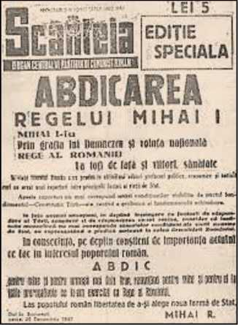

Vigneta 2.

Cine alive astăzi — metaforic vorbind — ar fi ajuns să fie prin capacităţile sale mare profesor universitar al României sau chiar membru al Academiei? Cine ar fi fost marii noştri profesori şi academicieni dacă nu ar fi existat jumătatea de veac de comunism în România? Cine oare? CGS

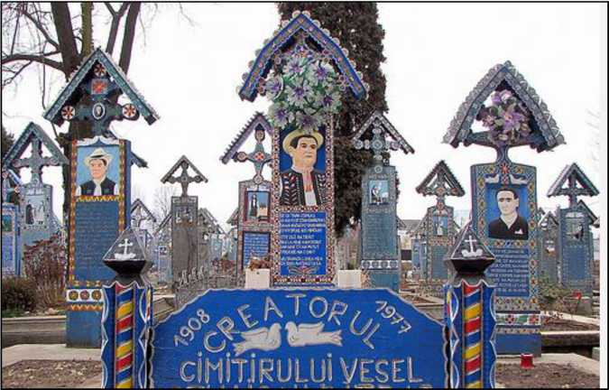

C ONTEMFORARY

Literature Press



<http://edltura.mttlc.ro> Bucureşti 2013

Constantin Noica (1909-1987)

44

Noica was a mass phenomenon: he had the force to pass to several generations of young people the virus of philosophising.

After his prison years, Noica embarked upon building a thinking method of his own, which relied on the Logos, the word, or what, in Romanian, would best be called with his favourite term, rostire. The source and proof of his thinking was Eminescu, with whom he entered in a life-long symbiosis. One thing is certain: Eminescu is more than a poet. He is a thinker whom Noica expands upon, explains, revalues and brings to life again in his work. Hence, the EminescuNoica hybrid.

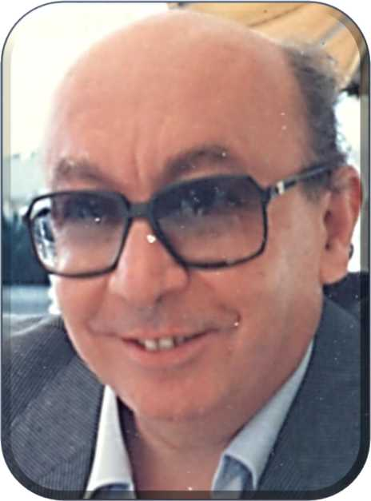

C ONTEMFORARY

Literature Press



<http://edltura.mttlc.ro> Bucureşti 2013

Constantin Noica (1909-1987)

45

II.

Noica's Eight Exiles.

C ONTEMFORARY

Literature Press



<http://edltura.mttlc.ro> Bucureşti 2013

Constantin Noica (1909-1987)

46

A Biography of Constantin Noica

written and published in England by his wife Katherine Muston in 1992, introducing the manuscript Pray for Brother Alexander—a book assembled from his correspondence by herself.

Constantin Noica was born on 24th of July 1909 on his father's landed property of Vitanesti, county Teleorman, Romania.

He went to two of the principal secondary schools in Bucharest. In 1927 he started writing articles for various Romanian magazines.

Between 1928 and 1931 he studied Letters and Philosophy at the Bucharest University. Between 1932-34 he was librarian to the Seminar of History of Philosophy. In 1932 he became a member of the literary society "Criterion" for which he lectured and he also contributed articles to the "Vremea" ("Time'') newspaper. In 1934 he was awarded a prize for his first book "Mathesis".

Then followed a year of studies in France (1938-39) and in 1940 he took his doctor's degree in Philosophy at the University of Bucharest. During 1940-41 he was given a job as a reader for Philosophy at the German-Romanian Institute in Berlin.

During the war he continued to publish books and articles on a variety of subjects as well as delivered a series of very popular radio broadcasts on various subjects ranging from religion and philosophy to contemporary problems of the society as a whole, all very original and challenging to the reader or listener.

In 1948 Constantin Noica and his English wife, Katherine Muston, the translator of this book, decided that in order to spare their two children a "life" under the communist regime imposed on Romania by the Soviets, the only solution was a divorce, which would have enabled his wife to return to England and take her children with her. It took years of hardship and intense frustrations before she managed to obtain an exit visa from Romania and she eventually arrived in England

in 1955.

C ONTEMFORARY

Literature Press



<http://e> ditura.mttk.ro

Bucureşti 2013

Constantin Noica (1909-1987)

47

Between 1948 and 1958 Constantin Noica was taken into custody by the dreaded Romanian "Securitatea" and sent into "compulsory residence" in the mountain village of Campulung. As during his "compulsory residence" Noica continued with his philosophical studies and many young intellectuals who shared his views used to visit him in his poor home in Campulung for discussions and debates, the communist authorities saw this as an open opposition to their regime and as a result in between December 1958 and 1964 Noica was imprisoned as a "political detainee".

His time in the communist political prisons is the subject of this book.

After his release from prison, as part of a UN campaign for the release of all political detainees in the Communist world, he became a pensioner in 1975, when he retired and spent the last 12 years of his life at Paltinis, a small village near Sibiu in Transylvania, where he became the spiritual mentor of [a] whole generation of young Romanian intellectuals. Before his death he visited his family in England twice, in 1972 and 1983 and although he could have easily applied for political asylum and stayed in the West, as many Romanian intellectuals of his generation did, Noica felt that his duty to his people was best served by living in Romania and not in exile.

He died on December 4th 1987 at Sibiu, but it was only after the fall of the communist regime in Romania that his philosophical ideas, his books and articles were published in Romania, causing a tremendous impact on the Romanian people, most of whom had sadly been unaware of the existence of such a brilliant and original mind amongst them, due to the communist censorship of men and ideas deemed to be "enemies of the people".

C ONTEMFORARY

Literature Press



<http://edltura.mttlc.ro> Bucureşti 2013

Constantin Noica (1909-1987)

48

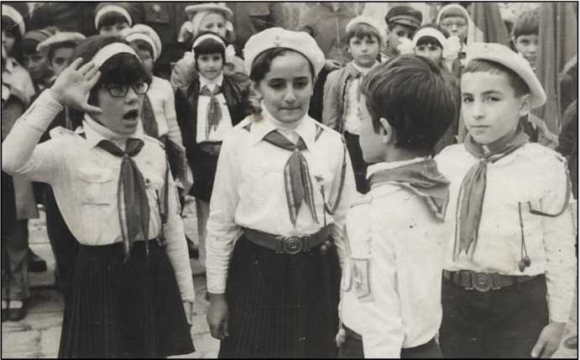

**Vigneta 3.**

Cum ar fi arătat România între 1944 şi 1990, fără comunism? Se întreabă oare cineva? Dacă nu, de ce nu?

Ne-ar ajuta mult să fim mai cinstiţi şi mai corecţi în gândirea noastră de toate zilele dacă am face aceasta!

Oamenii ar fi fost mai drepţi, mai sinceri, mai lipsiţi de hipocrizie.

Căci asta a caracterizat jumătatea de veac de comunism: minciuna, falsitatea, incorectitudinea, lipsa de "inimă deschisă".

Avem mare nevoie să reconstruim trecutul aşa cum a fost el!

Poate aşa s-ar fura mult mai puţin astăzi!

Cine mai bine decât Constantin Noica şi Leon Leviţchi ar fi fost cei doi oameni îndeajuns de curaţi la

suflet? Ei doi ar fi fost cei mai indicaţi să facă o

/

asemenea treabă — în vorbă şi în scris. Păcat că s-au dus aşa de repede. CGS

C ONTEMFORARY

Literature Press



<http://edltura.mttlc.ro> Bucureşti 2013

Constantin Noica (1909-1987)

49

Noica's Eight Exiles

1934-1938: Sinaia, the villa of Wendy Muston's parents.

1938-1939: Paris.

1940-1941: Berlin.

1944: was enrolled as translator in the war.

1945-1946: in the country-side, Chiriacu, near Alexandria and Casa Andronache, near Bucureşti.

**1948-1958: compulsory residence** in Câmpu Lung-Muscel.

**1958-1964: political prisoner** at Jilava.

1975-1987: after retirement, he moved to Păltiniş, which was a self-imposed exile "în afara Vechiului Regat."

Out of the 78 years of his life, Noica spent 35 years in various kinds of exile, among which 18 years as a political detainee, and 12 years as self-imposed exile far from the eye of "Big Brother".

Communism exiled Noica to places belonging to "Vechiul Regat". Twelve years before his death, Noica chose to exile himself outside it, to Păltiniş, a place in Transylvania.

C ONTEMFORARY

Literature Press



<http://edltura.mttlc.ro> Bucureşti 2013

Constantin Noica (1909-1987)

50

*/VCf* c *9*

**Holograph Monaco 1985**

v 5—^* > A- a /<? ff ‘

*.«/* t+JP €V

**r**

UL+.TUyi'? "l“*‘ • < \

^±1. 7 ' r>__ (S <'rV^OJ' )

**.** <7 **' ^ ■■ • xK, c^o.,**

c-î ‘ 7 ■”_ fc, ^ tX,

n 5 *Cj>n(r^*

**C,.vi>'vt** ,

**,,/V •**

**/93r,«-**

*frC.y^-O* ",

**y?i^.**

**- - : W«vs; , c*3- /9:5iZ' •**

_ \fi^u ,.-^/.v i ,

* ‘ «—:—: < . . — C W-m,i<^1 tv, c* •’

At C<c&. *~jh,cir<-&r<*

j7rtw c,<

ftt

/Tu.o f.fejA'^^

**Tl**

/•9V .

Ţr. c.Ufc- ■ ^V»-

**■f-o cv** )frn_

. **<'«?v'V**

^cV^VV-

~ <? suj^'/'n v-^V

- -

— „ty* — ^ V

**^^ ^ • ~7~w/**

**-—/, ymvccyt 72**—Hi **7 /*r3> ,1**

,-—7: ^-T^vfe 2. uz ~ ,.

_ . (WT^ŢJ^l' 0’"' *■“, . 1

- * X ^ ^ Ay-VO* a /l° O

_ . - <^vc7^ '; ^ r' ^

£^rVl> cVi

^JV't>c jr> CI

0 O-.'C^rO • / ?6 S-  
/<?^ ?

(Hr~>'t<'r^ C i^u w-\. .0 <• Pi:

2<.r^ t» c Tf't C FrrC'-'lj

*.* ***(«pcj***

***r' I <^-L- e^p'°***

7 *<~r<f-,'i’ Csu'frc*-<Uj* ^ 0*

<-• î~^(r-<. 6u-Cy^-c fâvT.

lp *-nr*> i«-<r f>?v»j2.v- r' 5- &f~*-J . 7^ • . ^ ?J2~

[crix^ C-^V,- ^vA»^y /M»L'V^c»

c, c*-C'

**'£w**

1 -

**Life and Work.**

**Holograph text written by C. Noica in Monaco in September 1985.**

C ONTEMFORARY

Literature Press



<http://edltura.mttlc.ro> Bucureşti 2013

Constantin Noica (1909-1987)

51

***Viată şi [ucrări***

N. 1909 România. Studiază filozofia, se interesează de matematică şi filologie clasică.

Studii în Franţa şi Germania, dr. în fit Bucureşti 1940. Trăieşte retras timp de 25 de ani. Din 1965 cercetătorprincipala Centrul de Logică din Bucureşti. Pu6lică [ucrări, cola6orează (a reviste.

***Lucrări (***în f. română)

***“Mathesis sau 6ucuriife simple”,*** 1934 (lucrare ce capătă premiul “ scriitorilor tineri”, alături de Eugen Ionescu şi Emil Cioran).

“Regulae ad directionem ingenii”, Descartes, traducere 1935, cu o introducere.

“Despre forma şi principiile lumii sensibile şi ale celei inteligibile”, Kant, traducere 1936, cu o introducere. ***“Concepte deschise în istoria filosofiei*** “ (PremiulAca.demiei Române) 1936.

“Meditationes de prima philosophia”, Descartes, trad. 1937.

***“Viata şi filosofia lui Descartes”,*** Bucureşti 1937.

***“De caelo. Încercare în jurul cunoaşterii şi individului”*** 1937.

***“Pentru o istorie a lui cum e cuputintă ceva nou”*** 1940.

“De magistro “ de Sf Augustin, tmducere în colab. 1942.

***“Două introduceri si o trecere spre idealism*** “. 1943.

***“Jurnal filosofic***”. 1944.

***“Pa.gini despre sufletul românesc “***1944

“Lysis sau despre înţelesulgrec al dragostei “ (1947 ap. 1969)

***“Introducere la o filozofie sistematică***” (1949, neapărut)

***“încercare de filozofie sistematică***” (1950, neapărut)

***“Despărţirea de Goethe***”(în 2 volume, 1954, neapărut)

***“Povestiri, din Hegel***’ (1957, apărut în rom. 1962 Paris)

“Comentarii la categorii “ traducere din 16 greacă 1968

“ Platon: Dialoguri “, după trad. lui C. Papacostea, cu două traduceri noi şi o introducere. 1968 ***“Douăzeci şi şapte trepte ale realului***” 1969 ***“Rostirea filozofică românească***”. 1969

“Introduction a la logique”, voi. I din ediţia TeofilCoridaleu, trad. în franceză. 1970 “Comentariile despre interpretare” tra.du.ceri. 1972 “Parva naturalia” de Aristotel. Trnd in colab. 1972

[câteva lucrări originale, gata redactate, n-au putut apărea în ultimii trei ani].

© C. George Sandulescu

C ONTEMFORARY

Literature Press



<http://edltura.mttlc.ro> Bucureşti 2013

Constantin Noica (1909-1987)

52

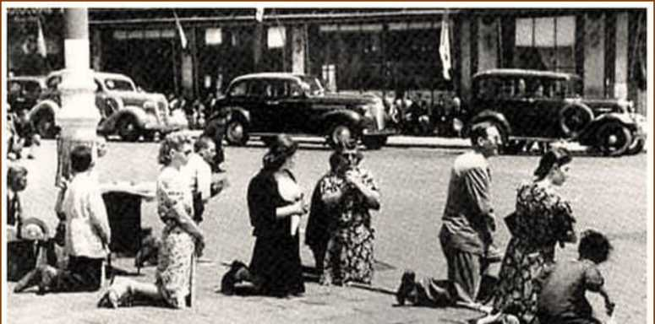

Bucureşti, 1340. **Zi de doliu naţional. României i s-a răpit Basarabia.**

**Vigneta 4.**

Cartea mea de căpătâi pe vremea când eram adolescent era The History of the World scrisă de H. G. Wells. De aşa ceva avem nevoie în zilele noastre pentru întreaga Europă a secolului XX.

O asemenea lucrare ar trebui să răspundă multor întrebări fundamentale. De pildă:

1. Cine era realmente Putin?
2. Ce principii în alegerea de cadre au fost adoptate în Irak la prăbuşirea lui Saddam Hussein?
3. Care au fost marile greşeli ale Statelor Unite în zilele lui George Bush Jr?
4. Cine era Tony Blair? Câtă dreptate avea Roman Polanski în filmul său?
5. Cine a creat Republica Moldova? Care este relaţia ei cu Transnistria?
6. Portretul real al lui Gorbaciov!

**CGS**

C ONTEMFORARY

Literature Press



<http://edltura.mttlc.ro> Bucureşti 2013

Constantin Noica (1909-1987)

53

**Jacqueline de Romilly**

Du chemin de la verite.

A *Member of the French Academy Speaks about the Life and Work of Constantin Noica.*

C ONTEMFORARY

Literature Press



<http://edltura.mttlc.ro> Bucureşti 2013

Constantin Noica (1909-1987)

54

J'ai rencontre Constantin Noica un certain nombre de fois dans les dernieres annees de sa vie. Au premier abord (je m'en souviens si bien!) on voyait apparaître un petit Monsieur en bottines, parlant un frangais elegant et montrant une rare courtoisie. On ne remarquait, du dehors, ni la force interieure de l'homme, ni son immense erudition. Mais, derriere le sourire bienveillant et derriere la douceur, l'on ne tardait pas â sentir en lui, comme une armature, un fond de fermete irreductible - celle d'un homme que rien, jamais, ne saurait faire devier du chemin de la verite.

Je savais, naturellement, qu'il etait au sens fort du terme, un philosophe. Il l'etait par son reuvre, mais dejâ par sa vie. Comment une helleniste n'aurait-elle pas ete sensible aux traits qui le rapprochent de Socrate? Socrate avait du boire la cigue: C. Noica avait passe dix ans de sa vie en residence surveillee et six ans en prison; il vivait dans le montagne, occupant une chambre etroite et glacee, se nourrissant mal, indifferent aux miseres materielles. Comme Socrate, il ne s'etait jamais lasse d'enseigner aux autres â penser: cet homme isole avait des disciples un peu partout, â qui il donnait des

I met Constantin Noica several times towards the end of his life. At first, I just saw him (and what a clear memory I have of him...) as a fine gentleman, wearing gaiters, speaking French with an elegant accent, behaving with such courtesy. But one could hardly suspect his inner force and superb erudition. And yet, behind his kind smile and his gentle manners, how could one fail to sense, armour-like, his rectitude, that absolute firmness of one whom nobody will ever swerve from the path of truth?

I was well aware that he was a philosopher in the strongest sense of the word. His work, but also his life, made him one. How could a Hellenist like myself fail to be touched by those features that brought him so close to Socrates? Socrates had been forced to drink hemlock: Constantin Noica had spent ten years of his life in forced residence, and six years in prison; he was living in a place in the mountains, a cold narrow room, he ate poorly, and was indifferent to physical misery. Just like Socrates, he had never given up teaching others how to think: an isolated man who had disciples almost everywhere. He planned their readings for them, he moulded their minds, he set their spirit free. Far from inculcating his doctrine, he taught them the very meaning of rigour.



Constantin Noica (1909-1987)

55

programmes de lecture, qu'il formait, dont il deliait l'esprit. Il ne leur inculquait pas sa doctrine, mais le sens meme de la rigueur. Ils pouvaient s'ecarter de lui sur telle ou telle question, parfois secouer un peu le joug (Alcibiade dit assez que l'emprise d'un maître appelle la reaction): il en faisait des philosophes - ce qui, dans un pays comme la Roumanie, etait un exploit. Meme en prison, d'ailleurs, que fait-il, sinon tenter d'eveiller l'esprit d'un gargon qui partageait sa cellule? Quand on croit en quelque chose, comment se retenir de toujours vouloir le repandre?

Expliquer en quoi il croyait est une entreprise un peu trop ambitieuse pour quelqu'un qui n'est pas philosophe.

On peut dire du moins qu'il croyait en la culture - la culture de l'Europe. Sa pensee avait ete nourrie d'auteurs qu'il avait traduits et commentes - des auteurs grecs, d'abord: Platon et Aristote, mais aussi les presocratiques, ou certains traites attestant la fagon dont la pensee d'Aristote fut regue â diverses epoques, allant jusqu'au XVIIe siecle. Mais il y avait aussi saint Augustin, Descartes, Kant, Hegel: sur tous il a medite et ecrit.

Disons le tout de suite: il a aussi medite et ecrit sur le sens de cette culture europeenne. Isole dans son

They often diverged from him in this or that matter, they sometimes struggled free (Alcibiades makes it quite clear that any master's teachings will bring about the student's response): he turned them into philosophers - and, in a country like Romania, that was quite an achievement. Even in prison of all places, he attempted to make the young man he had shared a cell with see the light. When one believes in something, how could one not be obsessed by the need to share that belief with others?

It may be hardy of someone who is not a philosopher to start explaining what Noica believed in.

I can say, at least, that he believed in culture - the culture of Europe. His mind fed on authors he had translated and commented upon - the Greeks, to begin with: Plato, Aristotle, as well as the Pre-Socratic philosophers, and a number of treatises regarding the reception of Aristotle's philosophy at various times, until as late as the 17th century. And then there were Saint Augustine, Descartes, Kant and Hegel: he meditated and wrote about them all.

We must not forget, though: he also meditated and wrote about the meaning of European culture. Isolated in his own country, cut off from the world, he never forsook that tradition, and he explained the reasons of his faithfulness to it with remarkable lucidity. I am all the more touched by those reasons, since



Constantin Noica (1909-1987)

56

pays, coupe de tout, il est reste toujours fidele â cette

tradition et il a exprime lucidement les raisons de sa fidelite. Or ces raisons me touchent d'autant plus que ce sont exactement celles qui m'ont attachee, quant â moi, â cette Grece antique ou s'elaborerent les debuts de cette culture europeenne, ouverte et eprise d'universalite. C. Noica l'a dit: l'Europe est le lieu ou le logos est chez lui, et la culture europeenne est le resultat d'une serie de retablissements par lesquels tout element etranger est accueilli, assimile et remanie; elle est en perpetuel renouvellement.

C'est dans cette lignee-lâ qu'il a, au cours de toute une vie, construit son systeme propre. Logicien avant tout, il aspirait â l'universel; et il se refusait â toutes les tentations du pathos. De plus, penetre comme il l'etait de la longue tradition des philosophies de l'Etre, il a su combiner cette idee avec celle du devenir en fondant la notion d'un « Devenir vers l'Etre », qui est centrale dans toute sa pensee. On trouve le reflet de ces aspirations essentielles dans le livre qui est ici offert pour la premiere fois aux lecteurs frangais. Il s'y est propose de decrire, dans un effort global de classement (o souvenir d'Aristote !...), les diverses deviations de l'esprit, pris entre la general et l'individuel. Ces « maladies », souvent creatrices de grandes revres, forment

C ONTEMFORARY

Literature Press



<http://edltura.mttlc.ro>

they are the very reasons that brought me, too, close to ancient Greece, where the foundations of this European culture were laid, where its broad horizon and spirit of universality were born. As Constantin Noica himself said: "Europe is that space where the logos is at home, and European culture is the result of a number of revaluations, by means of which all foreign elements have been welcomed, assimilated and reshaped; its renewal never ceases."

It is along these lines that he made full use of his whole life to build his own system. A logician above all, he aspired to universality; he stayed away from the temptations of the pathos. And, what is more, he managed to combine his perception of a long tradition of philosophies of the Being with the idea of Becoming, and he authored the Concept of "Becoming into Being", which is the core of his thought. This book [Six maladies de l'esprit contemporain] translated into French mirrors these fundamental aspirations. In it, Noica aimed at describing, in a global effort to classify (not unlike Aristotle...), the various deviations of the spirit which is caught between the general and the individual. Quite often generating great works, these "maladies" build a kind of philosophical anthropology; they also reach beyond this line of thought, and embrace the Being: between too much

;i 2013

Constantin Noica (1909-1987)

57

une sorte d'anthropologie

philosophique; mais, par-delâ cette description, elles constituent comme des oscillations autour de l'Etre: entre le trop et le trop peu, elles le cernent et visent â l'atteindre.

J'ai parle ici de foi en la culture europeenne; et j'aime â retrouver chez C. Noica cette conviction eminemment stimulante. Mais il faut encore ajouter qu'il l'a maintenue dans la Roumanie d'alors, contre vents et marees. Il est reste roumain. C'est en roumain qu'il a traduit les textes que j'ai dits. Il a aime la langue roumaine et s'est parfois fonde sur certaines de ses particularites pour orienter sa meditation (ainsi le întru du « Devenir- Vers-l'Etre ») : il a aime la tradition des villages roumains. Lâ aussi le gout du general, qui etait l'Europe, a du etre concilie avec l'appartenance â une tradition particuliere. C'est un juste retour que les reuvres de cet Europeen de Roumanie soient maintenant traduites dans les divers pays d'Europe et y soient chaque jour un peu mieux connues.

Pour moi, qui tente ici de rendre justice, en quelques mots, â une vie et â une reuvre, toutes deux vouees a une si haute exigence, je sens, en ecrivant, le remords me gagner. Derriere la silhouette du Monsieur souriant que j'ai vu un jour apparaître, il y a quelques annees, tout simple et

and too little, they scrutinize it, and have high hopes of mapping it as a whole.

I have mentioned here a belief in European culture; I am pleased to find this highly stimulating conviction existing there in Noica's work. But I must make a point of stressing the fact that he maintained it against all odds, as he was living in the Romania of his time. A Romanian he was: a Romanian he remained! It is in Romanian that he translated all the texts I have been talking about. He was in love with the Romanian language, and he at times relied on some of its peculiarities in order to structure his meditation (for example, întru - used as "Becoming-within-Being"): he was in love with the traditions of the Romanian villages. He certainly had to reconcile his inclination for the general, which meant Europe in this case, with his belonging to one particular tradition. It is a well- deserved tribute paid to him that the works of this European thinker, coming from Romania, should now be translated in the various European countries, and should reach an ever wider public.

As far as I am concerned, while trying to capture in a few words here a life and a work that both stood under the sign of high philosophical requirements, I am overwhelmed by remorse while writing about him. When, one day, several years back, I was introduced to this unpretentious gentleman and his courteous smile, did I really perceive the



Constantin Noica (1909-1987)

58

courtois, ai-je assez su reconnaître la noblesse de cette vie et de cette pensee ? N'aurais-je pas du mieux le questionner et mieux l'ecouter ? On ne croise pas tous les jours des gens d'une telle puissance intellectuelle et morale. Et l'on regrette apres coup de n'avoir pas mieux saisi sa chance.

Du moins reste-t-il l'reuvre ; car ce Socrate-lâ n'a pas eu besoin d'un Platon pour dire ce qu'il pensait : on peut tardivement l'aborder, avec humilite et gratitude.

true nobility of his life and thought? I wish I had asked more questions, and paid far more attention to his answers. It is not often that one comes across such strong minds and such moral integrity. And one is always left with the regret that one did not make better use of the opportunity at the time.

We have his work, at least: in order to say what he thought, this particular Socrates had no need of a Plato: late in the day it may be, but we must approach him in all humility and gratitude.

Jacqueline de Romilly de l'Academie frangaise

Translated into English by Lidia Vianu

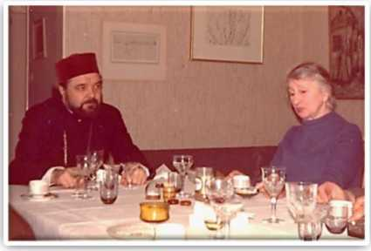

Bishop Antonie with Elena Sandulescu, C. George Sandulescu’s mother.

C ONTEMFORARY

Literature Press



<http://edltura.mttlc.ro> Bucureşti 2013

Constantin Noica (1909-1987)

59

The Observer Weekend Review, Sunday, May 18, 1961.

THE OBSERVER WEEKEND REVIEW

IthMkill, Viul.1!', .y.lf îî. I'liţ.l II

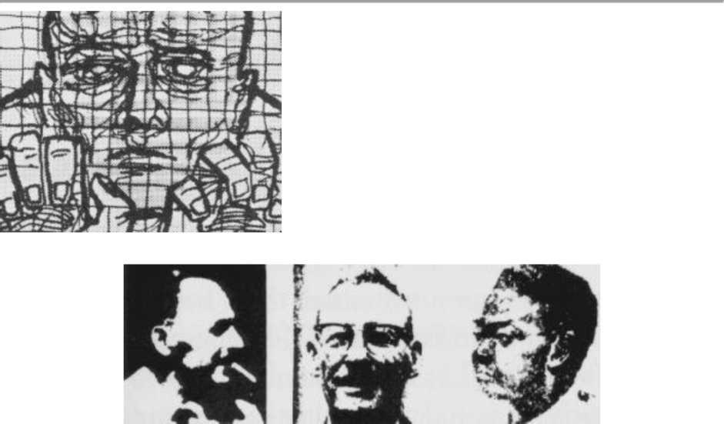

SIX POLITICAL PRISONERS: left, Constatin Noica, the philosopher, now in a Rumanian gaol [...]

*ON BOTH SIDES of the Iron Curtain, thousands of men and women are being held in gaol without trial because their political or religious views differ from those of their Governments. Peter Benenson, a London lawyer, conceived the idea of a world campaign, APPEAL FOR AMNESTY, 1961, to urge Governments to release these people or at least give them a fair trial. The campaign opens to-day, and "The Observer" is glad to offer it a platform.*

C ONTEMFORARY

Literature Press



<http://edltura.mttlc.ro> Bucureşti 2013

Constantin Noica (1909-1987)

60

**The Forgotten Prisoners**

OPEN your newspaper any day of the week and you will find a report from somewhere in the world of someone being imprisoned, tortured or executed because his opinions or religion are unacceptable to his government. There are several million such people in prison - by no means all of them behind the Iron and Bamboo Curtains

* and their numbers are growing. The newspaper reader feels a sickening sense of impotence. Yet if these feelings of disgust all over the world could be united into common action, something effective could be done.

In 1945 the founder members of the United Nations approved the [Universal Declaration of Human Rights:](http://www.hrweb.org/legal/udhr.html) -

[... ]

From Rumania, we shall print the story of Constantin Noica, the philosopher, who was sentenced to twenty-five years' imprisonment because, while "rusticated," his friends and pupils continued to visit him, to listen to his talk on philosophy and literature.

C ONTEMFORARY

Literature Press



<http://edltura.mttlc.ro> Bucureşti 2013

Constantin Noica (1909-1987)

61

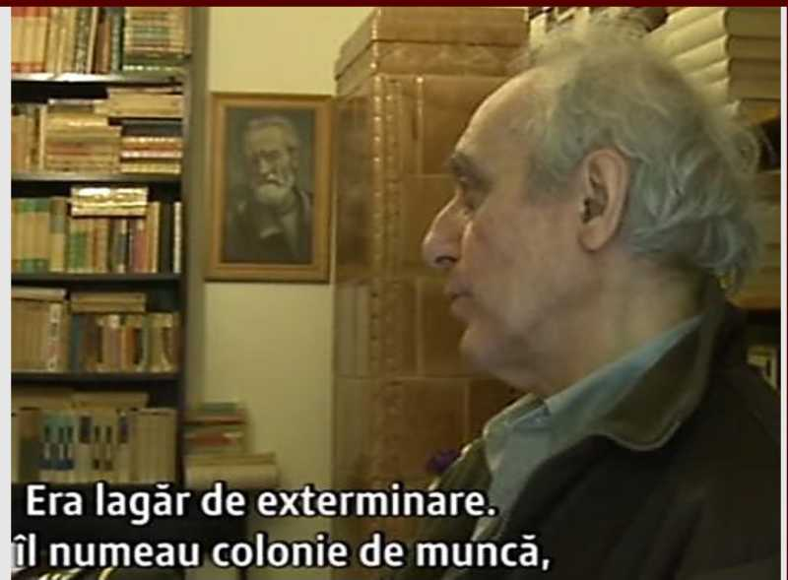

**Vigneta 5.**

Tăcere covârşitoare în jurul numelui lui Dragoş Protopopescu: de ce? Nimeni nu-i pomenea numele în anii

studentiei mele. De ce? Leon Levitchi — niciodată! Dan

/ /

Dutescu — niciodată! Ana Cartianu — niciodată! De ce? Este

/

o întrebare deosebit de importantă pentru istoria culturii româneşti în ansamblu.

*

Tăcerea eete primul lucru care trebuie să dispară în

orice discuţie a evenimentelor secolului XX.

/

**CGS**

C ONTEMFORARY

Literature Press



<http://edltura.mttlc.ro> Bucureşti 2013

Constantin Noica (1909-1987)

62

**III.**

Testamentul literar al lui Noica. Noica's Literary Testament

*Îl invidiez pe Noica pentru textul acestui testament. Îmi pare deosebit de rău că mi-a luat-o îniante!*

C. George Sandulescu

C ONTEMFORARY

Literature Press



<http://edltura.mttlc.ro> Bucureşti 2013

Constantin Noica (1909-1987)

63

Notă testamentară,

în Stelian Tănase: Anatomia Mistificării. 1944-1989. Humanitas. Ediţia 1.1997

/

Lui Andrei Pleşu, cu rugămintea de a publica această notă, în ceasul despărţirii mele:

Dacă se va interesa cineva de activitatea mea cărturărească, îl rog să nu ţină seama de următoarele:

1. De bibliografia mea, ce nu are conţinut, în bună parte, din voinţă proprie.
2. De traducerile mele literare şi pro-literare, exclusiv sub solicitări exterioare. Am tradus pentru bani nişte romane poliţiste.
3. De două din traducerile mele filozofice şi anume cea din presocratici, vol. I, partea finală, ajunsă la tipar în condiţii regretabile, precum şi întinsa traducere din Alexandru din Afrodisia, aflată în Arhivele Academiei.

Mi-am trăit viaţa fără rost. Este bine să sfîrşim.

**(Arhiva SRI, Fond D, Cartea albă a securităţii, Editura Presa românească, 1996, pp. 377-378)**

Anexa , KI .

Notă testamentară a lui Constantin Noica

Lui Andrei Pleşu, cu rugămintea de a publica această no­tă, în ceasul despărţirii mele:

Dacă se va interesa cineva de activitatea mea cărturăreas­că. îl rog să nu ţină seama de următoarele: ^

1. De biografia mea, ce nu are conţinut, in bună parte, din

V°12tDert°raducerile mele literare şi pro-literare, exclusiv sub solicitări exterioare. Am tradus pentru bani nişte romane po-

' 3 ţ)e două din traducerile mele filozofice şi anume cea din presocratici, voi. I, partea finală, ajunsă la tipar tn condiţii regretabile, precum şi întinsa traducere din Alexandru din Afrodisia, aflată în Arhivele Academiei.

Mi-am trăit viaţa fără rost. Este bine să sfirşirru

(Arhiva SRI, Fond D, Cartea alba a securităţii, Editura Presa românească, 1996, pp. 377-378)

C ONTEMFORARY

Literature Press



<http://edltura.mttlc.ro> Bucureşti 2013

Constantin Noica (1909-1987)

64

Acest text autentic circulă frecvent în publicaţii în diverse versiuni, probabil falsificate.

Cele şapte versiuni ale Testamentului literar Constantin Noica

1. 2012 [Notă testamentară, în EVZ.ro Portal de Ştiri. 27 februarie 2012.]

„Securitatea avea informatori şi în cimitire!"

1. [Notă testamentară, în fondul documentar al Arhivei CNSAS, fila 309.] Cuvântul lui Antonie Plămădeală la funeraliile lui Constantin Noica.

6 decembrie 1987.

3.1997 [Notă testamentară, în Stelian Tănase: Anatomia Mistificării. 1944-1989.

Humanitas. Ediţia 1.1997]

4.1996 [Notă testamentară, în Cartea Albă a Securităţii. Istorii literare şi

artistice. 1969-1989. Editura Presa Românească. 1996. pp 377-378]

1. [Notă testamentară, în Viaţa Românească 3/1988, pp 10-12]
2. 2009 [Notă testamentară, în Stelian Tănase, Anatomia mistificării 1944-1989,

ediţia III, Humanitas 2009, pp 504-505]

1. 2012 [Notă testamentară, în Revista Conta 12/2012. Neamţ, pp 41-48.] Eseu

de Dan Iacob.



Constantin Noica (1909-1987)

65

1. Notă testamentară, în EVZ.ro Portal de Ştiri. Luni TI Februarie 2012.

*„Mi-am trăit viaţa fără rost. în idee. Este bine să sfîrşim".*

Constantin Noica

1. Notă testamentară, în fondul documentar al Arhivei CNSAS, fila 309.

Lui Andrei Pleşu, cu rugămintea de a publica această notă în ceasul despărţirii

mele:

Dacă se va interesa cineva de activitatea mea cărturărească, îl rog să nu ţină seama de următoarele:

1. De biografia mea, ce nu are conţinut în bună parte din voinţă proprie.
2. De traducerile mele literare şi pro-literare, exclusiv din solicitări exterioare. Am tradus pentru nişte bani, nişte romane poliţiste.
3. De două din traducerile mele filozofice şi anume cea din presocratici, vol. 1, partea finală, ajunsă la tipar în condiţii regretabile, precum şi de întinsa traducere din Alexandru din Afrodisia, aflată în arhivele Academiei.

Mi-am trăit fără rost viaţa. în idee. Este bine să sfîrşim.

**[(http://www.scritube.com/stiinta/stiinte-politice/Cuvantul-lui-Antonie-Plamadeal20152614.php](http://www.scritube.com/stiinta/stiinte-politice/Cuvantul-lui-Antonie-Plamadeal20152614.php) )**

1. Notă testamentară, în Stelian Tănase: Anatomia Mistificării. 1944-1989. Humanitas. Ediţia 1.1997

Lui Andrei Pleşu, cu rugămintea de a publica această notă, în ceasul despărţirii

mele:

Dacă se va interesa cineva de activitatea mea cărturărească, îl rog să nu ţină seama de următoarele:

1. De bibliografia mea, ce nu are conţinut, în bună parte, din voinţă proprie.
2. De traducerile mele literare şi pro-literare, exclusiv sub solicitări exterioare. Am tradus pentru bani nişte romane poliţiste.
3. De două din traducerile mele filozofice şi anume cea din presocratici, vol. I, partea finală, ajunsă la tipar în condiţii regretabile, precum şi întinsa traducere din Alexandru din Afrodisia, aflată în Arhivele Academiei.

Mi-am trăit fără rost viaţa. în idee. Este bine să sfîrşim.

C ONTEMFORARY

Literature Press



<http://edltura.mttlc.ro> Bucureşti 2013

Constantin Noica (1909-1987)

66

1. Notă testamentară, în Cartea Albă a Securităţii. Istorii literare şi artistice. 1969­1989. Editura Presa Românească. 1996. pp 377-378

Lui Andrei Pleşu, cu rugămintea de a publica această notă, în ceasul despărţirii

mele:

Dacă se va interesa cineva de activitatea mea cărturărească, îl rog să nu ţină seama de următoarele:

1. De biografia mea, ce nu are conţinut, în bună parte, din voinţă proprie.
2. De traducerile mele literare şi pro-literare, exclusiv sub solicitări exterioare. Am tradus pentru bani nişte romane poliţiste.
3. De două din traducerile mele filozofice şi anume cea din presocratici, vol. I, partea finală, ajunsă la tipar în condiţii regretabile, precum şi întinsa traducere din Alexandru din Afrodisia, aflată în Arhivele Academiei.

Mi-am trăit viaţa fără rost. în idee. Este bine să sfârşim.

**A.S.R.I., Fond „D", dosar nr. 10 962, vol. 7, f. 282- 285**

1. Notă testamentară, în Viaţa Românească 3/1988, pp 10-12

CONSTANTIN NOICA

**În 1980 Constantin Noica a conceput o** Notă testamentară **pe care, copiind-o în trei exemplare, a lăsat-o lui Sorin Vieru, Andrei Pleşu şi Gabriel Liiceanu „cu rugămintea de a publica undeva rîndurile acestea, după săvîrşirea mea din viaţă". Am socotit potrivit să-i împlinim dorinţa încredinţînd** Nota

**revistei „Viaţa Românească".**

/

**Examinarea manuscriselor rămase după moartea lui Constantin Noica a arătat că sînt puţine textele care nu fuseseră încredinţate tiparului de către autorul însuşi. Cu excepţia cîtorva mii de pagini alcătuite din note de lectură şi care, publicate poate cîndva în ediţia operelor complete, vor face cunoscut laboratorul acestei opere de excepţie, partea inedită a manuscriselor lui Constantin Noica cuprinde un** Jurnal de idei **(redactat cu intermitenţe între 1964 şi 1985), ce va apărea în cursul anului acesta la editura „Cartea Românească", şi pagini răzleţe din care „Viaţa Românească" urmează să publice începînd cu acest număr.**

**Textul cu care se deschide seria de inedite, transcris după o ciornă a autorului, a fost scris în vara anului 1984 la Păltiniş. El vorbeşte despre viaţa filozofului ca alergare, hrănită din iubire, înspre o**

**ţintă nevăzută.**

/

**G. L.**

C ONTEMFORARY

Literature Press



<http://edltura.mttlc.ro> Bucureşti 2013

Constantin Noica (1909-1987)

67

Notă testamentară

Dacă se va interesa cineva de activitatea mea cărturească, îl rog să nu ţină seamă de următoarele:

1. de biografia mea, ce n-are conţinut, în bună parte din voinţă proprie;
2. de traducerile mele literare sau pseudo-literare, întreprinse exclusiv din motive exterioare
3. de două din traducerile mele filozofice, anume de cea din Presocratici (partea finală), ajunsă la tipar în condiţii cu totul regretabile, precum şi de traducerea din Alexandru din Afrodisia, aflată în manuscris la Academia de Ştiinţe Sociale şi Politice.

Mi-am trăit viaţa în idee, fără Vest, spre deosebire de alţii care şi-o sfîrşesc cu un rest şi care astfel merită să fie regretaţi. Sînt în ceea ce am publicat. Dacă lucrările mele nu sfîrşesc odată cu mine, voi sfîrşi a doua oară odată cu ele. Este bine să sfîrşim. Păltiniş 198..

CONSTANTIN NOICA

In 1**80 Constantin Noica a conceput o Notă testamentară pe caro. copilnd-o In trei exemplare, n lasat-o Iul Sorin Vleru, Andrei Pl.'şu »l Gabrlel I.lliceanu cu rugămintea de a publica undeva rlndurile acestea, dupfl sflvlrslrea mea din viată*. Am socotit potrivit să-l împlinim dorinţa Incredinţlnd Aota revistei „Viata Ho- maneasca.

Examinarea manuscriselor rămase dup/l moartea Iul Constantin Noica a arătat cA sînt puţine textele care nu fuseseră Incredlntate tiparului de către anto­nii însuşi. Cu excepţia cltorva mll de pagini alcătuite din note de lecturii şi «are. publicate poate clndva In ediţia operelor complete, vor face cunoscut laboratorul acestei opere de excepţie, partea Inediţi n manus.rls.-lor lui Constantin Noica cu­prinde un Jurnal dc Ulei (mlnctat cil Intermitente Intre 1M4 şl l'iflS). ce va andrea In cursul anului aresta la editura „Cartea ItomAneasia*, ş| pagini rfl?lete din cur* „Vlatajîomftnească* urmează să publi.e In.vptnd cu acest numflr.

.extul cu care se deschide s. ria de Ineflite. transcris după o clornl a au­torului. a fost scris In vara anului 1M84 la PMtinls. R| vorbeşte despre viata Mo- xofului ca alergare, hrănită din iubire. Insnre o tinta nev/Wmrt

NOTA TESTAMENTARA

G. L.

Dacă so va interesa cineva de activitatea mea cărturărească, II rog să nu ţină seamă de următoarele :

1. de biografia mea, ce n-are conţinut, In bună parte din voinţă proprie ;
2. do traducerile mele literare sau pseudo-literare, întreprinse ex­clusiv din motive exterioare;
3. de două din traducerile mele filozofice, anume de cea din Pre­socratici (partea finală), ajunsă la tipar In condiţii cu totul regretabile, precum şi de traducerea din Alexandru din Afrodisia, aflată in manuscris la Academia de Ştiinţe Sociale şl Politice.

Mi-am trăit viaţa In Idee, fără rest, spre deosebire de alţii care şl-o sfirşesc cu un rest şi care astfel merită să fie regretati. Slnt In ceea ce am publicat. Dacă lucrările mele nu sfîrşesc odată cu mine, voi sfîrşi a doua oară odată cu ele. Este bine să sfîrşim.

Păltiniş 198...

1. Notă testamentară, în Stelian Tănase, Anatomia mistificării 1944-1989, ediţia III, Humanitas 2009, pp 504-505

Dacă se va interesa cineva de activitatea mea cărturărească, îl rog să nu ţină seama de următoarele:

1. de biografia mea, ce nu are conţinut, în bună parte, din voinţă proprie;

C ONTEMFORARY

Literature Press



<http://edltura.mttlc.ro> Bucureşti 2013

Constantin Noica (1909-1987)

68

1. de traducerile mele literare sau pseudoliterare, exclusiv din motive exterioare;
2. de două din traducerile mele filozofice, anume cea din presocratici, (partea finală), ajunsă la tipar în condiţii cu totul regretabile, precum şi de traducerea din Alexandru din Afrodisia, aflată în manuscris la Academia de Ştiinţe Sociale şi Politice.

Mi-am trăit viaţa în idee, fără rest, spre deosebire de alţii care şi-o sfîrşesc cu un rest şi care astfel merită să fie regretaţi. Sînt în ceea ce am publicat. Dacă lucrările mele nu sfîrşesc odată cu mine, voi sfîrşi a doua oară odată cu ele. Este bine să sfîrşim. Păltiniş 198..

*(Viaţa Românească,* martie, 1988)

1. Notă testamentară, în Revista Conta 12/2012. Neamţ, pp 41-48. Eseu de Dan Iacob.

„Notă testamentară

*Dacă se va interesa cineva de activitatea mea cărturărească, îl rog să nu ţină seama de următoarele:*

1. *de biografia mea, ce n-are conţinut, în bună parte, din voinţă proprie;*
2. *de traducerile mele literare sau pseudo-literare, întreprinse exclusive din motive exterioare;*
3. *de două din traducerile mele filosofice, anume cea din Presocratici, (partea finală), ajunsă la tipar în condiţii cu totul regretabile, precum şi de traducerea din Alexandru din Afrodisia, aflată în manuscris la Academia de Ştiinţe Sociale şi Politice.*

Mi-am trăit viaţa în idee, fără rest, spre deosebire de alţii care şi-o sfîrşesc cu un rest şi care astfel merită să fie regretaţi. Sînt în ceea ce am publicat. Dacă lucrările mele nu sfîrşesc odată cu mine, voi sfîrşi a doua oară odată cu ele. Este bine să sfîrşim. Păltiniş 198..

*Păltiniş 198..."*

C ONTEMFORARY

Literature Press



<http://edltura.mttlc.ro> Bucureşti 2013

Constantin Noica (1909-1987)

69

**Vigneta 6.**

Cine era Romulus Zăroni?

Cine era Cincinat Pavelescu?

Cine era Parhon?

Care era funcţia politică a lui Iorgu Iordan alături de cea academică?

Cine era Ştefan Milcu?

Ce capitală a României a propus Ceauşescu?

Ce complot a organizat Ana Pauker şi împreună cu cine? A scris Mircea Eliade ceva despre asta?

Cine era Gheorghe Mihoc?

Cine era Jean Livescu?

Cine era Lothar Rădăceanu?

Cine era Lucreţiu Pătrăşcanu?

**CGS**

—

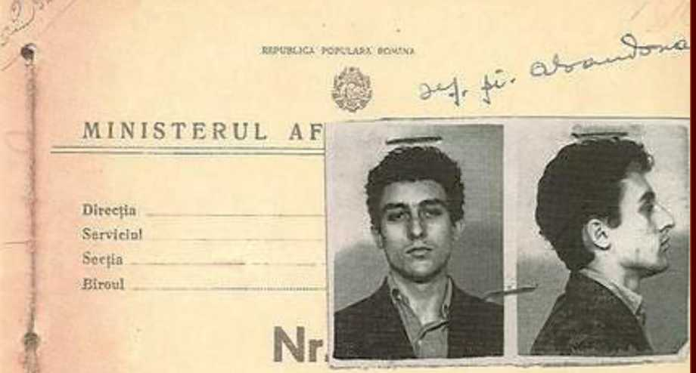

DOSAR PERSONAL

I *"11 *—■

C ONTEMFORARY

Literature Press



<http://edltura.mttlc.ro> Bucureşti 2013

Constantin Noica (1909-1987)

70

IV. Appendices

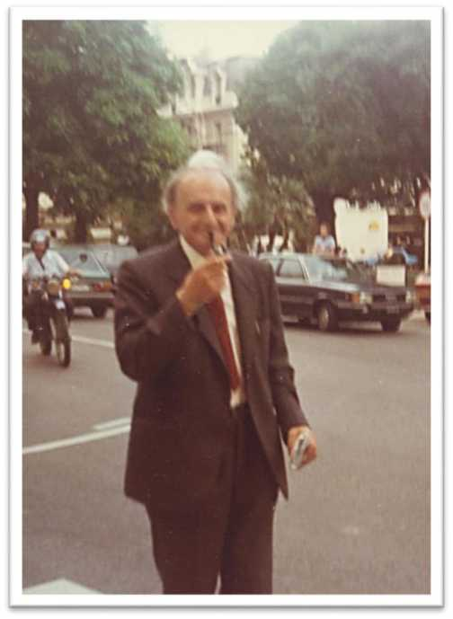

C ONTEMFORARY

Literature Press



<http://edltura.mttlc.ro> Bucureşti 2013

Constantin Noica (1909-1987)

71

Noica in English, translated by his nephew, C. George Sandulescu

**Extracts**

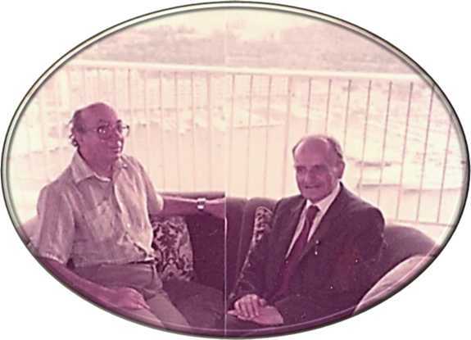

**Constantin Noica, in Monaco, September 1985, with C. George Sandulescu.**

C ONTEMFORARY

Literature Press



<http://edltura.mttlc.ro> Bucureşti 2013

Constantin Noica (1909-1987)

72

Death of the Tomorrow Man

**Published in a Bucharest periodical called** Criterion, **year 1, No. 1 page 5, on 15 October 1934. Its pair article on the same page was written by Mircea Eliade, and was entitled "The Day After Tomorrow".**

**A highly prophetic vision? Yes, but not quite. For the then Romanians, yes, very much so. But for the whole world, in 21st Century retrospect, not at all:**

**After the fatidic 1933, Hitler started at once building his so famous speedways; after 1922, Mussolini was building his voice-carrying auditoriums (I used to lecture in one of them in Rome); and ever since 1917 both Lenin & Stalin were more than busy sculpting New Man. (Noica himself was prophesying here his prison brainwash.)**

**In letters, Aldous Huxley published** Brave New World **in 1932, (Read It!), and Mussolini's good friend Ezra Pound was patiently radio-lecturing that Capital is Good: profit from capital is Evil. (Read that too!) Hitler had already drawn his own conclusion... Auschwitz & Katyn (q.v) were on the shadow cards.**

**Noica was just looking around him, seeing, and writing. Opening Romanian eyes with pieces like the following.**

**(The difference? None of The Three Great (H + F + C) Ideologies was asking The Individual TO THINK. Only God (the 4th Great Ideology) was... and not exactly Him either!)**

What are we in the process of doing now, d'you know? We are in the very process of serving the Man of Tomorrow. We have brushed aside all other things that we were doing, and are most feverishly preparing optimal conditions for the man of tomorrow. The Charities have already set up proper hospitals where the man of tomorrow will be put on the path of the suitably required hygiene of life. Building engineers are making highways, and the architects are designing buildings full of light... For whom, you may ask? For the man of tomorrow.

**G.S.**

C ONTEMFORARY

Literature Press



<http://edltura.mttlc.ro>

Bucureşti 2013

Constantin Noica (1909-1987)

73

Medical doctors are in the process of finding remedies for all possible diseases

* also for him. Politicians, high and low, big and small, are devising ideal conditions for living in society; also for him. Girls, who are sure to grow up to be genuinely beautiful, are being born for his exclusive enjoyment and benefit too.

The tomorrow man will be full of health, will be surrounded by comfort and congeniality. And will have the Radio at his disposal. Only at that moment he will be able to think. Never before.

No matter how indignant the philosopher might be who had once said: it cannot be that the sole goal of civilisation is to devise speediest means of carrying booze for the benefit of thirsty individuals. Such a philosopher cannot possibly be right. But for the time being, that is our sole goal: to do it all in such a way that the man of tomorrow should not remain thirsty — not for a single split-second. Otherwise, he feels disturbed. And won't be at all able to think.

That is the very reason for which we could not think. We used to live, you see, at first in caves; and life in there was hard and difficult. We then started shepherding: who at the time could think of anything else except good green grass? Then we came round to ploughing the land with the express purpose of creating "far better living conditions"; but then the Barbarian invaders came. And with them came the wars. And we have been warring ever since.

Slow but steady, the peoples began to take a settled shape against the background of History: but fighting never ceased — not for a second. There was no longer a tribe fighting another: there was a country fighting another. And a race fighting another. And in the very turmoil of total general fighting, there were barely more than few Egyptian high priests who found the leisure to think. So very few of them. At any rate, far fewer than the Greek thinkers, who were not at all many either. History never gave Man time to think: for it was constantly bullying him to proclaim the advent of tomorrow's man.

When Jesus emerged, we thought that would mean the end of the world. We had, until then, lived within time. But He was taking us out of time. Until then, we had been bowing to and sweating for The Man of Tomorrow. He presumed to take That Man out of our heads. You, too, are the sons of God, He kept telling us. Stop thinking of The Other One. Go kill the Man of Tomorrow that resides in you. Concentrate only on your own salvation. At the end of the world, everybody will come back alive and will be of exactly the same age.

And the world was just about to come to an end. But no, not yet. That would have indeed happened if all men, all of them, had become Christian. But who really

C ONTEMFORARY

Literature Press



<http://edltura.mttlc.ro> Bucureşti 2013

Constantin Noica (1909-1987)

74

chose to become Christian? With every passing year, nay, with every passing Century, the initial teaching was gradually forgotten. And everybody started focusing their attention on the tomorrow man, more and more.

We were all very pleased, for everything was postponed: our sole target was the hunger of the Body; whereas the Spirit was put to sleep... But something was missing — it was the Doctrine. There was acute need for a smidge of Theory, just in order to be able to create within ourselves the feeling of full achievement.

It was at that point that Marxism came about. How relieved we felt in our very hearts! For how very long we had all been waiting for the king of kings to tell us: "Eat first! And think afterwards!"

We had been waiting for that injunction since the beginning of time. "Postpone all the needs of the Spirit until you have fully fulfilled the needs of the Body!"

Go on engineering the world further and further: for perhaps then, the man of tomorrow will feel even better, and will begin to think!

Are you feeling all right, you, The Man of Tomorrow? No, he is still not feeling quite all right... He is still badly in need of a cushion under his right elbow... The electric light is too strong for his eyes. The Radio is far too low. Is it all right now, You, the man of tomorrow?

I sometimes wonder how it will all end. What if, in spite of all that, He won't start thinking?

At that point, it seems to me, we waste our lives.

Translated into English by C. George Sandulescu.

C ONTEMFORARY

Literature Press



<http://edltura.mttlc.ro> Bucureşti 2013

Constantin Noica (1909-1987)

75

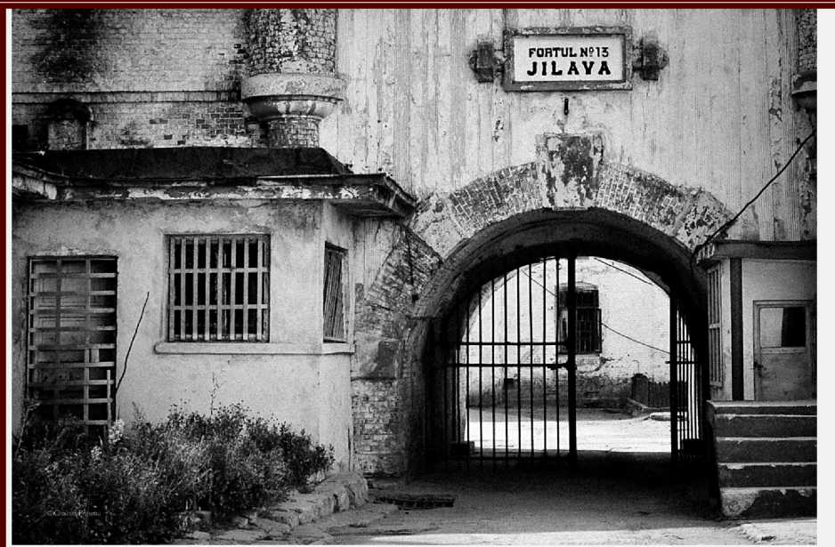

**Vigneta 7.**

Unde a murit Mircea Vulcănescu?

Unde a murit Iuliu Maniu?

Unde a murit Codreanu?

Unde a murit Nicolae Iorga?

Ce relaţie era între Monica Lovinescu şi Virgil Ierunca? Unde au locuit ei întotdeauna? Ce revistă împortantă a publicat Virgil Ierunca? Cine era Dictachiorul şi cum a murit el?

Câţi intelectuali au murit în închisori? Ne gândim noi oare des la

ei?

**CGS**

C ONTEMFORARY

Literature Press



<http://edltura.mttlc.ro> Bucureşti 2013

Constantin Noica (1909-1987)

76

MATHESIS, or the Simple Joys

**First published 1934 by** Fundaţia pentru literatură şi artă "Regele Carol II"**, Bucureşti (80 pages).**

*PREFACE*

*Why do we like to deal in half-truths? The author of these lines is fully aware that he is not always right. He would have liked to be right, and was angry at himself.*

*He went on the road to excess, he looked for excess. As a relief. But there are so many excesses around us, the life forms - all of them - seem to be so unnatural from the viewpoint of truth - that this unnatural attempt too can in its turn be forgiven.*

*In fact, somebody once said: "If lost in a wood, do be steadfast in a single direction and one only, and you will become a path-finder." This is indeed an invitation to excess. For perhaps we are not talking about new paths. But rather about passages, ways of life, beaten paths pure and simple - and all in a world in which nobody knows much at all about anything anyhow.*

It is today clearly ascertained in science that the whole of the universe, in point of form, can be effectively wrapped up in a formula of the kind f (x, y, z). There was even a scientist who declared himself able to put a whole statue in formulaic shape — the Venus of Milo, for instance. It would be a long equation for sure, and most probably quite repelling to look at. Ever so many symbols would be needed to replace that simple and direct beauty! But what does it all matter? It would indeed be an equation, would it not? It would represent a new beauty, the other face of Venus of Milo. Will we ever learn to see her too?



I.

C ONTEMFORARY

Literature Press



<http://e> ditura.mttk.ro

Bucureşti 2013

Constantin Noica (1909-1987)

77



The statement we are trying to make is the following: our culture is of a mathematical type, a format that is in absolute opposition to the historical format.

What at first sight characterizes a culture of the geometrical type is its ideal: the universal science — Mathesis universalis.

But what then is the meaning of a culture of the historical type?

It is a culture in which destiny is paramount. It is in consequence a blind culture. It is true that it is full of presences. But in order to live close to presences, in order to become them, in order to exist in and with them — means either to give up human status, or to surpass it.

In order to live as a member of a human culture of the historical type perhaps means to lead the life of trees, or of birds, or, who knows? that of angels. It signifies a life that is culturally different from the life of man. It is either too little, or far too much. Historical culture is biological, and hence angelic. Religion has handed us the second option. Does Historicism mean to push us back to our biological parameters?

We are told that this is not at all plain biology. For we are being proposed a transfigured biology.

A transfigured biology, you say? It seems to us that behind this transfiguration lies mere respect for biology. Culture was born in the process of disregarding biology, being sheer excess in its regard. At least half of our culture — everything that is geometry and geometric in it — lies far beyond biology.

Culture itself seems to have been born between two heart-beats of life — in an intermission, if we can put it that way. But that does not necessarily mean that culture



Our culture privileges "the manufactured" over the already given.



C ONTEMFORARY

Literature Press



<http://edltura.mttlc.ro>

Bucureşti 2013

Constantin Noica (1909-1987)

78

is not life. Culture is not only life: it is what is most generous in it — namely, excess. It is not a all suitable to say Culture and Life. For culture grows of itself out of the excess of life over itself, and as such it stands as a lengthening of it.

We are, possibly, spirit. We are emotional capability, universal in its very nature. Divided as we are in the world, we are, in spite of all, rhythms. Let us allow our own rhythms to make us solidary. If culture is supposed to give us anything, it is to save us from the shame of lying outside rhythms.

To promote form does not mean to kill life. Never believe scientists when they say that they are calm and unperturbed. Never believe Pascal when he says that philosophising calms pain. His apparent peace hides another inner turmoil, that's all. It is a displacement, it is a shift from biology and its effervescence on to formalism and its dramatic setups. Noise becomes song and imbalance becomes elegance.

Up to a point, all that may be a justification for the aspects of interior life to be expressed in the subsequent pages. It represents the search for a new excess, for a new absurdity, the range of our standard human absurdity. But a veritable interior life is being described, and it is a life which falls quite in step with the very premises of our culture. It is an outline of geometrical experience, the outward rhetoric of the new geometries.

All this is only mere suggestion. A single hope: to make the others smile an occasional smile. If nobody happens to smile, then everything was done in vain. All the more so, as we are firmly convinced that this is indeed the real sense of our culture

* about which I do want to deal with here — as well as the real f ate of man: both of them are bound to be ridiculous. Kant's moral man is ridiculous. The fully formula- adduced man must necessarily be ridiculous too. This is the highest level of understanding of historical life — to feel how thoroughly ridiculous it can be. The



C ONTEMFORARY

Literature Press



<http://edltura.mttlc.ro>

Bucureşti 2013

Constantin Noica (1909-1987)

79

ridiculous residing in the culture. The ridiculous residing in yourself... you who try to make, you who must try to make your own making... at a time when everything else merely is.

Existing alongside us are many things in the world, some are living organisms, others are not. They do not see, and they do not understand. Bu if one special day they would suddenly understand, it is more than certain that they would make fun of us. And far beyond our own world, there is a cheerful, merry god who does understand things genuinely and truly, and he does roar at us with laughter.

I am now waiting for night to fall over everything. The day has been so full of light, and I could see everything so awfully clear, that now I realise that nothing makes any sense at all.

There are far too many colours in the world. And by far too many shapes. This spider with so many legs is monstrous and so very repelling: it is called The Earth.

I am waiting for the night to come. It emerges slowly with "its calm full of wisdom" stretching over all things. It wipes out the colours, blurs the contours, keeping only major relations going, the truth reality gives us as shapes.

All-simplifying night!.. It is only now that I can understand. Now I can see, just because it is dark. I follow shapes with my eyes, I finish barely sketched contours, I am acting in homogeneous space which is almost black. I do round the shapes which seem too pointed. I know, I begin to know, in a vague, faint, and highly blurred way as much as I need to know. My senses are becoming free from obsessions, colours fail to insist in any way, no sound is too sharp. The spirit is free, and its dialectic can well begin.

High up, on Plato's sky, on that sky which he used to identify as the most overwhelming teacher of mankind — the stars have started making themselves noticeable one by one: they look like random points within the geometry of darkness...

Whenever I begin to look at history more attentively, it seems to me — I don't quite know in what way — that I have all inside myself, and also, that it moves from left to right. It is most certainly so, just because I am in the process of reading it; because I find it in books; and the already perused pages lie all of them on the left of me. When you finish a book, the whole of the book, with all its contents lies on the left of me. It is somewhat annoying that, but that's how it is indeed. I do feel the need of a one-way system, simply because such a one-way system is required by history. The



C ONTEMFORARY

Literature Press



<http://edltura.mttlc.ro>

Bucureşti 2013

Constantin Noica (1909-1987)

80

one-way system is in itself psychologically significant to me: and that is why, it must be moving from left to right.

In consequence, whenever we look inwards, and contemplate the Eighteenth Century, the only thing that we are doing is visualising it to the left of the Nineteenth Century. And is it indeed the latter that emerges, unfolds, and detaches itself from the former? But how is that done? Is it in the same way in which one truth detaches itself from another truth? But then, they do not take place in space, and they do not have "directionality" either. History does occur in a closed space, and moves in one single direction only. Exactly so: it moves from left to right. Does anybody believe anything else? What is on top, that comes only afterwards. And it only occurs in close conjunction with the laws of truth, which are the same everywhere: in both History and Geometry.

Plato lies to the left of Aristotle, never to the right of him. The causes of a war always and invariably come to the left of it, and never otherwise. Here lies the irreversibility of history. Unicity, that "only once", may happen to be more than just that. Left-to-right directionality — that indeed is the most extraordinary lesson that history gives us. What about the rest? Well, the rest you can very easily discover in any other field of research you wish.

But history! How can I not hate it, how can I not reject it with every single fibre of my whole being! This history, which is so indisciplined. This history which is so asymmetrical. This very fact which happens to hang more to the left than to the right; which goes astray; which goes the wrong way. This non-geometry, to say the least...

Why is man so very drawn by historical perspectivism? What is there in the essence of the fact of history that makes it be so very convincing?

I have proved that unicity is pure illusion. That it lives, that it is flexible, and fluid? Let us try and prove then that it is neither alive, nor is it flexible, or fluid.

Science is characterised by a certain principle, which is called The Principle of Solidification. Given a function f with several variables, we can particularize some of the variables, granting them specific values — which means "solidifying" them — and afterwards investigating the variability of the given function. Afterwards, successively liberating each and every one of the solidifying elements, one obtains the variation of the function in relation to all its variables.



C ONTEMFORARY

Literature Press



Bucureşti 2013

Constantin Noica (1909-1987)

81

You thus confront the historical fact, which is allegedly alive, flexible and fluid with this very principle of solidification. Is a historical fact alive? Is it both rich and abundant in value elements? Quite on the contrary, it only embodies and represents only one of the range of possible values. This signifies the equal and homogeneous death of all possible lives.

Is it then flexible? On the contrary: it is that least of all. How can it be flexible, and how flexible can it be, as it moves in a closed space, and its very destiny is to be positioned in one particular place and time?

As to fluid, in a certain sense it is fluid, for it runs: it does run like molten metal, or like hot lava, that will soon solidify just because it had from the start been conceived under the sign of solidification. The flow of history is a heavy flow, and a low one to boot.

I have always asked myself for what reason should I admit Blind Fatality in order to explain history, rather than a geometry God. For the whole of history is perhaps pervaded by a spirit of finality, which ultimately boils down to a vast application of The Principle of Solidification. History appears as the solidification imposed by a generating spirit... unable to instantaneously detect the variation of a function dependent on several variables. In that case, history is one special and particular value, taken at random, a mere God-given exemplification. Have you ever thought that all of us, taken together, carrying all our history on our backs — we could all be mere instantiations?

As I was passing in front of that house, the one which was being pulled down, with dust emerging from all quarters, and all tat was left of it was a solitary door- frame — I remembered the problem of the parts related to the whole, as well as of Leibniz's more than memorable question: Can the whole house vanish through a door? a question that nobody had managed to avoid. As to the house, which no longer and in any way was still a whole, it gradually vanished — piece by piece — through the very door, which was itself a part of it... while the workers went on quietly demolishing not only walls, but also the beginning of a problem.

Why then does the problem still linger on?



C ONTEMFORARY

Literature Press



<http://edltura.mttlc.ro>

Bucureşti 2013

Constantin Noica (1909-1987)

82

It occurs to me, sometimes, that it is not us who are the real and true humans.

Translated into English by C. George Sandulescu

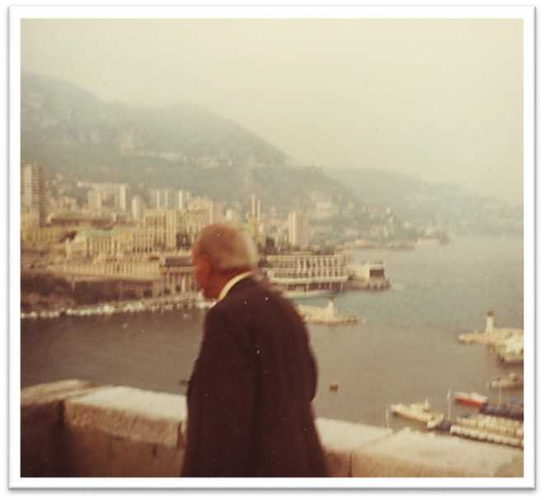

C ONTEMFORARY

Literature Press



<http://edltura.mttlc.ro> Bucureşti 2013

Constantin Noica (1909-1987)

83

De Caelo.

**First published 1937**

**by Vremea, Bucureşti (188 pagini).**

The Pythagoras man — how strange he must have felt himself in his skin. Enveloped in the seven spherical heavens, a prisoner in a world seven times locked up — he must have been contemplating, in his immobility, the dizzying movement of seven superimposed vaults. If only he could by chance perceive the sound harmony of the vaults, which appeared so disharmonious to the eye, each wholly ignoring the others in their respective movements. But the ear only records discontinuous harmonies. Whereas the vaults let go permanent sound. But then, let us imagine that the Pythagoras man did hear. Did that mean it was an additional freedom? Not at all: it was an additional slavery. Sight and hearing joined hands in order to make the man aware of the order surrounding him... in other words, aware of his own imprisonment.

The ancient man was destined to remain a long time in that cosmic slavery, which he in fact adopted and even justified in his own social order. The sentiment of belonging to nature — The Naturalism, if such a phrase could be coined — was indeed the most representative doctrine of antiquity, quite in spite of the desire of certain historians to turn the Greeks into notable humanists. The first philosophers are also called naturalist "physicists", on account of the fact that they attempt to solve the cosmological problem by trying to detect the fundamental components of the world. But they could also be called thus because they let themselves be moved by the same propensity, so very characteristic of the Greeks, of accepting nature: of searching its meanings, remaining at the same time conscious of their subordination to it. And was not Aristotle the most systematic and most authoritative philosopher who was a thorough naturalist from one end to the other of his whole philosophy? Was he not a thinker who only understands the world as a hierarchy, and was he not explaining Man only by inserting him in his proper place in the universal order of things?

C ONTEMFORARY

Literature Press



<http://edltura.mttlc.ro> Bucureşti 2013

Constantin Noica (1909-1987)

84

Such a philosophy came perhaps in the natural way of things to a man who considered himself locked up under so many vaults of heaven. The seven heavens, as Pythagoras willed them, were not enough. A whole range of astral movements remained without any explanation at all, and Eudoxios, in order to be able to give a comprehensive explanation, was obliged to increase the number of spheres from Seven to Twenty-seven. Pure and simple. As if that was all, and that was the end of it. But astronomer Callippos, correcting Eudoxios, increased the number to Thirty-four spheres. But it was Aristotle himself who went as high up as Fifty-six.

No matter how small modern man feels himself to be, with the whole globe of

help feeling the following: although limited, or better said, precisely because they were limited, Aristotle's vaults were more oppressive. Within the universe of today's science we might be able to feel a greater degree of freedom and evince more creativity than within the universe of ancient science. The new vision of the sky perhaps gives a new kind of freedom to the human being... Aristotle's man was imprisoned in a closed universe. The man of today could well feel more master of himself in a world deprived of limits, or within the immense frame proposed by Einstein (of 84 thousand million light years). Or, at any rate: the Aristotle man knew that between him and the universe he belonged to, placed in his appropriate corner, there was indeed a common measure; today's man could well drop overboard that prejudice.

In just a couple of words again, our man of today could feel that he is not nature (in the sense of outward "being" — that of belonging to something, and of being part of something). He could well think that his relations with the rest of humanity are not quantitative, not an infinitesimal point in a vast endlessness. He could further conceive, that he does not take a place in a hierarchy, where the substance making up the individuals placed in a higher echelon can be more noble than his own substance

* as was the prevalent belief in Aristotle's time. And finally, he could as well leave the area of space and no more be obsessed by the idea that he is bound to a particular spot in a particular place.

What would happen, however, if — just in order to avoid the objection raised by the naturalist thesis — the consciousness of the present-day man would one day become aware of something providing clear evidence that he does indeed occupy a place in the astronomical world? What would happen, for instance, if as was for a long



the Earth and all that, when faced with the infinity of astronomical space, he cannot

C ONTEMFORARY

Literature Press



<http://edltura.mttlc.ro>

Bucureşti 2013

Constantin Noica (1909-1987)

85

time suspected (and probably it is on the cards today) other rational living beings would be discovered on another planet, who we could communicate with, and whose existence would make us conscious beyond certainty of the place we are occupying in space? For, in that case, we would most surely be holding such a place, at least if only in relation with the newly discovered planet. And having such a place, and being fully aware of it, we would feel as being part of the whole — part of Nature.

There is one question though: how would we become aware of the existence and rationality of others, how could we communicate with them? Through Formulae, is it not? Through some formulae which would stand for certain truths. It has been proposed that in such a case communication should take place through the illumination of a gigantic figure representing the squared Hypothenuse: it would illustrate the fact that the square thus constructed stands equivalent to the sum of the squares thus constructed. If the beings on other planets are indeed rational they would necessarily understand the truth represented by our figure. It is only in that case that we have the right to ask the question: what is of greater interest — the Place, or the Idea? Our place, the place of each and every one of us, or the great element we detain, namely, The Truth, in which we find ourselves, all of us creators, all of us consciousnesses of the overall world?

It is quite certain that there is something quite primitive in Modern Man. With a view to saving him, today's historian declares him, quite lucidly, desperate. And indeed, if you consider the ready-made world, God-given, endowed with both angels and inter-planetary space, possessing a destiny, and crowds of humans, and its own History. But you are a desperate, exactly the way primitive man before he had discovered Magic, for instance. Primitives without magic, superstitious folk without any belief, fallen angels prone to paralysis, positiveness and boredom — that is what basically is our own mentality. In order to preserve a tiny particle of of the privileges that the individual has gradually lost, we should imagine that if we do not signify anything in the world we woke up in, we have the satisfaction to realise that this very world will come to an end together with us. We are at the end of the world: it will go down with us. If we are nothing, we have at least the satisfaction to know that in a relatively limited time from now, the whole world around us will come to nought.

It is this very conviction that betrays our primitive mentality more than anything else. It goes without saying that there exist among us genuine philosophers of culture, who see, understand and explain all the phenomena of the contemporary world. If they find signs of decadence, symptoms pointing to the end of the world within itself — in other words, if they conclude that our times wind up a whole cycle,

C ONTEMFORARY

Literature Press



<http://edltura.mttlc.ro> Bucureşti 2013

Constantin Noica (1909-1987)

86

their explanation has been based on a wealth of facts, which in itself is far too rich and

sentiment of The End. It gives birth to a sentiment that is present in each and every one of us. We are not here taking up the ideas of the great minds of the time, but rather ourselves, the rank and file, the ones who evince feelings without going too deep into the facts. Such a sentiment, not quite filtered by our critical spirit, and to a large extent uncontrolled, is being born from, and thrives on the apathy fundamentally characterising us. And what could presume to shake our passivity somewhat? That can only be done by Noise, Sensationalism, and... The Apocalypse. We like the hullabaloo. We are very much looking forward to the Big Endings, we eagerly expect the most resounding ones.

The fundamental need of Sensationalism that modern man acutely evinces has often been emphasised. Absolutely everything must needs be so very noisy for the hearing, and so colossal for the sight. Within the moral order too, we constantly look for effect, for surprise; and in the world of letters we cherish the paradox. It is quite true that we are also endowed with a sense of discretion and measure at times. Present-day jazz is pure noise, though it also retains a sense of reticence at the same time. But if our primitive essence moved towards becoming civilised, it could only do so by preserving an intact initial core. At other levels, our inherent yearning for the sensational, the use of a whole range of "strong" terms — the so-called superlatives —, the need to exalt the actual feelings and uplift the whole being do provide unmistakable proof that having a sense of measure is but a ploy. We ardently aspire to be constantly frenetic, or to permanently see things frenetic. Frenzy, however, invariably comes out in bold relief only if we are, occasionally, in states of peace and calm.

As to us all — the multitude — the arduous lovers of noise and of apocalypse, the end-of-all-in-the-world fans, it was one who lives among us today that uttered the wisest and most profoundly peaceful word: "The tree falls with loudest crack: but it does grow in utter silence."

The ones who popularise of science, and the positivists adoring it to the point of compromising themselves, do insist that Science can predict. For instance, they declare that a total eclipse of the sun will take place on 11 August 19991. Nobody doubts the astronomer in his prophecy: but the victorious positivist inquires whether

far too relevant to be brushed aside by the remark that the idea of end generates a



C ONTEMFORARY

Literature Press



<http://e> ditura.mttk.ro

Bucureşti 2013

Constantin Noica (1909-1987)

87

similar predictions might not be feasible in the moral domain. The answer, of course, is: yes, that can be done. And that is precisely why societies are not completely deprived of the force of Will. We have no idea at all how the various human societies making up Europe would look like on the eve of the year 20001. Who can predict today the thorough-going changes that will take place until then? However, certain things could be known: with a certitude widely different from the astronomical one, but as solid. Namely: whatever the shape of European societies in 1996, they are sure to be celebrating 400 years since the birth of Descartes. And whatever the societies of 2032, they are sure to commemorate 200 years since the death of Goethe. There is no doubt whatever about that: those two certainties are as certain as the 11 August 1999 sun eclipse.

i Please remember that this text was written by Noica in 1937.

Translated into English by C. George Sandulescu

C ONTEMFORARY

Literature Press



<http://edltura.mttlc.ro> Bucureşti 2013

Constantin Noica (1909-1987)

88

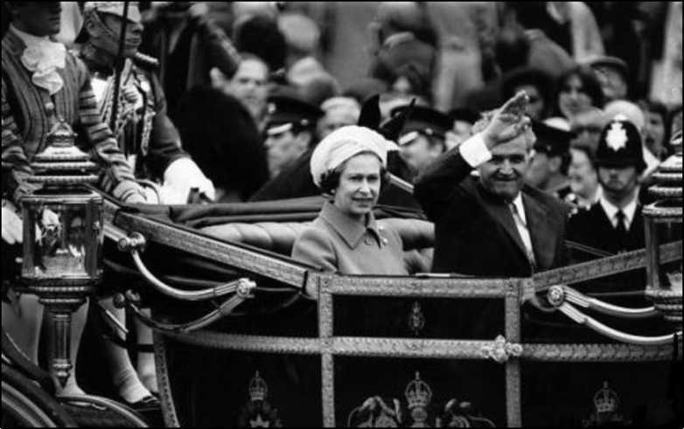

**Vigneta 8.**

Constantin Noica: 333 de întrebări. Martin Heidegger: 333 de întrebări.

Leon Levitchi: 333 de întrebări.

/

George Sandulescu: 333 de întrebări.

**CGS**

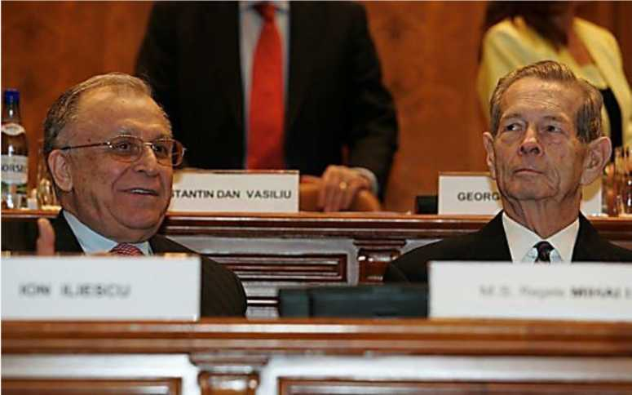

C ONTEMFORARY

Literature Press



<http://edltura.mttlc.ro> Bucureşti 2013

Constantin Noica (1909-1987)

89

Philosophical Journal.

**First published 1944**

by Editura Publicom, Bucureşti (123 pagini). [Entry Numbering inserted by the Anthology Editor.]

1. I dream of a school in which there should be — practically speaking — no teaching at all. To live in peace and quiet, somewhere on the fringes of a human settlement, and the youths, a handful of young men from around, to come there with the specific purpose of freeing themselves from professorial tyranny. For lessons should be given by everything and everybody. All there is must be learnt from outside, and inside out. They are allowed one thing, and one only: to ask questions, from time to time. But don't you see that they too have something to say? And don't you see also that we might not always have anything worth the saying to them? We are mere middlemen between them and their own selves. (Though not even that should be told them.)

✓VW

1. The disciple comes to you to ask for something. You must make him understand that he has nothing to receive; that he must grow up. The disciple would like to become an ivy bush. You must let him be what he must be — even a smock of weeds... And your own most glorious end must be — the climax of fertility — to be drowned by weeds.

C ONTEMFORARY

Literature Press



<http://edltura.mttlc.ro> Bucureşti 2013

Constantin Noica (1909-1987)

90

1. All our moral life is here included: sandwiched between the prodigal son and his brother. We lose our way, and we repent; or, if not, we harden up our heart. It is bad not to obey. But it is equally bad to know that you obey — and bear that in mind.
2. The thought of a School where nothing at all is being formally taught obsesses me. States of mind — that is what we are in duty bound to pass on to others. No hard information. No advice. No teachings. It is for that very reason that the lessons become wholly redundant. Even when somebody asks you something, there is no need whatever to give him "lessons". A book taken off you library shelf, a Bach Prelude played in the quiet of an evening, or a mere instantiation of intellectual serenity — all that is endowed with a far greater educational value than a Lesson. The young do notice that you are giving body to a new idea and they begin to do exactly the same thing themselves.

I believe that such a school must come into being.

(5"n

20. Yesterday I was looking for possible premises for such a School: a house on the outskirts of town — for me and a friend of mine. There is a newspaper stall at the exit point out of town, towards the Ştefăneşti woods. "Who exactly are you trying to find?" asks me the fairly talkative new vendor.

I am taken aback. For I was in point of fact looking for... myself. I was going there with the predetermined intention of meeting that weird being that is indeed oneself. Perhaps projected in the future. But I didn't quite have the strength of practising philosophy with a tobacconist. So, I tell him about a sort of teacher abiding there, without pupils, in a school in which there is nothing practically taught. "Haven't you heard of him?" I ask. "Oh, yes. I think I have. There is one...".

The man did know. I for one was not yet aware — but he, he did know. He did know all the others might be in need of... knowing.

(5"n AM y O

C ONTEMFORARY

Literature Press



<http://edltura.mttlc.ro> Bucureşti 2013

Constantin Noica (1909-1987)

91

28. Bach playing a fugue with his right hand on the clavier, while his left one was warmly clasping Anna Magdalena round her waist. "Perhaps this might be the very last thing I'll be thinking about," she thought.

Somewhere up there, among the hordes of angels, there might linger a wisp of jealousy...

1. I took a friend with me to show him there, on the outskirts of Bucharest, the School cottage I had last time chosen. Leaving the town wholly behind, meeting the sheds and the mud on the roads — all this made him indignant. "Don't you see how ugly it all is?" he said. No, I had not in fact noticed that. The actual cottage pleased him a little better. "But the so flat landscape, how monotonous it is...".

These humans who never see anything else except the beauty of things. But landscapes do become transfigured. An individual who goes through an experience does create a space for himself, he has a landscape of his own. "It's not only flatland," I hurry to add. "There are hills as well, if you attend to visualising it properly." But the cutting reply comes down most ruthlessly: "It goes without saying that Dulcinea was a most beautiful woman for the eyes of Don Quixote, and as to the windmills..."

Such platitudes again! But he is quite right: the Quixote experience stands valid, absolutely valid. We must live like that: within our own world. Though I'd rather adopt the stand: why not? If we compare, let's compare: another Spaniard — El Greco, by name — was always working, when his friends found him, with his blinds drawn down in the middle of the day. "I want to see my colours in a better light," he used to reply.

✓w\ ^ O

1. No, we are not into cheap idealism at all: it is us ourselves who create the world around us. But, for God's sake, it is never the World that will teach us what is to be done, when it is our own fate at stake, and NOT the fate of the World. It is even deprived of meaning to be living in such a beautiful surrounding that it becomes valid for itself and in itself. How inadequately prone to philosophy is that little corner of Ermenonville which Jean Jacques Rousseau had deliberately chosen for his philosophy! It was only and merely suitable for a temple — with nobody ever officiating in it. We must each live according to our measure, with the mud around

C ONTEMFORARY

Literature Press



<http://edltura.mttlc.ro> Bucureşti 2013

Constantin Noica (1909-1987)

92

us, with the shabby huts in which we live, with flatland all around — but with sincerity above all. And also, and moreover, without Rousseau-isms.

44. A young man will come to the School complaining bitterly that he does not know enough. But does he not feel all the joy of not yet having come into contact with Goethe?

O ignorance, what vast life there lies in you!

AM ^_P

51. A school in which the teacher does not himself learn anything is a patent

absurdity. I think I have found a motto for my School. It is that Leon Bloy's most extraordinary phrase: "One never knows who gives and who receives."

(5"n

91. Those who you fail to teach how to doubt are your own failure. If there were to exist a branch of medicine for the souls, its meaning should be quite contrary to current medicine: its main job being to make them feel unwell.

✓VW

106. I feel worried about something Paul Claudel says in Le Soulier de satin:

"Which doctor is ultimately more useful to malaria sufferers: the devoted medical man who sits by their side day and night, or that good-for-nothing who was instrumental in discovering the quinine?"

What an encouragement that is for the prodigal son!

✓w\ ^ O

1. We were standing there, frozen, face to face, tense, eyeball into eyeball, he the dog and me the man. I was sensing he was afraid of me but, me too, could not help feeling afraid of him. Neither of us moved, in order not to break the already established equilibrium between us. Something quite obscure, quite primitive was

C ONTEMFORARY

Literature Press



<http://edltura.mttlc.ro> Bucureşti 2013

Constantin Noica (1909-1987)

93

binding us together into such a unity, that I felt we were — he the dog and me the man — the two facets of an instance of existence.

Nicholas Berdiaeff is absolutely right: the man can stand in metaphysical relations with the dog.

**^s**

1. Absolute solitude? I sometimes conceive it thus: in the train, on a crowded corridor, sitting on the suitcase. You are then so far away not only from any other human being, but more especially so from those who prevent you to move. You are so very far away from any fixed point in space. You are somewhere, between one railway station and another, torn from something, on the way to somewhere else, taken out of Time, taken out of your own, carried on rails, carrying within you another train — full of people, situations, objects, ideas, all of them topsy-turvy, put in carriages which you leave behind at certain stations, you may lose between stations, you forget in space, thus emptying the world, speeding through the world, alone, more alone, ever so alone.

(5"n

142. This moral brother of mine, I visualise so clearly, that I am able to hear him pronouncing judgments about today's world, taking stands, holding courses of lectures, saying YES, but more especially so, saying NO. Just because he is a curious man, like any being of free will, will come to see what we are doing at the School. Somebody present will throw at him: "You are the brother of the prodigal son." He does not hear so very well, as all self-centred persons are in the habit of doing... they are somewhat deaf. Therefore, he is bound to say: "Excuse me, I am The Professor...", and will be expecting that somebody should ask him the subject-matter that he is in the habit of teaching. But nobody will ask him.

✓VW

154. When you are young, everybody will be doing their best to teach you how to succeed. But a far greater virtue, and at any rate, far more useful, than the way to success is that of knowing what to do with the absences of success. Not only that it is hard to succeed all the time, but it is also sterile. You become the invariable Prize- winner. And, thank God, the prodigal son was given some of them too.

C ONTEMFORARY

Literature Press



<http://edltura.mttlc.ro> Bucureşti 2013

Constantin Noica (1909-1987)

94

But as failures do exist, there is — without specially looking for it — a certain voluptuousness in the defeat, a voluptuousness that must be cultivated in the young. And that quality the prodigal son is indeed endowed with. And he makes it a point to be prodigal it too.

167. Reading Iphigenie, I realise all of a sudden why I do not like Racine. Though he is a moralist, he remains a humanist in the poor sense of the word, namely a pedagogue. This brand of people are most anxious to undertake everything; and resort to a lesson in the most direct and indiscreet way possible. And if that were not clear from the start, you have full evidence of it in the Prefaces.

Racine's Prefaces... How full of lack of poetry they are! The barrister behaviour

* in most cases. A critic breaking beauty to pieces. Iphigenia must needs not be his offer. "Quelle apparence que j'eusse souillee la scene par le meurtre horrible d'une personne aussi vertueuse et aussi aimable qu'il fallait (!) representer Iphigenie."

And in spite of all that, the logic of aesthetics requires that Iphigenia should die. I defy anybody who feels that there is destiny here to be aesthetically satisfied with a solution that would miraculously save Iphigenia. But the logic of a moralist and of a pedagogue requires a different solution. Iphigenia is virtuous — and, in consequence, her life should be saved. What would the spectator say otherwise? Would he not be scandalised? And then, "j'ai ete tres heureux de trouver dans les anciens cette autre Iphigenie", somewhat vaguely mentioned, it is true, but that is quite enough for the humanist Racine. After running her down in several respects, he takes up the other one — the good, the virtuous Iphigenia. In order to impeccably finalise her absolute perfection, she is given the pedagogical happiness of getting married to Achilles.

into righteous personalities. You only give life to a character the moment everything is in proper equilibrium, and when everybody is presented in the just way. That is the case with the Aeschylus heroes. Each in his own righteousness. Eteocles is right to defend the city of Thebes against his brother Polynices, who surrounds it with a foreign army. But Polynices is right too in order to undertake its siege, on account of the fact that Eteocles deprived him of his part of reign. And how splendid it is that even the Choir is divided in the end in The Seven against Thebes: half of it follows



178. An artist begins as an artist the moment he is able to turn all his characters

C ONTEMFORARY

Literature Press



<http://edltura.mttlc.ro>

Bucureşti 2013

Constantin Noica (1909-1987)

95

Polynices fighting for his rights; the other half follows Eteocles, who had died for his rights.

'VW (575

AM ^_P

181. A verse from Luke scares me: "Woe unto you, scribes and Pharisees,

hypocrites! for ye are as graves which appear not, and the men that walk over them are not aware of them."

For, I think, that is exactly what the scribes and the pharisees want: that it should be they that exist. And when they are inside the graves, these should be their graves, their own graves. What greater pain can there be than that Luke speaks about

* to lie in unknown graves? We are perhaps all the time stepping on the unknown grave of the squanderer son's brother.

(5"n

189. How wise! exclaim the others, seeing that he knows how to accept defeat, that he knows to take defeat with serenity. He is almost a stoic. He has achieved indifference, disregard, the state of ataraxy.

But most individuals do not know that there is also a positive indifference, the one belonging to life, leading to fullness. It is not at all a question of the suppression of desires, but rather the reduplication of each of them — that is the solution. There is a wisdom which presumes not to love anything. But there is also the one asking one to love this and that. Loving the alternative. Whatever happens in any given situation is good. Double your desires — do not kill them — and you'll be happy.

To put it in the terms of the prodigal son: "If my sin succeeds, it is good. Because I have achieved voluptuousness. If my sin does not succeed, it is good again. For I have achieved virtue."

But it is preferable to operate in your own terms.

>w*(575

192. I am at the School, waiting for the shy guy. Timidity contains something highly valuable: it keeps. More particularly, with the populations that reach maturity fairly easily — as is the case with the peoples that you might wish to call Latin —, timidity is an educational factor of very great value. The important thing is to prolong youth.

C ONTEMFORARY

Literature Press



<http://edltura.mttlc.ro> Bucureşti 2013

Constantin Noica (1909-1987)

96

By any means, including timidity. For all "superior animals" do have a long youth. (Biology has taught me that.)

From this arises the fight between true Teacher and Parent. The common teacher conspires with the parents in the process of turning the young into mature beings. That means passing on the required knowledge, they say, in order to prepare them for life, say all the others. It is then that the teacher intervenes. The young have no idea how to protect themselves, how to defend their only valuable treasure, namely their youth. For the young themselves evince certain impulses leading them directly to maturity. Though in his heart there lies a high-quality nostalgia: they seek apprenticeship, they seek the master.

How beautiful are the things happening between 20 and 25 years of age! The parents are pushing you out into life. The teachers are delivering diplomas. The surrounding world is opening its gates. The instincts pushing one to assert oneself are mushrooming. And what does the youth do? He still hesitates. But it is as clear as crystal, they say: here is a job; here is a girl to marry; there is a possible opening. What are you waiting for?

But NO! He is waiting... He is waiting for something. Something makes him tarry. Happy are those, who in that hour of decision, are being faced with a delaying factor.

(5"n

195. These people think that you are constructing a paradox when you say a

bridge or a railway engine is not something concrete. When you consider them a mere applied abstraction. An abstraction materialised. That the brother of the prodigal son is something concrete, but a highway is an abstraction. It is in fact their business to think that way. Each and every one of us moves in universes of their own choosing.

✓VW ^.P

201. The prodigal son has only one thing — voluptuousness. The brother of the prodigal son is endowed with curiosity and pride. Which one is the greater sinner?

Or, perhaps, curiosity characterises both of them. But the prodigal son opens the door. His brother only peeps through the keyhole.

C ONTEMFORARY

Literature Press



<http://edltura.mttlc.ro> Bucureşti 2013

Constantin Noica (1909-1987)

97

206. It seems to me sometimes that I know what philosophy is: it is the adventure of the universal when it becomes particular.

231. How lucky are the Revolutions that are fully aware of what they are fighting against: against all those wearing shoes, or against all those with a remarkable past. But on this side, there exists something which is both subtle and paralysing: it is the fact that the enemy is ever nearer. It is not the stranger, not the crook either, it is not al all the man of yore, not the good man, not even your comrade... until you realise that it becomes part of yourself. "Then you must become something else."

234. "All rivers flow into the sea, and the sea never overflows." How funny this Ecclesiastes! If the sea were to fill up, it should say: "The rivers flow into the sea, the sea fills up and overflows, and the rivers, reborn, flow on again into the sea."

As everything is, and must be — just vanity.

(5"n

1. Whenever I see a teenager I keep thinking what adverse fate the present-

day world has in store for him. It was quite different in the days of the Greeks. I know full well: the evil mouths of history have pushed us in another direction. But lying beyond the gossip and the scandals, there is here a problem. We should be well aware of that.

Having in front of him an 18-year-old girl, any wise man of the earth would evince extra care in point of both attention and understanding. For him, she does exist. Academicians and other learned old men gather all around her, and all of them place themselves at her disposal, with awkward grace. (The Greeks are sure to laugh their heads out at us!) But in the meantime, what moral status does an 18-year-old enjoy? "We are going to discuss about that later."

A girl at eighteen is everything — that is quite, quite true. She knows and understands everything. Her fight from now on will be hold and to keep what she has so far kept. And in much the same way in which she would desperately cling to her youth, she would simultaneously try — through culture, experience, and memory —

C ONTEMFORARY

Literature Press



<http://edltura.mttlc.ro> Bucureşti 2013

Constantin Noica (1909-1987)

98

to know just as much as she knew, at one gulp, then. I admit that, in a sense, she is more interesting. But in one sense only. Because she has no future. And if you do indeed value the future, the boy is the one who becomes more interesting.

Let him come nearer you; or you try to be closer to him. You must take his soul in your hands, and fashion it. Weigh it in your hands, as if it were a measure of wheat. How heavy is it? What prospects of fertility does it have? If you can, try not to play the part of a knowledgeable farmer. Rather, try to be the rain, that autumn rain which does not care a damn about harvesting and all that...

ever come about. But, at end of life, I'd be more than happy to be able to say: "I've done nothing else all life long!"

[N.B. The above excerpt contains 28 entries out of a total of 250.]



1. The School. That School of mine. I haven't the slightest idea whether it'll

Translated into English by C. George Sandulescu

C ONTEMFORARY

Literature Press



<http://e> ditura.mttk.ro

Bucureşti 2013

Constantin Noica (1909-1987)

99

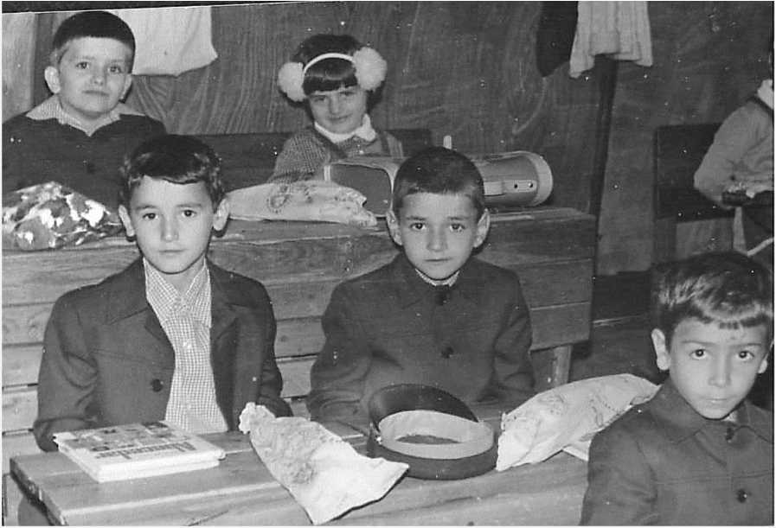

**Vigneta 9.**

Unde a fost asasinat Generalul Antonescu?

Ce a spus Antonescu poporului la jumătatea lui iunie 1941? Când a intrat armata rusă pe teritoriul românesc?

Ce este istoria instituţională şi ce este istoria naţională?

Ce este naţiunea? Teritoriu, sau limbă, sau amândouă? De când

/ ' '

şi până când?

Cine era Vlad Georgescu?

Prieten apropiat al cărui scriitor român a fost Giovanni Papini, care scriitor i-a tradus cartea Un uomo finito înainte de război?

Când a scris Papini Istoria lumii şi ce valoare academică are ea?

**CGS**

C ONTEMFORARY

Literature Press



<http://edltura.mttlc.ro> Bucureşti 2013

Constantin Noica (1909-1987)

100

"Do Invent Teachers - I Urge You!"

*Philosopher Constantin Noica addresses some Bucharest secondary school students in April 1986, on a suggestion by one of his good friends who was teaching there.*

I am not going to let the emotions and thoughts that this place arouses in me get the better of myself! At my age, I feel I must be harsh on young people, and not just say: you are so good at what you are doing, just keep it up! We cannot go on like this. In consequence, do not expect me to praise anyone - for I have only come here to urge you to do more, maybe less harshly than usual, but still, do more.

People are making a habit of complaining these days: some say they have too little, others that they have too much, implying either material possessions or information, or both. Everyone complains: there is too much knowledge, alas! As if we were meant to just race on, never stop, and never understand...

1. must begin by telling you plainly that there are two kinds of humans: Subjects and Objects. At your age, you have to understand that what you must strive for is to become human subjects. On the other hand, if you are happy with just being human objects, suit yourselves. Reality

will make some use of you, I expect. I am here to show those of you who aspire to being human subjects one day how to avoid the huge danger of falling into the traps of this contemporary world, which never ceases testing you, or which - in the words of Mihail Eminescu - can make you see how to avoid the danger of becoming mere human objects.

This will be worth your while. Actually, you are now at the age when you must try. For two generations now, mere young age has lost its importance to almost everyone, if taken independently of other things. Now, why is that? Simply because youthful courage and physical strength are no longer on the cards. It will come as no news to you, I suppose, that, wherever you may look on the globe, if young people manage to assert themselves, it is not by means of their age, but by what they have in their heads. This world has somehow turned against youth as such, and it is looking

C ONTEMFORARY

Literature Press



<http://edltura.mttlc.ro> Bucureşti 2013

Constantin Noica (1909-1987)

101

more and more intently at old values, at all those who live longer than ever before, and who stand to become more and more numerous in our society.

Just try to imagine the society of the future! Thirty years education, thirty years work, and thirty years enjoying old age. Almost half the members of society will be elderly people. In that case, you must find a way to make your youth meaningful, whereas the elderly must do the same for their old age. When you get there, you will see: one is never ready to grow old, unless one has some sort of preparation for it. Since I belong to the very first generation whose members grow old in large numbers, I have a confession to make: I am disappointed. We do not function well at all, and we do not use this gift of life to the full. Not at all!

I will give you an example of what youth used to mean of old: its bravery, its exploits... It is just an illustration, though - nothing more.

In the 1920s, aviation was just starting. A young pilot risked death fifty percent of the time: accidents were ever so common. Young pilots did not have a lot to learn - just a few skills. The plane cabin was open, protection was more than scanty. Those young people relied on their age above all, and so did the whole world. A mathematics teacher once told me he had been employed by a school for pilots, and he had once asked a candidate how many degrees there are in a circle. The candidate

* an aspiring officer - replied: "It depends!" So the teacher drew a circle on the blackboard, and asked again, "How many degrees are there in this circle?". The candidate took a step back and answered: "About 260 degrees!". What did the teacher do? He gave him a pass, of course, what could he have done? After all, the boy was about to risk his life, like so many of his generation.

Then, let us think of Christopher Columbus, for instance. He left Europe in hopes of finding one America or another. Just that! Any space expert today knows all about outer space in great detail - things that nobody ever knew before him. He is also bound by a strange sort of umbilical cord to the Earth. We all remember that, when the first people landed on the moon, the second spaceman, who went out after Armstrong, began dancing about (gravity being seven times smaller there, if I am not mistaken). Upon which those down here on the ground, in Pasadena, warned him:



C ONTEMFORARY

Literature Press



<http://edltura.mttlc.ro>

Bucureşti 2013

Constantin Noica (1909-1987)

102

"None of that!" He was protected by a strange sort of "umbilical cord" which Columbus never had. Columbus did his best, of course, but he did not even realize he had stumbled upon America - it was Amerigo Vespucci who gave it his name. Did Columbus know what he had almost discovered? He had expected to reach India... We know today what the moon is all about: we know it is enveloped in half a yard of dust, we know our outer world quite well.

You must KNOW things. You cannot just rely on your God-given natural abilities any more. You have a huge responsibility, and you must be aware of it. You simply cannot avoid it! Remember the old song of a conscript from Transylvania: "Sweet soldier's life/ Were it not for the gun!" What kind of soldier would that be, without a gun at all? In the same way, how can a young man be of any consequence today unless he knows things? There's no two ways about it - and I am here in order to tell you that. It may make you unhappy, but you must get used to it! I am here to urge you: start ploughing steadily while you are young!

How should we look at young people in the West, with all their mistakes? I would call theirs an unstable, misdirected youth. You cannot afford to be the same. In Eastern Europe, all the way from Vienna and further on eastwards, young people are stronger and more able, it so happens. They symbolise a human ideal, an excellent opportunity for the future of an exhausted Europe. Europe was once the salt of the earth, and, hopefully, it may become something akin to that once again.

Being young, taken alone, is worth next to nothing on the job market these days. What are your chances, then? You can only win if you decide to work upon yourselves. Improving our minds means being ready to work. It is up to you, and to you alone, to achieve that. You must find your own way. Do not wait for a ready- made armour to be dumped in your lap: it is your job to make one of your own.

My friend, Mircea Handoca, and myself - he being the toreador, while I am a mere picador here - are planning to publish what Mircea Eliade had been writing between the ages of fourteen and eighteen. That is an eloquent example of what a young Romanian could do as far back as the 1920s! He was not exactly an exemplary student - he failed in French when he was twelve -, but by the age of eighteen he had read all the novels of Honore de Balzac from cover to cover. Ninety-three books in all. And had already learnt Italian in order to be able to read Giovanni Papini. He looked through a microscope when he was twelve - imagine what the microscope might have been back in the 1920s! - and he saw something nobody else did. He had the intuition that under that microscope there existed a different world from the one we usually see all of us. As from that day he looked for his real world - in Natural

C ONTEMFORARY

Literature Press



<http://edltura.mttlc.ro> Bucureşti 2013

Constantin Noica (1909-1987)

103

Science, in chemistry, in the East, going into alchemy and the magical. His adventure should stand as an example to all of us. That is indeed the case for you. That is indeed the case for all of us here. And that is indeed the case for a whole Europe, where Giovanni Papini's book Un Uomo finito (A Man-Finished) was such a great success. It was a success in spite of the fact that it was a mere collection of "I wish I had...", "I dream I would...", while Eliade's books, his incursions into Natural Science, chemistry, alchemy were unexpectedly high achievements.

At your age now, and at this present stage in your life, being good students in all subjects is not enough. You must first learn to behave in a morally correct way. You must also learn to respect yourselves. I tend to think that girls might be better at all that than the boys are, precisely because the girls know what self-respect is, they pride themselves in being proud, they think more of themselves, and they feel that the proper answer to any question is the adequate one. They do give the right answers because they really mean to do so. What you must do, then, is find your own place in this almost infinite world of culture, you must find your own way and the right place for your own vocations and inclinations. Indeed, if you do look deep enough into your souls and into your intelligence, you will inevitably find out that each of you has a sense of his or her own perspective.

Well, that is your only way out! At that point, you can escape such a state, namely this condition of being objects. For the simple reason that this is what you are all the time you are simply fed knowledge, while you are being taught what we might think you must know in order to survive. All you have to do is simply pay attention.

Attention, Johann Wolfgang Goethe used to say, is a primeval instinct with all creatures. Morally, it means submission to an object, it means respect, tranquillity, and that wisdom which, as the beliefs preserved by our folklore suggest, defeats the devil. It means gentleness. A gentleness that overcomes everything! Attention paid to intellectual matters leads to the knowledge that stays valuable. It is the kind of attention which a Chinese uses when he contemplates the sun for five minutes every single morning. All important minds have made use of such type of attention when they made their discoveries, and were fully aware of what they were doing. You are now at a time in your lives when, as a poem by Johann Wolfgang Goethe puts it quite well... I will do my best to paraphrase it as follows: you look through the grass, you are sure to stumble upon the thistles. But, if you look at a thistle carefully, if you question what you see around yourself, you will notice a miracle of nature. With an inclination for Natural Science, you can begin to understand things regardless of what you were taught at school. I summarize once again: you look at the grass and see

C ONTEMFORARY

Literature Press



<http://edltura.mttlc.ro> Bucureşti 2013

Constantin Noica (1909-1987)

104

nothing. You look at a thistle and see a miracle. And then you look at all Nature around you, and see the same miracle all over again.

Technology can stir wonder in your heads, too. I once was fascinated looking at a young man who kept staring at a motorbike for five full minutes non stop. He saw something in there: we had no idea what it was. This ability to wonder must be systematically sustained, must necessarily be transferred upon the Word itself.

Are you aware that most people speak empty words when they speak, saying nothing, and still saying it. You notice someone taking someone else's arm. The victim says: "dă-mi drumul! (let me go!)". What does "dă-mi drumul! (let me go!)" mean? It simply means "Do let me (Going My Way)''. Sextil Puşcariu had a story about a trip to the mountains, when he met a shepherd grazing his sheep. He had almost got lost. The old shepherd there said to him: „ţi-oi da drumul!" (I'll give you your way!"). That was the moment when Sextil Puşcariu, the well known compiler of the Dictionary of the Romanian Language, finally understood the meaning of the Romanian phrase giving the way. At that moment he visualised the whole story behind that particular phrase: the Romanians, who had been taking refuge in woods for centuries when they were in great danger, would hold as hostages those who had attacked them. They would never harm them at all. They would just not show them the right way out! To give the way means, then, to move away from the state of ignorance, from the state of not knowing something.

Further, we say in Romanian: „îşi bate joc de mine". What does this phrase mean? To 'beat' the game, in the old days, when the Romanians used to play their own game called oină (a kind of handball played with the tennis ball), the players used to say the phrase "to beat the game" aloud. And, by some strange connection, the phrase came to mean (in English) to make fun of, to mock somebody. And the Romanian language is full of other phrases, like the following: "I am in the ninth heaven". And what does this "ninth heaven" mean? If I were the head of your examination board, and you told me that you were in the ninth heaven, yet could not explain what you meant, I would keep you standing there and you would fail your examination. The ninth heaven, indeed! There were seven heavens for the planets, plus the crystal dome (so Aristotle saw the sky), and the ninth dome was the heaven of fixed stars! Saying you are in the ninth heaven simply means you are using the set of concepts belonging to the language of Aristotle himself!

You must see the miracles around you! This is what you must do. The miracle of nature, the miracle of man, the miracle of love. It takes so little to see a miracle. It is on our free days, during those hours when we seem to be idle, that we can become

C ONTEMFORARY

Literature Press



<http://edltura.mttlc.ro> Bucureşti 2013

Constantin Noica (1909-1987)

105

aware of miracles. There are miracles hidden all around us. All we have to do is to stretch out our hands and pick them, as it was once done in heaven. All we need is attention, and the ability to detect that particular direction which can lead each of us to seeing the miracle in things and beings. People often turn their full attention to astrology, and they say: I was born under such and such a sign, such and such a star, it governs my life, and so on. Not at all! The star is right here, so very near us that we can touch it.

A religious Polish tale says a rabbi once dreamt there was a treasure under a tree. He goes there, starts digging, till a man comes and tells him he has dreamt of a rabbi who has a treasure buried in his own house. The rabbi goes home and there stands the treasure - a treasure indeed. This is what it is all about: attention, submission to the object, and - who knows how or where - you will eventually come to realize what you will be doing with your lives in the future.

This vibration can also be superficial: good music or a football match can make you vibrate - why not? (I have seen football fans among the very old!) But... profound vibration is something that changes chaos into cosmos. You are at a time of chaos right now, and you must experience cosmic time, find your true identity, ask your own questions. You must know, for instance, that Latin syntax can really help the programming ability of one who dreams of becoming a computer specialist. An important French computer specialist recently mentioned that young people need to be taught more Latin, because Latin syntax is useful to computer science.

We can postpone the miracle of nature, but that miracle is within us. In high school, you are precisely at that point: as the Ancients say, in the beginning is the mist, then come the clouds, followed by rain, and fair weather comes last of all. You are surrounded by mist right now; by nebulosity, at best. The best I can wish you is to find the age of true beauty, and, for the sake of this country, it is yourselves who should symbolise what is fair and fine in it!

At one point, Lucian Blaga was the one who made Romanian folklore part and parcel of his profession, which was philosophy. The substance of any culture can only be seen in the topics which are taken up. Our folklore no longer creates, but it always becomes embodied in the works of Vasile Alecsandri, Alecu Russo, Mihail Eminescu, Lucian Blaga. All of them summarized and brought to a focus the lyricism of folk poetry. We have gone through a historical process during which one creator recreated



C ONTEMFORARY

Literature Press



<http://e> ditura.mttk.ro

Bucureşti 2013

Constantin Noica (1909-1987)

106

what a vast number of anonymous poets had done without being artistically fully aware of what they were doing. Lucian Blaga is one of the last ones who did that, and I just wonder if any other poet from now on will ever be able to capture the essence of the Romanian phenomenon, its Romanian meanings, symbols, and myths. He should be a poet profoundly in touch with our mioritic space. It must all of it, of course, be placed against a historical background.

Another phrase we make use of is "The moon and the stars". Anthropocentrism has gradually died, of course, but here we are, immersed in a new kind of anthropocentrism: even though we have no idea whether we hold the moon and the stars in the palm of our hand... But meeting Nature and meeting Technology may help a little on the way...

Romanians have a major defect: we all have strong encyclopaedic tendencies! It is not at all enough to know one particular subject, once we know it. We are bound to move outside it, just like Dimitrie Cantemir, Bogdan Petriceicu Haşdeu, Nicolae Iorga or Mircea Eliade. This phenomenon has considerably upset the westerners. The musician George Enescu went to America as a violinist; but then he went on to play the piano; and then he went on to conduct an orchestra; and last of all he performed his own compositions. From America, he went to Germany and did the same.

Do read O viaţă de om (A Man's Life). Nicolae Iorga rushes through the whole university language studies in one single year, then wins a contest, and becomes a high-school Latin teacher at nineteen. Alexandru Odobescu, who was Minister of Education at the time, gives him a scholarship abroad. Iorga goes, of course. Instead of studying classical languages, he delves into mediaeval studies, and so, becomes a historian. On his way back, he spends time in a few capitals and copies Greek and Latin manuscripts concerning the Romanian Principalities. Once back, he meets Alexandru D. Xenopol, his former teacher, who asks him: "What are you doing now?" "I am planning to write a history of Romania," he retorts. To summarize the Iorga story: from a Latinist he becomes a specialist in mediaeval studies, then a historian of all Romanians, goes to France, lectures there, develops a passion for Byzantium, becomes a Byzantium expert, and ends up writing a history of Romanian literature... At which particular point in his life, the French, the Germans and the English, well contained within their narrow specializations, become suspicious. The same had happened before with Cantemir and Haşdeu.



C ONTEMFORARY

Literature Press



<http://e> ditura.mttk.ro

Bucureşti 2013

Constantin Noica (1909-1987)

107

How could we not dabble in a multiplicity of subjects when we were always obliged to know so much more, by implication, living, as we do, on the outskirts of the larger cultures? When they were in Paris, Romanian students had a great advantage over everybody else: they could speak two or three languages, while the other young people there could hardly speak their own language adequately. It is an advantage, indeed, but, if you want to qualify as a man of culture, it is a disadvantage as well: all the great specialists from abroad are suspicious of you.

Who are the great figures of our Romanian culture in the 20th century? Constantin Brancusi, Lucian Blaga and Mircea Eliade. The others are only famous to us, to us Romanians, but the three names mentioned above made it into the culture of the world, achieving a status there.

It is an age-old problem: what are the chances of a philosophy expressed in a small language to become known world-wide? I have my doubts about its universal circulation, but we can certainly find some good philosophising here! English is the most widely spoken language today, for example. But English can hardly boast of any philosophy at all. It has encouraged linguistics, the study of languages. English, as a linguistic system, does not really have words - it has syntagms, that is phrases, that is groups of words. There is no depth to it. Come to think of it, Romanian, the same as Slav languages such as - which one should I take up? - Russian, of course, and then the same with German, all of them are languages of real depth. All this comes from the fact that their words have biographies! I wish I could persuade the publisher to reprint my Rostirea filosofică românească (Philosophy of Romanian Discourse); one can find there, in that particular book, some thirty or forty Romanian words that have a long story of their own, not unlike those I have already mentioned.

As an example, do you have any idea what the origin of cumplit (dread-ful) is? It comes from completus. We find in the Genesis: dread (cumplit) and darkness. So the human soul and mind see consummation, perfection as cumplit (full of dread). And then, when we talk about the being, we have so much more to say. Hamlet can only say to be or not to be, but we also have va fi fiind, a fost să fie, n-a fost să fie, va fi să fie (all untranslatable)... The Romanian language may not give us extensive reciprocal access to all culture, but it certainly connects us to all great philosophy!

As far as philosophy goes, we should smile and admit we know nothing at all. We have a certain knowledge - I can, for instance, recite Aristotle's ten and Kant's



C ONTEMFORARY

Literature Press



<http://edltura.mttlc.ro>

Bucureşti 2013

Constantin Noica (1909-1987)

108

twelve categories by heart. That is as far as I can go! It is a field that requires knowledge, no doubt - so that one can make associations, see meanings (which Romanians also call noime, from the Greek noema, which means 'knowledge that is certain'. We have turned that particular Greek word into noimă, which signifies: 'utterly uncertain', 'is it true?', 'is it not true?', 'does it mean anything?', 'what exactly could it mean?').

We need highly accurate tools in philosophy. One can do nothing as a philosopher without Greek - for the roots of ancient philosophy; and Latin - for the roots of modern philosophy; and without mathematics. We have made some progress, of course, but we are afflicted with what I have called "strong encyclopaedic tendencies", which unfortunately often turn into amateurism. Unless one is Dimitrie Cantemir or Mircea Eliade, who took special precautions against it, one runs the risk of being an amateur.

I almost resent young people who disregard these requirements. The more uncertain the results, the more schooling one needs. A physicist was awarded the Nobel Prize at the age of thirty, because he had hit upon something of great relevance. But in the case of a philosopher that would be unheard of, because in the Humanities one needs a lot more inspiration and a lot more research.

The golden period for a researcher in the humanities is between sixty and seventy. Studies take much longer in the humanities; at sixty one is free at last. We are free from our own expectations, and we can then set out. At that point, we do precisely what we can, what we know how to do!

In art, there is always someone interposed between creator and consumer: he is the literary historian, the specialist in the history of art, etc. I find it hard to deal with a term such as art consumer. We must all be good enough to be researchers! A consumer enjoys a concert conducted by Sergiu Celibidache or eating a piece of grilled meat in exactly the same way... Which is not at all the way art should be understood!

I am dissatisfied with younger poets of today, because they no longer learn their trade. All artists must learn: a painter is bound know chemistry and geometry, a musician should study harmony and counterpoint... But poets no longer have any idea of the art of prosody: they rely on no more than an anaemic lyrical impulse.

Most artists complain that society never understands or helps them. The idea is that each artist should imagine he is alone on a deserted island; he should do nothing but practise his chosen art - with the clear aim of reaching other people, of course. But the fact is that, before reaching other people, or being listened to, or before managing to help them even, one must reach the gods of knowledge and of culture.

C ONTEMFORARY

Literature Press



<http://edltura.mttlc.ro> Bucureşti 2013

Constantin Noica (1909-1987)

109

One does not learn from teachers, unfortunately! They are all good teachers, and I am happy to see that Romanian high-school teachers are again as good as they used to be before the war. High-school teachers are far more important than university professors, when it comes to education proper. However, do not give in to your teachers, however seductive their teaching may be. Focus on yourselves, learn from art albums, from books, from nature, from music. Everywhere you look, there is learning to be pursued. Everywhere you look, you find something worthy of your attention. Nature can be a teacher, second-hand bookshops can be a teacher. Be true students and invent teachers, invent your own teachers, I urge you to do so.

Translated into English by George Sandulescu and Lidia Vianu.

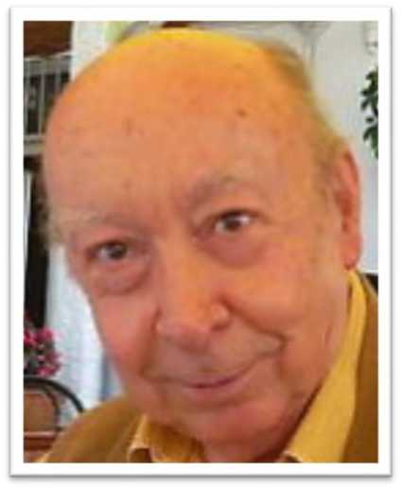

C ONTEMFORARY

Literature Press



<http://edltura.mttlc.ro> Bucureşti 2013

Constantin Noica (1909-1987)

110

**Noica and Eminescu.**

C ONTEMFORARY

Literature Press



<http://edltura.mttlc.ro> Bucureşti 2013

Constantin Noica (1909-1987)

111

The Notebooks of Eminescu and the Notebooks of Valery.

At the end of the 19th century, a German critic stated that in Goethe, and in all he stood for, the German people had a thoroughly complete man. And he added that no other people could boast such an asset.

The German critic may be right or not, but if we can hazard such ideas we shall make so bold as to say - on the strength of the 7,000 manuscript pages kept at the Romanian Academy - that through Mihai Eminescu, from his formative years to his last speculations, the Romanian people acquired the awareness of its culture. And to this we shall add that perhaps such a gift has been bestowed on no other people.

In order to substantiate this statement - whose fabric, that is the interpretations we shall give to Eminescu's notebooks, will serve to sustain it - we need not compare Eminescu with cultural figures that one can approach by other means than their works. We shall not dwell on Augustine who, in a way, said all there was to say about himself, nor or Montaigne who perhaps said more than all he could have said about his own instruction and character, nor on Pascal who made a clear confession of his most profound thoughts, nor on Rousseau who confessed his most humoral thoughts. All these figures, outstanding as they are, can no longer be used as reference terms. Moreover, they spoke about themselves and, not unnaturally, they will allow us to enter their intimate laboratory, in the depths of their awareness of culture and see only what they themselves liked or, with the pathos of their sincerity, what they disliked.

To make a meaningful comparison we shall select someone whose private laboratory we can see for ourselves in its entirety, someone whose subjectivity can be only objectively rendered. As we have to deal with human documents which, given the means of dissemination in the past, could not normally reach a large audience -

C ONTEMFORARY

Literature Press



<http://edltura.mttlc.ro> Bucureşti 2013

Constantin Noica (1909-1987)

112

intimate notations, plans, aspirations, dreams - that is such documents as lose part of their truth when printed, Eminescu's notebooks can only be compared with the manuscripts of a modern or contemporary writer.

Maybe the notebooks of Novalis, Holderlin or Shelley - had these poets been constantly concerned with rendering their cultural and literary creative effort - would have been akin to those of Eminescu. They do not seem to have left such notebooks, anyway they are not available to us. But we do have the notebooks of Paul Valery.

Like Eminescu, Valery surely never thought his notebooks would ever be published, least of all in their crude form. That is why they are all the more significant to us. But again, as with Eminescu, Valery must have been dimly aware that these notebooks had a rather special value and meaning, not as mere workbooks, since he dated and kept them with such piety. It is all the more surprising to find that Eminescu, whose chaotic life made it difficult for the poet to be constant in his concerns and made it impossible for him to show piety or devotion to things, carefully treasured along the short years of his life the notebooks that he claimed from his friends and protectors even during the years of his mental alienation. Now when the notebooks of Valery have been faithfully reproduced in an impressive edition and when Eminescu's notebooks are due to appear in facsimile, it must be said that what they reveal through our indiscretion and admiration is not a casual facet of their authors' personalities but the image they admitted for their own.

As is known, Valery's notebooks appeared in 1957, a decade or so after the poet's death, under the generous sponsorship of the great French establishment Centre National de Recherches Scientifiques. Issued in a comparatively limited circulation, the 29 volumes, each containing more than 900 pages, are an editorial and cultural monument. They cover the years 1894-1945, that is half a century during which Valery's consciousness reflected reality as it was transmitted by his thinking. Indeed, what surprises and delights in the more than twenty-five thousand pages of Valery's psychogram or noogram is the triumph of thought. This triumph is so complete that it rules out everything else; the notebooks contain no poems, no real situations, nor even autobiographical incidents and only a few casual remarks about books and writers. Whose is this human document, so extensive, so even in tone and content and so finely monotonous? One could easily ascribe it to Monsieur Teste, but the latter is only an absolute impersonation of Valery. Teste ou Vie de celui qui se voit vivre, as written on page 254, in volume 10. He should have said: celui qui se pense... Consequently, Valery's notebooks mirror nobody else's but the poet's own thought. Not only does he not indulge in confessions but he will not allow spontaneousness,

C ONTEMFORARY

Literature Press



<http://edltura.mttlc.ro> Bucureşti 2013

Constantin Noica (1909-1987)

113

the immediate impulse, angry outbursts or love effusions. When he notes on page 349 in volume 5 that he has hit on a "romantic subject" he is detached and self-contained as if he were writing about somebody else: L'homme plein de douleur de ne plus comprendre les idees sublimes qu'il a produites dans une epoque precedente. He means man not people or himself. But this is not concrete man. M. Taste se mit a rire, he writes somewhere in the first volume. If only Teste and Valery himself laughed! But laughter is not called for where there is no injustice and where there is nobody else but oneself.

Then, what are all these pages about? They are about everything lying beyond the area of particularization. Valery himself speaks somewhere of de l'exces sur le tout. This is precisely the subject of the twenty-five thousand pages, the excess of everything which is pure thought, nurtured on its own substance or on those in immediate proximity - the soul and the body. In addition to drawings, and psychological remarks there are numerous mathematical notes on the bodily condition of creation and of our spiritual being. Naturally, aesthetic remarks are plentiful but they are almost invariably detached or else concern literary criticism itself, as for instance his considerations on the novel as such. His reflections on number, time, the theory of the act, are stamped by the generalizing bias as those on "the origin of my favourite ideas" (vol. 4, p. 679).

One can't help being fascinated by his reflections on moods, essences, elements, on the most intimate approaches to things and on the intentions to approach things. What he has to say under the title "Du choc" (vol. 7, p. 428) captivates equally by his explanations of the self, cognition, the possible, order, language, of the representation of languages, the art of thinking, sensitiveness and of le faire. When he states Connaissance est pouvoir de substituer (vol. 11, p. 894) he suggests quite a number of problems. Sometimes, when he speaks about poetry directly and more especially when you chance upon a title such as "Mallarme et moi" (vol. 24, p. 117), you are seized with excitement, maybe he will disclose to you what he himself considered impossible to reveal, le hydre poetique. However he does not linger on the subject of the self and on his own message; but he does dwell on the ego and the ways of the spirit hovering over the world. On ne voit a quoi pourrait penser un dieu, he writes in volume 19, page 69. Is it really difficult to assume this? Without the slightest impulse to worship but with a natural admiration that can turn into frank disappointment in front of the divine (rien que les cieux) one is tempted to reply: a god's thoughts would not be much different from those scattered in Valery's pages, they would be just as elevated and monotonous as the thoughts in these numerous pages. And if disappointment with godly justice seems to turn into disappointment with man, that

C ONTEMFORARY

Literature Press



<http://edltura.mttlc.ro> Bucureşti 2013

Constantin Noica (1909-1987)

114

is with a spirit under the curse of purity, your judgement will not grow into disgust with this ocean, which is equal to itself like nothingness, but will give a start as if confronted with injustice when the author states: Je vis pour moitie dans un monde fantastique, dont la fiente tombe sur ces cahiers (vol. 5, p. 914). When translating you reluctantly bring yourself to repeat: "I am only half alive in a fantastic world whose droppings fall on these notebooks." No, this mind has no right to be so detached from itself. You will, however, forgive it, slightly paraphrasing one of its reflections: M. Teste se mit a sourire.

In a way, all the 29 volumes are suggestive of a smile that is alien to such crudity. And all this sacred and sober intoxication gives you the feeling that, in the diary of the inmost depth of consciousness, you face a genuine "etre de raison''. Occasionally, as in the famous essay "Crise de l'esprit europeen'', this pure spirit did concentrate for once on facts and assessed them. In these notebooks he chooses to remain an alien. If one were to judge from the notebooks alone, one could say without irony and also perhaps without jealousy that Valery is the man who for 50 years was conspicuously absent from the world.

The tenor of Eminescu's notebooks is entirely different. To begin with, the man was different and he was fathered by different gods. For the information of those who are not acquainted with the poet's background let us briefly mention that he was born in North Moldavia in 1850; he spent a happy childhood in the midst of nature, went to school, where his training was partly German, gave up school to travel all over the country accompanying theatrical troupes and getting to know the soul of the people, the language and the past of this country. As a student in Vienna in 1869 and later in Berlin, he did philosophy for five years voraciously reading all the great books of several cultures, interested himself in other subjects and translated a large part of "The Critique of Pure Reason." He began to write poetry and had poems published by magazines in Romania where he was offered a position in the University of Jassy on condition he obtained his doctorate. As he never got his doctor's degree and because of his artistic temperament, Eminescu became a librarian, school inspector and journalist to go mad at the age of 33 and die at 39. No volume of his verse was published during the years when he was sane but with the publication of about a hundred poems that were collected in a volume by his friends he went down in history as the Poet of the Romanian nation. Nowadays he has become something like a natural



C ONTEMFORARY

Literature Press



<http://edltura.mttlc.ro>

Bucureşti 2013

Constantin Noica (1909-1987)

115

element in the midst of Romanian culture. He ended by becoming part and parcel of the subjectivity of any Romanian cultured person or intellectual so that no objective projection of his personality seems possible; any judgement of the poet strikes one as a mere personal point of view and any statuesque representation fails to satisfy. If it occurred to anyone to question his work and cast doubt upon his memory, this would not cause revolt but astonishment. It is as if one rose against natural springs or against the blowing wind.

The question may naturally arise whether this devotion to Eminescu does not lapse into obnubilation. The great critic and Eminescu-scholar George Călinescu warned against the exaggerated worship of the poet. What is worse about devotion, however, is the fact that it can become a sort of repose of the Romanian spirit committed to Eminescu. The certainty that he felt and uttered some fundamental truths sets us at ease and gratifies our expectations. Through him we believe we know what we are and how deep down we can go. His magic name opens all the gates of the spirit for us. Eminescu has become so much for us that he may not mean anything definite at all for us while varnishing our own insignificance. In front of Eminescu a lazy deity seems to hold sway over the feeling and thinking of the Romanian intellectual.

This reconciliation with ourselves that we attain through Eminescu, and this reverence that makes no demands upon us can only be dispelled by his notebooks. Nowadays, while the young poets worship Eminescu, their better judgment makes the essence of their poetry free of his influence. If they knew his notebooks the Romanian intellectuals would definitely "liberate" themselves from Eminescu; they would demythologize him and become free of obnubilation. It is true they should lose a god but they might gain something more: a subject.

Somewhere in his notebooks Eminescu says: "God went wrong when he multiplied the world - I am just a dot in the book of destiny that ought not to have existed." No, God certainly did not go wrong. It is fair to say, however, that the moment you open his notebooks the poet ceases to appear like a god or a pure spirit nor even exclusively as a poet but rather like a "poor" pilgrim of culture. He is a dot in the book of Destiny, but this Dot - like in an Eminescu stanza about the beginning of the world - grows in size and wanders in the realm of culture. It can get lost in the nothingness the poet called forth several times and his notebooks can literally rot on the shelves of the Academy Library in Bucharest. However, when they are brought to light, Eminescu, emerging from legend, will fulfil a different function, a more vital function among the community where his "dot" has been inscribed.

C ONTEMFORARY

Literature Press



<http://edltura.mttlc.ro> Bucureşti 2013

Constantin Noica (1909-1987)

116

Eminescu's notebooks have been collected in 44 manuscripts which, unlike Valery's, are not chronologically dated. Dating them in accordance with their subject or handwriting or with other internal or external criteria is no easy task. It is most likely, however, that the poet began to make notes while he was in Vienna. The youth of 19 appears to his friends in Vienna, even to the older ones, in particular to the writer Ion Slavici, as a young man widely read in philosophy and literature, keenly interested in the origins of great cultures and of Romanian culture, an impassioned temperament fired by the passion of cognition and capable of providing guidance to others including Slavici himself. However neatly they might be bound, the notebooks would strike one as a reflex of a mind desultorily encompassing the whole field of human culture.

Unlike Valery, Eminescu does not leave out poetry. Throughout a number of notebooks one comes across verses out of which the exquisite posthumous poems have been culled; in addition to these there are unsuccessful rhyming lines, others containing empty, formal or mechanical rhymes, verses achieving a surrealist effect and lines that attain rare expressiveness. However, poetry does not exclude philosophical remarks, lecture notes, grammar exercises in different languages living and dead, the excursions into various sciences, mathematical exercises, as well as prose attempts in the form of novels, short stories and dramas. In 70 years (as the Romanian Academy was presented with the notebooks by the poet's protector, the critic Titu Maiorescu in 1902, who kept them for almost twenty years) since they have been available to researchers, not only the unpublished poems but also Eminescu's entire literary prose has been made known; the latter is less effective than the poetry but it is certainly significant for Eminescu's ideas and creation.

After having culled from these notebooks everything that seemed worthwhile as a self-contained work, and the sketch of a work, as a variant, and as definite or inceptive ideas, one is struck by the fact that the content of the notebooks is intact. A great deal is yet to be puzzled out (particularly the many German notes); interesting ideas and intentions have been missed; and a great critic such as George Călinescu was able to throw fresh light on pages that had been overlooked; moreover, one realizes that everything that has been printed has assumed a usual aspect, while the chaos in which all kinds of works and notes lie, Eminescu's handwriting and the intimacy of the poet's creative laboratory, all this lends the unusual impression which the manuscripts produce, a magic power that one would wish to be recovered as in the case of Valery.

C ONTEMFORARY

Literature Press



<http://edltura.mttlc.ro> Bucureşti 2013

Constantin Noica (1909-1987)

117

When the publication of Goethe's work was undertaken in the 45-volume Propylaen edition - which is not exhaustive as regards the material as the Weimar edition, nor is it as explanatory and enlightening as other editions, when the works and documents were put together, an extraordinary thing was achieved, namely the flux of Goethe's becoming or rather the fluidity of his spiritual present. This plane of the present, the "now" in whose flow Goethe's becoming is made and remade in course of time, is generally lost in a printed work which claims to be judged on its own merit. Only an edition where everything co-exists can do justice to the creator and not to creation alone, particularly to Goethe, whose writing, as Merck argues, was less effective than what it said and what it said was less effective than what was said through it in sixty years. However, in Eminescu it is not possible to trace the flux of becoming along the 15 years of his conscious life and creation, nor is this necessary perhaps, since the notebooks provide a total if chaotic picture which supersedes the integrated moments of becoming. As Romanian moral nature is one of being while the German intellectual nature is one of becoming, Eminescu's laboratory is bound to contain everything in a bulk whereas in Goethe's everything must flow.

What then are we likely to find in the notebooks? Everything thrown together. For instance at the beginning of MS 2255 we come up against German notes and remarks on the principium rationis sufficientis, literary prose, the whole novel Barren Genius, mathematical exercises, philosophical remarks including an assessment of Kant's antinomies. Eminescu translated more than a fourth of Kant's major work in the notebooks showing remarkable skill and dexterity, which is all the more significant as it is obvious that the translation was not designed for wide audiences. The manuscript begins with several glossary pages where Eminescu jotted down the Greek origin of some words (a agonisi = to acquire, derived from "agonizo" or temei = foundation, basis, from "temelion") or ascertains the meaning of some rare words (semădău = cel care dă seamă, i.e. he who gives an account; a discuviinţa = a dezaproba i.e. to disapprove of smb. or smth.; a dănui de la danie = a dărui i.e. to bestow (as a gift) on; jidovină = o mică scursătură de apă i.e. small valley; or else he tries, as he often does, to find the German equivalent of some Romanian phrases (or vice versa): a petrece ţările = Lander durchwandern. Then, on page 20, there are several didactic lines which when read out of context, as they appear in the edition published by Academician Perpessicius, do not mean much poetically but when read in the light of the translation from Kant following them they acquire fresh significance which their author certainly did not intend. The lines read:

C ONTEMFORARY

Literature Press



<http://edltura.mttlc.ro> Bucureşti 2013

Constantin Noica (1909-1987)

118

On new conjectures most intent two thinkers went apace To find what they were looking for in their void upper space.

The earth was like a motley voice resounding from afar,

And one of them cried out in bliss, "I now can make and mar,

I'm very like unto a god - there's nobody on high."

The other cast an angry glance at the abysses. "Why,"

Said he, "I cannot be, for lo,

1. don't see anyone below."

In the light of the translation from the Critique of Pure Reason these lines take on added significance. They suggest the two risks run by philosophy: that of getting lost in the void and of mastering the void. It is the first of these risks that Kant's Critique reveals and rejects: getting lost in the void, rising above "possible experience," the illusion that one can get to know anything in the realm of the transcendent. However, in so doing, Kant ran the other risk, the transdescendent, the search for what is before not beyond experience. When Eminescu's philosopher says "I don't see anyone below" he comes close to the "unfathomed depths" of Heidegger's philosophy or to Kant's apriori that supports everything and itself rests on nothing.

However, Eminescu wholeheartedly accepts Kant's message, and the devotion with which he attempts to render it "in our unsophisticated Romanian" must be taken for what it is in MS 2258. Eminescu's translation was printed (the Cuza edition of 1914) with spelling mistakes and misprints, with unacceptable alterations and without the necessary notes and explanations. The translation is to be reissued in, one hopes, better conditions, but nothing can suggest the trial and error process, the quests, the sense of devotion, endeavour, candour and unusual skill evidenced by the pages of the manuscript. And nothing can equal the excitement aroused by some beautiful and penetrating remark made by Eminescu on the margin of some page he translated. Here is the gloss made on the margin of page 114 on a fundamental text of Kant: "Representation is a ball of thread absolute and simultaneous. The uncoiling of this simultaneous ball is time and experience. Or a tow from which we spin the thread of time, our only way of finding out what it contains. Unfortunately, both the spinning and the tow never end. He who can watch the tow and ignore the spinning has a propensity to philosophy." This comment was also quoted by Ion Rădulescu Pogoneanu in the only notable study of the translation from Kant in 1906. The present author has also included and explained it in the Introduction to the new edition of

C ONTEMFORARY

Literature Press



<http://edltura.mttlc.ro> Bucureşti 2013

Constantin Noica (1909-1987)

119

Eminescu's translation which is due to appear shortly. Whoever reads it on page 114 will understand the irresistible fascination of things placed in the appropriate context. In some notebooks, as in Ms 2266, we shall come across Greek words (following exercises in Arabic and Sanskrit in earlier notebooks), the beginning of the Iliad in modern Greek transcription, Latin words and, quite unexpectedly, "The theory of universal equation or of the constant relations of the finite to the infinite." Occasionally we get an insight into the elaboration of some article as in Ms. 2264 where Eminescu makes scrupulous economic notes to combat the project of the liberal party with regard to the "Personal credit." To this effect he examined scores of pages to acquaint himself with the real credit and the stock exchange speculations, with the "time speculation" and "bonus speculation." Further on he adds: "You can do nothing in a country ineffectively run." Did he fight through his writing to set things right? These notes, however, are those of a mind turned in upon itself, hence they express a truth other than that of direct action. It is very likely that none of the reports written by the inspector of the still mediaeval village schools in a Romania that claimed to be modern, found its way in the note on the back of page 213 of the same manuscript: "Under the circumstances the schools in the county of Vaslui are the best possible schools, as the world of Leibniz, despite its obvious misery and vanity, is the best of all possible worlds."

That is why Eminescu's most topical comments carry a wider cultural meaning. These comments come close or, at times overlap the poet's attempts to encompass all fields of culture. On the back of the pages of MS 2267, where under the title "Notes on the potentialities of inanimate nature," Eminescu translated an article by Wohler and Liebig from the Annalen der Chemie und Pharmacie (1842) as he had translated and explained on several pages the problems of physics related to heat; on the back of the scientific text he comments: "What is freedom? It is the faculty to translate unhampered one's manual labour into intellectual labour," or further: "The progress of mankind consists in the fact that new, young people appropriate to themselves the intellectual gains of those grown old." In this way, Eminescu could be a pure spirit like Valery, but for his restlessness and openness to culture in all forms.

Among his notes on physics there are comments on word building which are followed by statistical data about the growth of rural population, several pages devoted to Byzantinism, poems and more notes on physics as in MS 2270. MS 2276 begins with Turkish, Greek and Bulgarian numerals followed by Latin texts and exercises, more than 170 pages of verse, a play, and on page 200 a fragment from a novel or a letter to someone loved: "I am so cold deep inside, I am so old. You have

C ONTEMFORARY

Literature Press



<http://edltura.mttlc.ro> Bucureşti 2013

Constantin Noica (1909-1987)

120

brought the spring of my life to an end..." A few pages further we come upon a surprising comment: "An idea is born in an old country... the interest in it lasts for a day and then it dies. The same idea can reach the soul of a young people and spark off a revolution..." And further still: "The soul ought to be treated like the soil, it should be provided with all it needs to be productive." A few pages further there are ample explanations about "the pronunciation of Spanish sounds" and, at the end, verses again.

Throughout, the pages of these notebooks carry evidence of the poet's life experience in a way Valery's notebooks do not. Thus we are duly informed about the poet's invocations to some unnamed god, such as "Restore me to non-existence" (MS 2857); and on pages 88 of MS 2277, among pages of verse, we come across a note to the following effect:

Debts Urgent

Moise 100 Wachtel 200

Fatther 1 200

Wachtel 200

3010 940

to be followed by the lines:

When both alight And lighting clear Did in the night Sometimes appear The lunar disk Advancing still With beams that frisk On every hill.

and a few pages further by file variant:

The lunar disk Swims, slow and still,

With beams that frisk

C ONTEMFORARY

Literature Press



<http://edltura.mttlc.ro> Bucureşti 2013

Constantin Noica (1909-1987)

121

On every hill For both alight And lighting clear It did at night Sometimes appear.

How are these testimonies of life to be rendered other than as they have left their imprint on the lava of Time on a manuscript page?

Here is a man who lived, left an unequalled poetic message in his mother tongue, went mad, died and was buried under a lime tree. This is enough to create a legend. But he also bequeathed to us his travel notes in the realm of culture. Are they to be relegated to legend too?

All those who have known these manuscripts in full have experienced the excitement of coming across a human document which, despite all its imperfections, should not be relegated to non-existence nor even to legend. In 1939 the great historian Nicolae Iorga wrote: "A commission should have been appointed to set this admirable material in the notebooks in chronological order and to issue a complete, exhaustive edition." Eminescu appears to Iorga in the notebooks as "an example of the mind that constantly turns in upon itself to complete itself, and he searches for this completion in every living sources round him." And Iorga concludes on an admirable note that could stand as a motto to a future edition of the notebooks: "A complete man, at a time when what we badly need is the restoration of complete man whom our age has broken to pieces thus destroying mankind in its original and final essence."

This complete man is the gift bestowed upon the Romanian nation through the poet Mihai Eminescu. Not a complete man in Goethe's sense of a fulfilled man, Eminescu's perfection, his completion does not go beyond his poetry. But Eminescu has a complete awareness of culture ranging from the tragic at one pole of culture to the as yet undeveloped body of mathematics at the other pole. It would certainly not do to compare him with Goethe who despite his plenitude lacked both responsiveness to the tragic and to mathematics. What I believe we can say, though, is that he means to the Romanian nation what Goethe means to the German one and through it, to the rest of the world. Nor would it be an exaggeration to say that the publication of his notebooks is more relevant for the "restoration of complete man" than the notebooks of Valery.

Contemporary France has gone so far as to institutionalize the Valery myth by making a facsimile of his notebooks. Contemporary Romania will make so bold as to

C ONTEMFORARY

Literature Press



<http://edltura.mttlc.ro> Bucureşti 2013

Constantin Noica (1909-1987)

122

disavow Eminescu and demythologize him. A nation can take pride in its illustrious shadows but it can only be trained through people.

**[Translator anonymous] Published in** Romanian Review, **XXIV year, No. 3, 1970, pages 94 to 99.**

C ONTEMFORARY

Literature Press



<http://edltura.mttlc.ro> Bucureşti 2013

Constantin Noica (1909-1987)

123

**Vigneta 10.**

Esenţa filozofiei lui Martin Heidegger, pe care a preluat-o Constantin Noica, era să pui întrebarea exactă: a pune întrebarea exactă înseamnă a da răspunsul, cu context cu tot şi comentarii. CGS

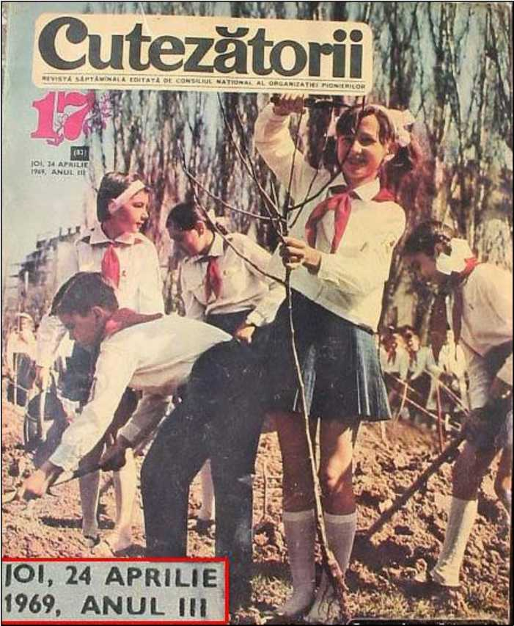

C ONTEMFORARY

Literature Press



<http://edltura.mttlc.ro> Bucureşti 2013

Constantin Noica (1909-1987)

124

Eminescu and the Non-Being.

Too much has been said about "dor" (yearning, longing, melancholy and grief

* cf. German "Sehnsucht" - Ed.) with Romanians; too much has been said about non- being with Eminescu.

But non-being brings about rest. Eminescu on the other hand brings about unrest. We cannot find rest with Eminescu. The whole range of his openings towards the world and culture gather for us into one throbbing heart.

Which people has ever been made such a present? A better conscience, better and exemplary sayings are of course in the endowment of a few great peoples and their culture. But how many of them actually have a heart?

Is this heart suffering:

*"Take pity and put out my too long days..."*

as the poet himself says? But his days used to be long out of their fullness, not out of their emptiness.

Is his world outlook that of a downfall:

*"Can we be sure we are not living in a world, which unawares is falling?"*

or:

*"And my thoughts add up to nations driven wildly by the wind...?"*

Yes, all this is fully true. But they are nations of thoughts, there used to be nations in his conscience.

If no other Romanian writer invoked non-being to a greater extent, it is because none of them faced it to a greater extent. You must face non-being with your hand full. That is how he came - and then what remains out of the non-being invoked?

C ONTEMFORARY

Literature Press



<http://edltura.mttlc.ro> Bucureşti 2013

Constantin Noica (1909-1987)

125

Very much as he could seem to us for a moment turned too much towards the

past:

*“Where the railroad comes..."*

as if he had regretted a novelty of his century, while in fact very few people were like him up to that novelty, given his opening towards sciences; very much as nowadays, in the latter half of the 20th century - when science and technology have grown mature, so that they no longer drive away songs (as Eminescu said in the same poem

* Ed.) folklore is turning, with its style and visions towards the future, and Eminescu himself may also be turned towards the future; in much the same way as old Romanian sayings do it at the same time, for you can read in them an anticipation of the clarifications and developments that are in store for man.

In exactly the same way, Eminescu's invocation of nothingness may no longer appear now as nostalgia, but a human challenge.

In his treatise on Man's Dignity - the only one in which Pico della Mirandola can still tell us something - he stated that man was the only being that had emerged without a determined appearance, without special visions (like those of the angels, he says) and without a home - in order to be able to acquire all of them. That is why, Pico della Mirandola adds, man can acquire the name of all creatures in the world; but in this way man is above them for "he would not be second to anything."

Eminescu came before non-being with his hand full. "Stray, unsolaced, like a soul without a dowry," exactly as the Renaissance man used to say about man that he is the only being that has no place of its own, our poet received his lot, living within its measurement, within its bounds - or even within its boundlessness.

The present that was made to us through Eminescu? There appeared in our world somebody who aspired to be a complete human being. Somebody who did not want to take the second place.

**[Translator anonymous] Published in** Romanian Review **No. 1, 1984, pages 90 to 91.**

C ONTEMFORARY

Literature Press



<http://edltura.mttlc.ro> Bucureşti 2013

Constantin Noica (1909-1987)

126

Facsimilaţi „Caietele lui Eminescu"!

**Written in March 1968. Never published.**

De peste o jumătate de veac s-a pus problema unei statui Eminescu pe gustul tuturor. Nu s-a putut face.

S-a pus problema, la Universitate, a unei catedre Eminescu. Nu s-a putut face.

S-a pus problema unui anuar Eminescu sau a unei reviste, care să publice ineditele poetului şi comentarii asupră-i. Nu s-a putut face

S-a pus, în sfârşit, problema unei ediţii Eminescu complete. S-a început una, dar nu s-a putut încă face până la capăt.

Este în schimb ceva care se poate face, care trebuie făcut şi care interesează mai mult decât o statuie, o catedră, un anuar, ceva care echivalează cu operele complete: este editarea întocmai, facsimilarea Caietelor lui Eminescu.

Există, într-adevăr, în mijlocul nostru o comoară de care abia ne atingem, de teamă să n-o prăpădim: sunt cele 44 de caiete ale lui Eminescu. Ele se păstrează cu grijă la Biblioteca Academiei şi se împrumută foarte rar, numai cercetătorilor mai în vârstă, caietele ascunzându-şi tot mai mult slova lor aleasă de lumina zilei şi rămânând să fie păstrate în cât mai bună stare pentru generaţiile viitoare.

Dar ele ne privesc pe toţi! Ele pot vorbi tuturor, într-un fel, şi mai ales oamenilor tineri. Niciun tânăr nu are acces la caietele acestea, şi totuşi pentru nimeni întâlnirea cu ele nu ar fi mai răscolitoare decât pentru un tânăr deschis către cultură.

Din caietele acestea s-au scos majoritatea postumelor lui Eminescu; de aici variantele; de aici s-au desprins scrierile sale în proză, asupra caietelor acestora a lucrat Călinescu spre a da splendida sa operă critică, aici, în sfârşit, a întârziat atâţia ani Perpessicius, care a putut da în trei decenii doar 6 din cele făgăduite ale operei complete.

Şi, totuşi, chiar dacă ediţia ar fi completă şi oricum ar mai fi folosite caietele, ele păstrează un rest. Întâi, ele arată nu numai câtă învrednicire avea Eminescu, dar şi câtă vrednicie, ceea ce e bine ca omul tânăr de astăzi să ştie; apoi caietele reprezintă

C ONTEMFORARY

Literature Press



<http://edltura.mttlc.ro> Bucureşti 2013

Constantin Noica (1909-1987)

127

un adevăr de viaţă fascinant, din mijlocul căruia ţâşnesc gânduri şi frumuseţi neaşteptate.

Nicio operă tipărită nu-ţi va reda, de pildă, lista datoriilor lui Eminescu, consemnată cu umilinţă la fila 66 a ms. 2 277 pe două coloane; în stânga: Moise l00 lei, Tata 1 200, Wachtel 200 ş.a.m.d.; în dreapta, „presante": Wachtel 200 ş.a.m.d., total 940, reţineţi: 940 lei vechi, bietul de el; pentru ca imediat apoi să apară versurile:

*Cînd luminat Şi luminînd S-au arătat Din cînd în cînd Al lunii disc Ce trece lin Pe orice pisc Punând senin...*

E o altă întâlnire cu poezia, după cum e o altă întâlnire cu gândul filozofic. Ceva neverosimil, ca viaţa, ca miracolul creaţiei, îţi stă înainte, în mijlocul molozului şi mizeriei de a fi om. Atunci porneşti orbeşte prin toate caietele în căutarea neştiutului Eminescu. Din aceste caiete am vrut să scoatem, în mai multe articole, gânduri şi judecăţi ce ne par potrivite pentru lumea de astăzi. Majoritatea a reţinut, desigur,

atenţia editorilor trecuţi; dar câteva sunt inedite. Ce interesează, însă, e relieful cel nou

/ / 7 77

în care apar lucrurile în caiete sau recolta de gânduri şi frumuseţi pe care fiecare o poate face singur, ca şi cum ar fi fost un contemporan al lui Eminescu, prin caietele lui, şi ar veni acum să istorisească ce ştie despre marele său prieten.

Iată, de pildă, ce gândea Eminescu despre fantezia tinerilor, despre poezia lor şi despre dreptul lor de creaţie.

„Se zice - scrie Eminescu în ms. 2 285 la fila 113 - că fantezia tinerilor este mult mai vie... C'est une question... În reproducerea fidelă în toate fineţele ei a lucrurilor, fantezia oamenilor copţi este mai credincioasă - pentru cei tineri acestea se prezintă sub o culoare sau prea obscură şi conturele se pierd în întuneric - sau prea vie, viorie sau roză, şi conturele se confundă în lumină.

Această calitate de a vide totul într-un fel de negură face că poeziile junilor sînt atît de pline de abstracţiuni...

S-ar putea zice că tinerii colorează gros toate lucrurile, căci altfel nu le-ar vide defel. Dar poate că e şi altceva. Ei nu domină pe deplin limba, nu stăpînesc

C ONTEMFORARY

Literature Press



<http://edltura.mttlc.ro> Bucureşti 2013

Constantin Noica (1909-1987)

128

deplin materialul ei de fineţă şi distincţiuni şi numesc multe lucruri cu acelaşi nume, cum rutenii au pentru verde şi albastru aceeaşi vorbă, deşi în fapt ei disting culorile... "

Nu ni se pare că este un adevăr în gândurile lui Eminescu? Undeva, poate, judecata lui e prea aspră: lotul tânărului nu e doar abstractul, ţipătul lui liric nu-i întotdeauna atât de frust exprimat încât să confunde culorile ca rutenii. Dar ce lecţie şi ce avertisment pentru omul tânăr, în gândurile acestea!

Să le primească tinerii noştri scriitori de astăzi, căci le vin de la marele tânăr al culturii noastre. Iar dacă ei ar întreba: cum să faci să-ţi maturizezi fantezia, cum să faci să-ţi stăpâneşti, pe de altă parte, limba, atunci vom răspunde: tocmai de aceea cerem să se facsimileze cele 44 de caiete Eminescu: spre a se vedea ce a făcut, cât a trudit şi cât ştia Eminescu, în ceasul acela al culturii româneşti,

*Cînd luminat Şi luminând S-au arătat Din când în când*

uimirii noastre.

C ONTEMFORARY

Literature Press



<http://edltura.mttlc.ro> Bucureşti 2013

Constantin Noica (1909-1987)

129

Scrisoare despre „Caietele lui Eminescu".

După cum ştiţi, de aproape şaptezeci de ani o lungă serie de personalităţi, între care N. Iorga şi G. Călinescu, au cerut publicarea întocmai a manuscriselor eminesciene. Când, în ultimii doi ani, s-a repus problema editării lor sub formă facsimilată - singura care le poate reda întocmai, ceea ce e esenţial - s-au ivit două propuneri: una a Bibliotecii Centrale de Stat din Bucureşti, care se oferea să ia asupra- şi, la solicitarea Uniunii Scriitorilor, facsimilarea celor 44 manuscrise eminesciene conţinând caietele, cu cheltuieli minime (prin reproducere la aparate xerox de tip nou) şi într-un tiraj de 10 000 exemplare, ceea ce făcea ca la costul de numai 200-300 lei pentru toată seria de 44 volume să se asigure câştiguri de peste un milion de lei şi răspândirea ediţiei până la tânărul din Botoşani, Năsăud sau Constanţa; o a doua propunere, cea a specialiştilor de la Editura Uniunii Scriitorilor, potrivit cărora reproducerea ar trebui făcută la orice cost, pe clişee speciale, într-un tiraj mai degrabă pentru istoricii literari şi biblioteci, fiecare volum facsimilat fiind însoţit de o broşură (sau de un volum în cazul manuscriselor întinse) cu transliterarea textului eminescian şi cu note explicative.

A prevalat a doua propunere, conducerea Uniunii Scriitorilor adoptând, cum era firesc, avizul redactorilor săi competenţi. Între timp, în mai multe rânduri înainte şi după înfiinţarea editurii respective, s-a anunţat editarea caietelor lui Eminescu, iar ulterior s-a făcut cunoscut prin presă că în cursul lui 1971 vor apărea primele trei caiete-manuscrise. Satisfăcut, ca orice alt cititor, că s-a ajuns aici, autorul acestor rânduri - implicat doar întâmplător în unele din fazele anterioare ale proiectului - socotea că nu mai e nimic de spus, ci doar de aşteptat. Dar de ce nu amândouă proiectele?, şi-a spus mai târziu.

Proiectul Uniunii Scriitorilor e admirabil, fireşte, şi cu adevărat demn de Eminescu. Dar poate fi el operant în fapt? Sunt două semne de întrebare pe care le ridică proiectul, laolaltă cu un neajuns sigur. Să vi le enumăr, aşa cum am făcut-o, dar poate prea timid, către redactorii respectivi, şi apoi să las la aprecierea Dvs. dacă ele sunt de invocat în continuare ori nu.

1. Cincisprezece ani. Ni se oferă trei volume pe an; aceasta înseamnă, date fiind

C ONTEMFORARY

Literature Press



<http://edltura.mttlc.ro>

Bucureşti 2013

Constantin Noica (1909-1987)

130

cele 44 volume, nu mai puţin de cincisprezece ani. Chiar dacă s-ar încerca grăbirea termenelor de apariţie, se opune punctul doi, transliterarea, de care vom vorbi îndată. Aşadar cincisprezece ani. Populaţia umanităţii se dublează în treizeci şi ceva de ani. Vom putea lucra la proiectele noastre chiar aşa de tihnit? Probleme noi, situaţii noi, poate favorabile, poate mai puţin favorabile, se vor ivi în acest răstimp. Nu ai întotdeauna răgazul să faci esenţialul; uneori trebuie să te resemnezi cu elementarul. Ştim bine că atâta vreme cât se va vorbi româneşte în colţul nostru de lume, Eminescu va supravieţui. Dar vor supravieţui şi manuscrisele lui?

Să nu spunem chiar că apele Dâmboviţei se vor umfla într-o zi ca ale râului Arno şi vor deteriora manuscrisele lui Eminescu întocmai unora din Florenţa. Să nu spunem nici că instalaţia de calorifer a Bibliotecii Academiei va face explozie din cine ştie ce neglijenţă. Să nu dăm curs unor asemenea lamentabile spaime, nici altora de cine ştie ce ordin. Dar nu e un noroc pentru generaţia noastră că are încă intacte aceste manuscrise? Nu e chiar un privilegiu că n-au fost publicate în trecut şi pot fi astăzi? Ne putem juca atât de lesne cu anii?

Dacă îngăduiţi o reflecţie mai liberă, voi spune că popoarele ca şi indivizii trăiesc prin salturi, nu pe bază de continuitate bine asigurată. Ai un ceas bun în viaţă, eşti dator să faci un pas înainte.(...) Nu se poate lăsa altor generaţii ceea ce poate fi făcut acum, sub cuvânt că trebuie să facem lucrurile desăvârşit de bine. Desăvârşirea înăbuşă câteodată săvârşirea. Şi de altfel nimic nu ne împiedică să facem una şi să încercăm alta. Căci a edita în chip desăvârşit manuscrisele rămâne o simplă încercare.

1. Transliterarea. Într-adevăr, să admitem că pe clişee costisitoare manuscrisul eminescian va arăta mai clar decât prin xerografiere, deşi noile maşini xerox de care dispunem (spre deosebire de cel al Academiei) vor reda, după proba făcută de Biblioteca Centrală de Stat cel puţin, claritatea originalului. Rămâne transliterarea şi rămân notele explicative. Cine să le facă? În cât timp şi cu ce rezultat? Trebuie să vă împărtăşesc, la acest punct, că pentru adnotările filozofice în limba germană a fost însărcinat în principiu semnatarul acestor rânduri. Am fost onorat de însărcinarea primită, voi face totul ca s-o duc la îndeplinire, singur sau cu alianţa tuturor germaniştilor disponibili, dar vă mărturisesc că m-am poticnit încă de la două adnotări pe marginea traducerii din Critica raţiunii pure. De altfel, Eminescu făcea note, ca orice cărturar, pentru sine, cu prescurtări sau trimiteri de nedezlegat astăzi decât prin cine ştie ce întâmplare fericită. La fel trebuie să stea lucrurile şi cu unele note în limba română. Cum rămâne însă cu desăvârşirea? Pe de altă parte, scrisul frumos al lui Eminescu este clar pentru oricine, în proporţie de 95 la sută. Pentru rest, numai acad. Perpessicius - al cărui meşteşug din păcate nu l-a deprins nimeni - ar fi putut

C ONTEMFORARY

Literature Press



<http://edltura.mttlc.ro> Bucureşti 2013

Constantin Noica (1909-1987)

131

descifra ceva, o parte rămânând în aşa fel încifrată încât te întrebi dacă, aşa cum se întâmplă oricărui autor, Eminescu ar mai înţelege absolut tot ce a scris în febrilitatea

notaţiei.

/

Şi mai sunt notele explicative. Ar urma să se arate, în fiecare vers, din ce poezie face parte şi din ce variantă; ba la unele notaţii în proză, unde anume au fost folosite; la unele gânduri ori pagini, dacă sunt originale sau traduceri, şi de unde. Ar urma să se dateze caietele (după scris, după cerneală etc.) care sunt legate la întâmplare, uneori chiar greşit, cum s-a dovedit în câteva cazuri. Ar urma să se facă totul dinainte.

Dar nu este unul din rosturile ediţiei facsimilate tocmai acela de-a forma

/

cercetători? Nu se poate spera că la îndemâna atâtor cărturari, mai ales tineri, Caietele vor conduce la ceea ce se cere acum în gol: la specializare, adâncire şi cunoaştere a textului eminescian?

Dacă stăruim să obţinem desăvârşirea de la început, nu înseamnă oare să amânăm tocmai mijlocul prin care putem pune pe lume agenţii desăvârşirii? Şi dealtfel - este editarea Caietelor tul Eminescu o chestiune pentru specialişti doar? Sau e una pentru sufletul românesc?

1. Aici se înscrie, dincolo de cele două semne de întrebare ce însoţesc ediţia

' / /

proiectată, neajunsul de care vorbeam: ea nu-şi poate atinge rostul decât în condiţii ideale, peste mulţi ani, şi lasă până atunci cultura noastră cu-adevărat fără inimă.

Îşi au şi exegeţii literari rostul lor de seamă, dar ei n-au dreptul să confişte pentru ei filele eminesciene, căci stă închis într-însele ceva esenţial fiinţei noastre spirituale. Înţelegi acest lucru, sau nu-l înţelegi. Şi-l înţelegi numai dacă ai în faţă, în masivitatea ei, dăruirea către cultură a poetului, iar nu dacă o înregistrezi în câte trei volumaşe pe an, cu imperfecţiunile lor inerente. Întâlnirea cu Eminescu nu este o chestiune de exactitate, ci una de vibraţie. Ce exactitate poate fi în joc, în unele cazuri? Să vedem oare din ce gramatică latină sau din ce tratat elementar de matematici şi-a luat el temele pentru exerciţii? Să ne înduioşăm de greşelile de franceză sau de greacă pe care le face?

Dar prin Eminescu şi moştenirea miraculos rămasă de la el ni s-a făcut un dar de care n-au avut parte alte culturi, fie şi cele mari. La scara culturii noastre, funcţia lui Eminescu poate fi mai vie decât cea a lui Shakespeare în Anglia sau a lui Goethe în Germania, căci el nu e un simplu poet, nici un simplu suflet nenorocit, ci o conştiinţă de cultură completă, de la deschiderea spre matematici, pe care abia le cunoaşte, până la aceea către istorie, pentru care avea un organ deosebit. Dacă vrem matematicieni pentru anul 2020, oameni de cultură cu răspunderea specialităţii lor, dacă vrem să se abată şi la noi acea binecuvântată ruşine de-a nu şti tot, atunci n-ar trebui să întârziem

C ONTEMFORARY

Literature Press



<http://edltura.mttlc.ro> Bucureşti 2013

Constantin Noica (1909-1987)

132

editarea caietelor.

Veţi spune: aceasta e părerea dumitale. Tocmai aici vă cer să interveniţi. Nu stau să mai invoc pe cei mari din trecutul nostru, care au spus că niciun rând din Eminescu nu trebuie lăsat nepublicat. Vă cer să luaţi mărturia celor în viaţă, care cunosc manuscrisele şi al căror nume îl ştiţi desigur. Dar vă cer propria Dvs. mărturie şi a celor pe care îi preţuiţi ca oameni de cultură. Dacă veţi spune că nici ei, nici Dvs. nu cunoaşteţi manuscrisele şi că ele nu se mai împrumută acum nimănui, iată vă ofer o soluţie: un sfert din manuscrise sunt fotocopiate şi ele nu vi se vor refuza la Biblioteca Academiei. Vă dau şi cota lor: 2 259, 2 260, 2 261, 2 268, 2 276 A şi B, 2 277, 2 282, 2 283,

1. 284, 2 262, 2 263. La cererea noastră a fost fotocopiat ms. 2 258, cu Kant. E adevărat că reprezintă doar un sfert şi că par alese după criterii exclusiv literare, lipsind admirabile manuscrise ca 2 257, 2 275 B, 2 287; dar, oricum, sunt un sfert. Răsfoiţi- le măcar pe acestea, Dvs. sau aleşii Dvs., dar pe toate. Cufundaţi-vă în magia întregului eminescian.

Apoi, dacă credeţi că am dreptate, uitaţi de copilul satului ce v-a semnalat o comoară - căci nu am fost mai mult decât atât - şi îndemnaţi pe cei ce pot s-o facă să dezgroape comoara. Cât despre numărul banilor, au să-l facă zarafii mai târziu.

**Pulished in** Ramuri, **No. 9, Craiova, on 15 September 1981, page 3.**

C ONTEMFORARY

Literature Press



<http://edltura.mttlc.ro> Bucureşti 2013

Constantin Noica (1909-1987)

133

Prezenta fizică a lui Eminescu în lumea noastră.

Dacă, prin imposibil, Eminescu ne-ar apărea înaintea ochilor (fie şi la televizor), discutând pătimaş în câte o redacţie de ziar ultima carte citită sau ideile politice ale

zilei, l-am urmări cu emoţie.

' /

Dacă am avea trupul lui îmbălsămat, aşa cum au sovieticii pe al lui Lenin, milioane de români ar fi trecut şi ar trece pe lângă sicriul de sticlă. Dacă, măcar, vocea lui ar fi putut fi înregistrată, din nou milioane de oameni ar sta s-o asculte şi să resimtă ceva din prezenţa lui fizică.

Dar noi avem o formă de prezenţă fizică a lui Eminescu mai adevărată şi mai cuprinzătoare decât apariţia de o clipă a omului viu. Iar această mai adevărată prezenţă fizică nu a fost înregistrată decât de câteva zeci de cărturari români.

Cum oare? Mâna îmbălsămată a lui Eminescu ne-ar fi spus ceva viu, iar scrisul acelei mâini - scrisul în care unii vor să vadă omul întreg, cu natura lui fizică şi morală

* să fie ceva mort pentru noi? Vocea omului să-l fi readus printre noi, iar pentru partitura, ca şi muzicală, a zbuciumului său, înregistrat pe câte o filă de manuscris, noi să nu avem auz?

Dar nu o singură filă cu această prezenţă fizică a lui Eminescu ne stă la dispoziţie, ci 8 sau 9 mii de file. Nu le-au sorbit cu ochii generaţiile trecute, dar au tipărit din ele şi ce era bun, şi ce era mai puţin bun. Numai că, tiparul abstractizează şi stinge viaţa unei file de manuscris. Este cu totul altceva să vezi tipărită o notaţie care, dacă e modestă şi nesemnificativă odată tipărită - şi să ai sub ochi, în haosul câte unei file, imaginea câte unui chip interior, acea imagine vie, în care şi ce este simplu ori mizerabil, ca un exerciţiu de matematici sau rezumatul unui tratat ştiinţific ori al unei gramatici străine, se înnobilează şi se însufleţeşte.

44 de asemenea caiete - cuprinzând toată ucenicia, dar şi toată opera lui Eminescu - ar putea figura xerografiate sau redate oricum cu mijloacele tehnicii moderne în aproape orice bibliotecă de cărturar, în locul unui volum de versuri şi a două de proză, ca astăzi. Fiecare am deschide din când în când un caiet, după ce le vom fi răsfoit febril pe toate, spre a recăpăta de aici puteri, ca din apele noastre vii.

C ONTEMFORARY

Literature Press



<http://edltura.mttlc.ro> Bucureşti 2013

Constantin Noica (1909-1987)

134

Dar să admitem - cum ni se spune - că manuscrisele nu pot fi încă puse sub ochii oricui, din cauza câtorva pagini prea xenofobe (deşi ar putea fi lesne lăsate deoparte) sau din cauza notaţiilor germane, nedescifrate încă. Să păstrăm pentru generaţiile viitoare această prezenţă fizică a lui Eminescu.

Dar cum o păstrăm? Se află cumva la Iaşi, în rafturile bibliotecii al cărei director a fost cândva Eminescu, o fotocopie sau xerogramă a manuscriselor sale? Există vreuna la muzeul din Botoşani? Şi există vreo răspândire a lor, pentru cazul că un incendiu sau oarba întâmplare ar distruge aripa Bibliotecii Academiei din Bucureşti ce le adăposteşte? Nu există nicio răspândire a manuscriselor sub formă reprodusă. Nici Biblioteca Centrală de Stat din Bucureşti, nici cea Universitară, nici Muzeul de istorie a literaturii nu posedau o replică a manuscriselor, la sfârşitul lui august 1977. La Biblioteca Academiei, de altfel, nu erau fotocopiate - la aceeaşi dată - decât 14 manuscrise, un număr de 36 fiind microfilmate, iar toate fotocopiile ca şi microfilmele sunt păstrate doar acolo, multiplicate şi astfel supuse aceluiaşi risc ca manuscrisele originale.

Cele de mai sus reprezintă o simplă tentativă de a clătina inerţia. Nu s-ar putea, totuşi, ca să se înscrie şi propunerea noastră sub forma cererii ferme ca o reproducere, măcar după cele 14 fotocopii şi 36 microfilme, să figureze şi la Iaşi? Ca Iaşii lui Eminescu să adăpostească şi ei imaginea prezenţei lui fizice printre noi?

Poate că abia manuscrisele, cu deschiderea lor către universul culturii şi cel al limbilor, ne-ar arăta concret ce înseamnă împletirea necesară dintre universal şi naţional. Fără universal, naţionalul este zoologie. Cu aceste manuscrise, în schimb, avem cel mai impresionant nouă document uman - şi unic în cultura europeană, exceptând caietele lui Leonardo da Vinci - cu privire la miracolul spiritului, „rătecit, nemângâiet" cum este, de-a pute fi întreg şi în cuvinte moldoveneşti.

**Talk read at a Iaşi Conference on Eminescu on 9 October 1977, and published in** Ramuri**, No. 8, Craiova, on 15 August 1981, page 3.**

C ONTEMFORARY

Literature Press



<http://edltura.mttlc.ro> Bucureşti 2013

Constantin Noica (1909-1987)

135

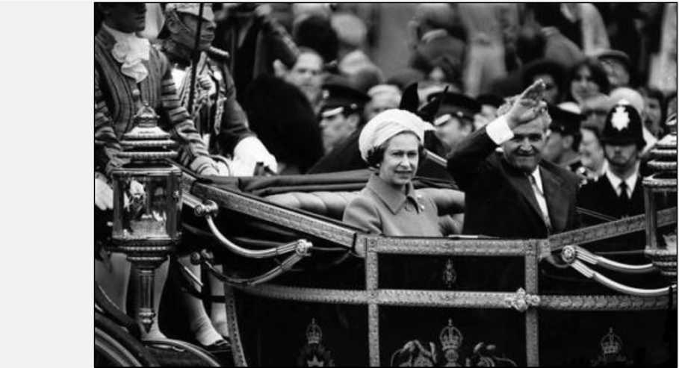

Vigneta 11 (vezi Vigneta 8).

Constantin Noica: 333 de întrebări. Martin Heidegger: 333 de întrebări.

Leon Leviţchi: 333 de întrebări.

/

George Sandulescu: 333 de întrebări.

**CGS**

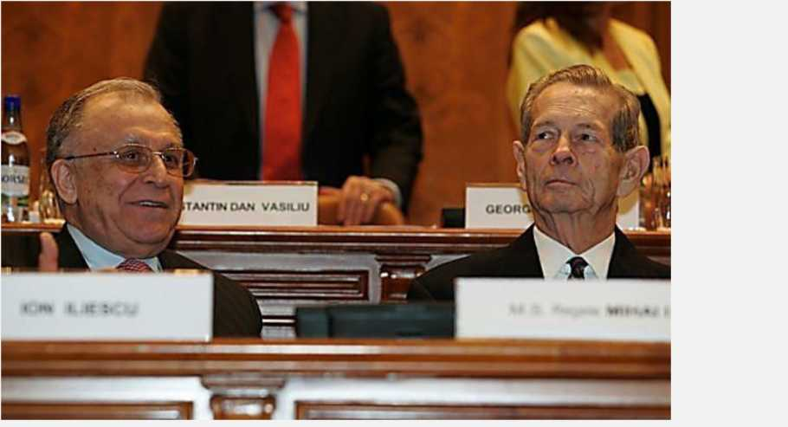

C ONTEMFORARY

Literature Press



<http://edltura.mttlc.ro> Bucureşti 2013

Constantin Noica (1909-1987)

136

**Constantin Noica**

**Ce nu se vede**



(O echipă de cineaşti de la Studioul Sahia a venit în staţiunea montană Păltiniş pentru un film documentar. La cererea ce i s-a făcut de a figura în acest film, autorul de faţă a răspuns, filmat, cele de mai jos.)

Aţi venit aici să furaţi un chip şi să-l arătaţi altora. Nu vă temeţi că veţi pleca îndărăt cu mîinile goale? E adevărat, „în orice om o lume îşi face încercarea", cum spunea Eminescu; dar în felul cum vreţi să redaţi pe ecran lucrurile, nu veţi reţine nici încercarea, nici lumea, ci doar un biet chip de om. Oricare dintre noi, dealtfel, poate replica sculptorului, care ar voi să-i redea fiinţa trupească, aceea ce spunea Plotin în antichitatea tîrzie: „Nu e destul că-mi suport trupul? Să-l mai văd şi reprodus?" Am să vă supăr de pe acum spunînd că nu vreau să văd secvenţa D-voastră.

Recunosc, astăzi sîntem mai puţin severi cu fiinţa trupească decît era un Plotin. Trupul e una cu sufletul, sau abia trupul îl exprimă cu-adevărat pe acesta. Spre a vă cita iarăşi o vorbă, de astă dată a unui singuratic de la începuturile creştinismului, Antonie cel Mare: „Semnele după care se cunoaşte un suflet raţional şi virtuos sînt: privirea, mersul, glasul, rîsul, ocupaţiile şi întîlnirile cu oamenii." Aşa trebuie să fie. Dar noi mai simţim că sufletul e una cu trupul doar aşa cum fac una călăreţul şi calul. Iar D-voastră s-ar putea să nu redaţi decît calul, nu şi călăreţul. Căci există un galop al calului, cu călăreţ cu tot, dar pe deasupra sa este galopul călăreţului către ţinta lui, nevăzută. Pe primul îl puteţi reda — şi mi se pare că de aici a şi început cinematografia, de la încercarea de a reda galopul calului—, dar pe cel de-al doilea, galopul călăreţului, nu-l redaţi. Tot ce e adevărat pe lumea aceasta nu se vede. Mai de grabă puteţi reda în imagini Paradisul decît aspiraţia către Paradis, de vreme ce aţi pus atît de bine în joc

C ONTEMFORARY

Literature Press



<http://edltura.mttlc.ro> Bucureşti 2013

Constantin Noica (1909-1987)

137

ochiul exterior, trăgînd în jos pleoapele ochiului interior. Cine vrea să fie om adevărat trebuie să devină un duh, o umbră. D-voastră nu aveţi ce face cu umbrele.

Împreună cu toată lumea de astăzi, lucraţi asupra contextului, nu a textului. Nici nu ne dăm seama cît de mult întîrzie lumea modernă asupra contextului, a condiţiilor exterioare. Vrem să creiem pentru toţi, cu ideologiile noastre, condiţiile potrivite (spre a?) sau vrem să pregătim apariţia a nu ştim bine ce; antrenăm perfect cai pentru galopuri spre ţinte nedesluşite, iar mijloacele noastre sporite şi banul, mai ales banul, în atîtea inimi şi într-o bună parte a lumii, reprezintă contextul prin excelenţă. Pînă şi strădania aceasta, legitimă, spre pace şi echilibru în lume, se înscrie grandios pe linia contextului. Dar care ne e textul?

Iar contextul se vede, în timp ce textul nu se vede. Cînd îl ai, sau atunci cînd îţi faci iluzia că ai un text, contextul vine de la sine, creşte singur din text — sau îţi este ca şi indiferent. Mă găsiţi în mansarda aceasta, fericit, sau sub o iluzorie fericire, oarecum nepăsător faţă de context, care în definitiv poate fi şi al altora, în primul rînd al prietenilor ce vor să reţină ceva pe un ecran interior. Unui pictor tînăr rătăcit pe aici i- am cerut să picteze nişte bizoni, pe pereţii sălii mansardate ce duce la odaia mea şi care seamănă cu grota de la Altamira. Peste vreo doi ani, dacă mai trăiesc, voi cere altui pictor tînăr să redea cîteva fresce bizantine. Dacă vin două fete să afle ceva despre textul unei existenţe, le voi pune să planteze un răsad cu flori, cum vor vroi ele, în faţa casei. Nu mă aflu în casa mea, dar sînt ca şi în casa mea, care este şi a altora. Ce bucurie, non-posesiunea! Una din încîntările vieţii este să ai proprietate fără posesiune.

În momentul de faţă trebuie să scriu o istorie a filozofiei în vreo 80 de pagini, pentru o Enciclopedie. Am visat întotdeauna să ajung într-un asemenea ceas, cînd voi scrie o istorie a filozofiei fără filozofi. Filozofii sînt plicticoşi, o recunosc; dar filozofia este peste tot în rest, iar o istorie a filozofiei ca istorie a spiritului european, cu înţelesuri adînci dar implicite, în opere literare, în creaţii de artă, în ştiinţe, în rînduielile şi smintelile societăţii istorice, aşa ceva ar putea fi grăitor, şi tocmai pe linia adevărurilor care nu se văd. Problema ultimă a filozofiei este Fiinţa, iar încercarea fiecărui lucru de a intra în fiinţă este activă peste tot! Ştiţi de ce spun asta? Pentru că — aşa cum spunea un medieval — fiinţa nu este, pînă la urmă, cea divină, cea desăvîrşită, este numai iubirea ei. Oriunde este iubire, de la dragostea între oameni, dragostea către copil, pînă la dragostea pentru un gînd şi pentru un sens de viaţă care să ţină, peste tot este şi fiinţă. Dealtfel, cînd iubeşti nici nu te mai întrebi ce este pe lume. Dar iubirea e pentru un text, nu pentru context, iar textele nu se văd. Sînt ale celor ce ţi-au devenit duhuri, umbre.

C ONTEMFORARY

Literature Press



<http://edltura.mttlc.ro> Bucureşti 2013

Constantin Noica (1909-1987)

138

Cred că nu va încăpea ordine în lume şi în cetate, ba chiar în cunoaştere (cum o arată zbuciumul ştiinţelor de astăzi), decît atunci cînd vom găsi în afară de fiecare dată şi ne vom găsi fiecare textul, devenind şi văzînd în jurul nostru bune umbre. De altfel ce sîntem, cei în viaţă, decît mijlocitori între umbrele care nu mai sînt şi cele care nu sînt încă? Altundeva, deci, decît în lumea care poate fi privită pe peliculă se desfăşoară petrecerea lumii.

Cineva care a vrut să petreacă în lumea aceasta, şi nu doar să treacă, vă urează petrecere bună.

**Viaţa Românească 3/1988, pp 10-12**

C ONTEMFORARY

Literature Press



<http://edltura.mttlc.ro> Bucureşti 2013

Constantin Noica (1909-1987)

139

**C. George Sandulescu Disectorium: HISTORY â la Morgue.**

C ONTEMFORARY

Literature Press



<http://edltura.mttlc.ro> Bucureşti 2013

Constantin Noica (1909-1987)

140



**Vigneta 1.**

În domeniul lui mic-mititel al lexicografiei — în fapt chiar opusul filozofiei — Leon Leviţchi a fost marele dascăl care Noica ar fi vrut atât de mult să fi reuşit să fie. Dar n-a ajuns decât un prăpădit de bibliotecar la Universitatea din Bucureşti. CGS



C ONTEMFORARY

Literature Press



<http://edltura.mttlc.ro> Bucureşti 2013

Constantin Noica (1909-1987)

141



**Vigneta 2.**

Cine alive astăzi — metaforic vorbind — ar fi ajuns să fie prin capacităţile sale mare profesor universitar al României sau chiar membru al Academiei? Cine ar fi fost marii noştri profesori şi academicieni dacă nu ar fi existat jumătatea de veac de comunism în România? Cine oare? CGS



C ONTEMFORARY

Literature Press



<http://edltura.mttlc.ro> Bucureşti 2013

Constantin Noica (1909-1987)

142

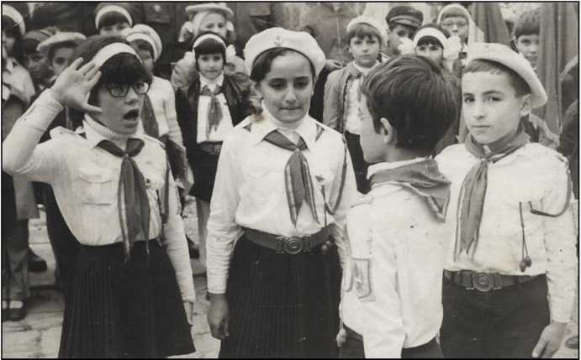

**Vigneta 3.**

Cum ar fi arătat România între 1944 şi 1990, fără comunism? Se întreabă oare cineva? Dacă nu, de ce nu?

Ne-ar ajuta mult să fim mai cinstiţi şi mai corecţi în gândirea noastră de toate zilele dacă am face aceasta!

Oamenii ar fi fost mai drepţi, mai sinceri, mai lipsiţi de hipocrizie.

Căci asta a caracterizat jumătatea de veac de comunism: minciuna, falsitatea, incorectitudinea, lipsa de "inimă deschisă".

Avem mare nevoie să reconstruim trecutul aşa cum a fost el!

Poate aşa s-ar fura mult mai puţin astăzi!

Cine mai bine decât Constantin Noica şi Leon Leviţchi ar fi fost cei doi oameni îndeajuns de curaţi la

suflet? Ei doi ar fi fost cei mai indicaţi să facă o

/

asemenea treabă — în vorbă şi în scris. Păcat că s-au dus aşa de repede. CGS

C ONTEMFORARY

Literature Press



<http://edltura.mttlc.ro> Bucureşti 2013

Constantin Noica (1909-1987)

143

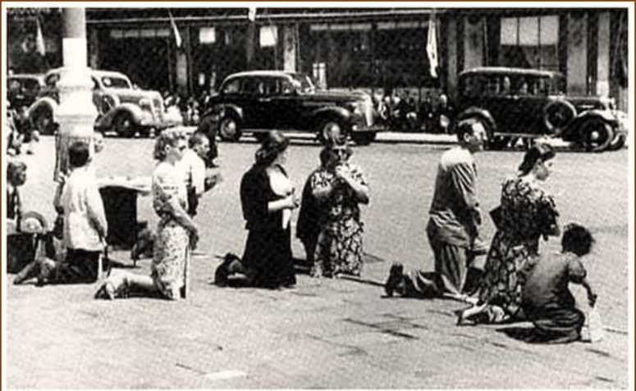

**Bucureşti, 1340. Zi de doliu naţional. României i s-a răpit Basarabia**

**Vigneta 4.**

Cartea mea de căpătâi pe vremea când eram adolescent era The History of the World scrisă de H. G. Wells. De aşa ceva avem nevoie în zilele noastre pentru întreaga Europă a secolului XX.

O asemenea lucrare ar trebui să răspundă multor întrebări fundamentale. De pildă:

1. Cine era realmente Putin?
2. Ce principii în alegerea de cadre au fost adoptate în Irak la prăbuşirea lui Saddam Hussein?
3. Care au fost marile greşeli ale Statelor Unite în zilele lui George Bush Jr?
4. Cine era Tony Blair? Câtă dreptate avea Roman Polanski în filmul său?
5. Cine a creat Republica Moldova? Care este relaţia ei cu Transnistria?
6. Portretul real al lui Gorbaciov!

**CGS**

C ONTEMFORARY

Literature Press



<http://edltura.mttlc.ro> Bucureşti 2013

Constantin Noica (1909-1987)

144

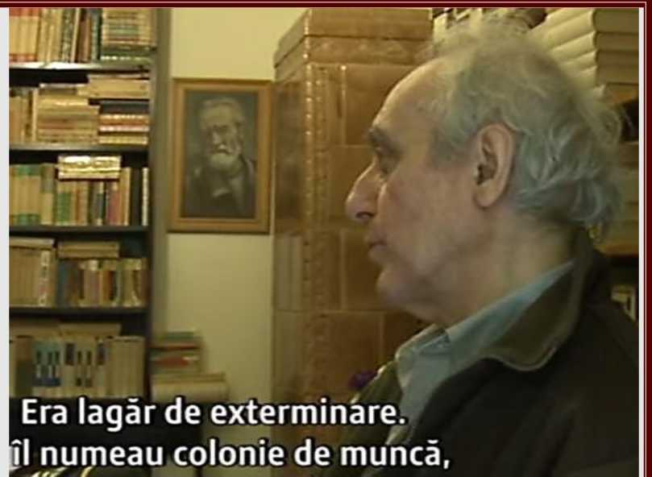

**Vigneta 5.**

Tăcere covârşitoare în jurul numelui lui Dragoş Protopopescu: de ce? Nimeni nu-i pomenea numele în anii

studenţiei mele. De ce? Leon Leviţchi — niciodată! Dan

/ /

Duţescu — niciodată! Ana Cartianu — niciodată! De ce? Este

/

o întrebare deosebit de importantă pentru istoria culturii româneşti în ansamblu.

*

Tăcerea eete primul lucru care trebuie să dispară în

orice discuţie a evenimentelor secolului XX.

/

**CGS**

C ONTEMFORARY

Literature Press



<http://edltura.mttlc.ro> Bucureşti 2013

Constantin Noica (1909-1987)

145

**Vigneta 6.**

Cine era Romulus Zăroni?

Cine era Cincinat Pavelescu?

Cine era Parhon?

Care era funcţia politică a lui Iorgu Iordan alături de cea academică?

Cine era Ştefan Milcu?

Ce capitală a României a propus Ceauşescu?

Ce complot a organizat Ana Pauker şi împreună cu cine? A scris Mircea Eliade ceva despre asta?

Cine era Gheorghe Mihoc?

Cine era Jean Livescu?

Cine era Lothar Rădăceanu?

Cine era Lucreţiu Pătrăşcanu?

**CGS**

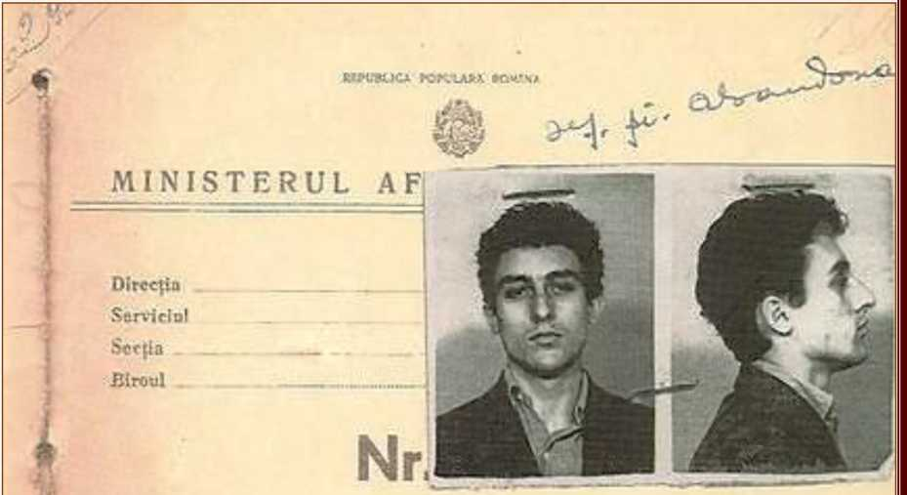

DOSAR PERSONAL

I *"11 *—■

C ONTEMFORARY

Literature Press



<http://edltura.mttlc.ro> Bucureşti 2013

Constantin Noica (1909-1987)

146



**Vigneta 7.**

Unde a murit Mircea Vulcănescu?

Unde a murit Iuliu Maniu?

Unde a murit Codreanu?

Unde a murit Nicolae Iorga?

Ce relaţie era între Monica Lovinescu şi Virgil Ierunca? Unde au locuit ei întotdeauna? Ce revistă împortantă a publicat Virgil Ierunca? Cine era Dictachiorul şi cum a murit el?

Câţi intelectuali au murit în închisori? Ne gândim noi oare des la

ei?

**CGS**

C ONTEMFORARY

Literature Press



<http://edltura.mttlc.ro> Bucureşti 2013

Constantin Noica (1909-1987)

147



**Vigneta 8.**

Constantin Noica: 333 de întrebări. Martin Heidegger: 333 de întrebări.

Leon Leviţchi: 333 de întrebări.

/

George Sandulescu: 333 de întrebări.

**CGS**



C ONTEMFORARY

Literature Press



<http://edltura.mttlc.ro> Bucureşti 2013

Constantin Noica (1909-1987)

148

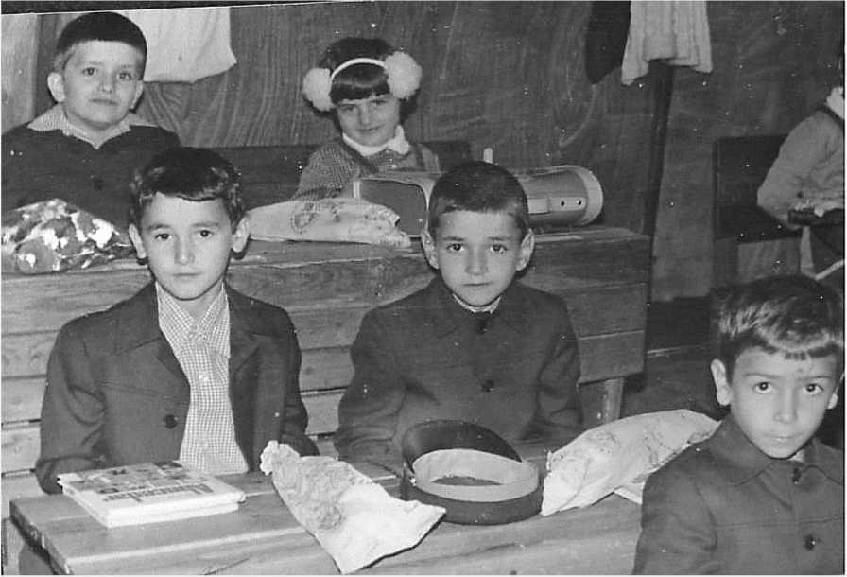

**Vigneta 9.**

Unde a fost asasinat Generalul Antonescu?

Ce a spus Antonescu poporului la jumătatea lui iunie 1941? Când a intrat armata rusă pe teritoriul românesc?

Ce este istoria instituţională şi ce este istoria naţională?

Ce este naţiunea? Teritoriu, sau limbă, sau amândouă? De când

/ *' '*

şi până când?

Cine era Vlad Georgescu?

Prieten apropiat al cărui scriitor român a fost Giovanni Papini, care scriitor i-a tradus cartea Un uomo finito înainte de război?

Când a scris Papini Istoria lumii şi ce valoare academică are ea?

**CGS**

C ONTEMFORARY

Literature Press



<http://edltura.mttlc.ro> Bucureşti 2013

Constantin Noica (1909-1987)

149

**Vigneta 10.**

Esenţa filozofiei lui Martin Heidegger, pe care a preluat-o Constantin Noica, era să pui întrebarea exactă: a pune întrebarea exactă înseamnă a da răspunsul, cu context cu tot şi comentarii. CGS



C ONTEMFORARY

Literature Press



<http://edltura.mttlc.ro> Bucureşti 2013

Constantin Noica (1909-1987)

150



Vigneta 11 (vezi Vigneta 8).

Constantin Noica: 333 de întrebări. Martin Heidegger: 333 de întrebări.

Leon Leviţchi: 333 de întrebări.

/

George Sandulescu: 333 de întrebări.

**CGS**



C ONTEMFORARY

Literature Press



<http://edltura.mttlc.ro> Bucureşti 2013

Constantin Noica (1909-1987)

151

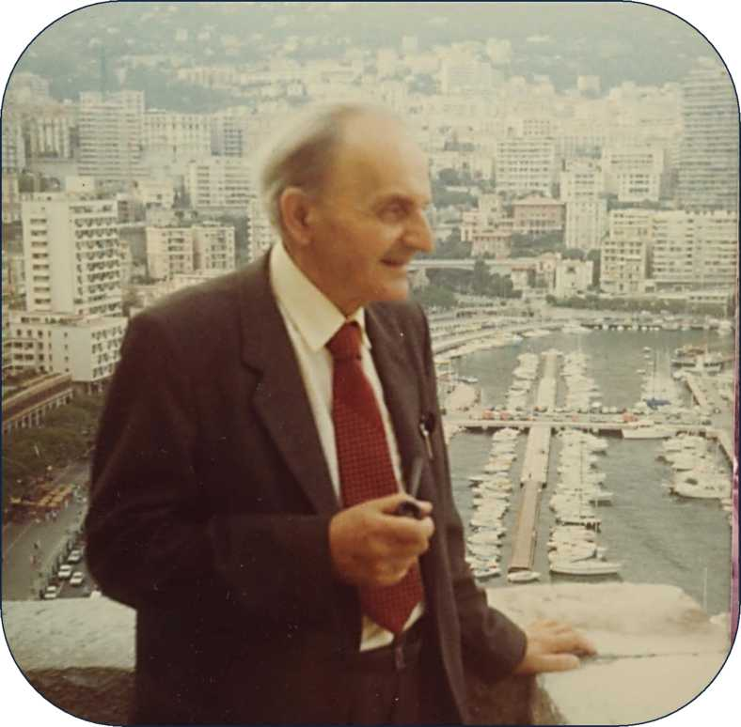

Ce bucurie că viaţa n-are sens. **Pot să-i dau eu unul...**

Jurnalul de Idei.

